**Census 2000 and American Community Survey 2005-2009 SES Scales Based on Factor Analysis**

Last Updated: 11/13/2012

**TABLE OF CONTENTS**

I. INTRODUCTION 5

II. SCALES CREATED FOR USE WITH CENSUS 2000 AND ACS2005-2009 (FINAL SCALES) 5

II.A. VARIABLES USED 6

Table 1: List of variables used in principal components analysis to create SES scales. In the last column, PC1 refers to Race/Ethnicity only PCA, PC2 refers to other SES only PCA, and PC3 refers to Full variables PCA. 6

II.B. PRINCIPAL COMPONENTS ANALYSIS 8

II.B.1. FULL VARIABLES ANALYSIS 8

Figure 1. Scree Plot and Variance explained plot for the Full variables PCA (PC3) 10

Table 2: Factor loadings (with varimax rotation) and variance explained for 5 factors kept in the Full variables factor analysis (N=129002). (PC3) 10

Table 3: Pearson Correlations of the 5 factors kept in the Full variables factor analysis (PC3). 11

Figure 2: Plots of rotated factor patterns for Full Variables PCA (PC3) 11

II.B.2. RACE/ETHNICITY/CROWDING VARIABLES ANALYSIS 13

Figure 3. Scree Plot and Variance explained plot for the Race/Ethnicity/Crowding variables PCA (PC1) 14

Table 4: Factor loadings (with varimax rotation) and variance explained for 2 factors kept in the Race/Ethnicity/Crowding variables factor analysis (N=129875). (PC1) 15

Table 5: Pearson Correlations of the 2 factors kept in the Race/Ethnicity/Crowding variables factor analysis (PC1). 15

Figure 4: Plots of rotated factor patterns for Race/Ethnicity/Crowding Variables PCA (PC1) 15

II.B.3. OTHER SES VARIABLES ANALYSIS 16

Figure 5. Scree Plot and Variance explained plot for the Other SES variables PCA (PC2) 17

Table 6: Factor loadings (with varimax rotation) and variance explained for 4 factors kept in the Other SES variables factor analysis (N=129002). (PC2) 17

Table 7: Pearson Correlations of the 4 factors kept in the Other SES variables factor analysis (PC2). 18

Figure 6: Plots of rotated factor patterns for Other SES Variables PCA (PC2) 18

III. SCALE CREATED BASED ON ANA DIEZ-ROUX CENSUS 1990 FACTOR ANALYSIS 19

Table 8: List of variables used in principal factor analysis to create scale based on Ana Diez-Roux Census 1990 analysis. 20

IV. SCALES CREATED FOR CENSUS BASED ON MAHASIN MUJAHID’S METHODS 20

IV.A. VARIABLES USED 20

Table 9: List of variables used in factor analysis to create SES scales based on Mahasin Mujahid’s methods. 21

IV.B. FACTOR ANALYSIS 22

Table 10: Eigenvalues of the Weighted Reduced Correlation Matrix for the ML factor analysis with Heywood case coding: Total=65.307581 Average=3.62819889 23

Table 11: Final communality estimates and variable weights for the ML factor analysis with Heywood case coding: Total communality: Weighted=84.073144 Unweighted=13.773993 23

Figure 7. Scree Plot and Variance explained plot for the final ML factor analysis for Census 2000 25

Table 12: Factor loadings (with promax rotation) and variance explained for 5 factors kept in the final ML factor analysis for Census 2000 (N=64919). 25

Table 13: Pearson correlations of factor loadings for 5 factors kept in the final ML factor analysis for Census 2000. 26

Figure 8: Plots of rotated factor patterns for final ML factor analysis for Census 2000 27

V. COMPARISON OF VARIABLES FOR CENSUS 2000 AND ACS2005-2009 29

Table 14: Pearson Correlations comparing Full Variables PCA (PC3) with Race/Ethnicity/Crowding Variables PCA (PC1) for combined data. 29

Table 15: Pearson Correlations comparing Full Variables PCA (PC3) with Other SES PCA (PC2) for combined data. 30

Table 16: Pearson Correlations comparing Race/Ethnicity/Crowding Variables PCA (PC1) with Other SES PCA (PC2) for combined data. 30

Table 17: Comparison of Census2000 to ACS2005-2009 Variables and Factor Scales. Difference is ACS-Census2000. 31

VI. ADDITIONAL METHODS TRIED WITH CENSUS 2000 AND ACS2005-2009 36

VII. NOTES FOR CREATION AND LOCATION OF FINAL DATASETS 37

Table 18: Name, Location, and Sample size of final datasets 38

APPENDIX A: VARIABLES IN CENSUS FACTOR SCALES DATASETS 39

Table A1: List of variables in Census 2000 (census2000.sas7bdat) and ACS2005-2009 (acs0509.sas7bdat) datasets. 39

APPENDIX B: ADDITIONAL TABLES OF DESCRIPTIVE STATISTICS 47

Table B1: Skewness statistics for variables used in principal components analysis or factor analysis 47

Table B2: Pearson Correlations of all variables with one another 50

APPENDIX C: PCA RESULTS FOR CENSUS 2000 AND ACS DATASETS SEPARATELY 71

Figure C1. Scree Plot and Variance explained plot for the Full variables PCA (PC3) for Census 2000 71

Table C1: Factor loadings (with varimax rotation) and variance explained for 5 factors kept in the Full variables factor analysis (N=64928). (PC3) for Census 2000 71

Figure C2. Scree Plot and Variance explained plot for the Race/Ethnicity/Crowding variables PCA (PC1) for Census 2000 72

Table C2: Factor loadings (with varimax rotation) and variance explained for 2 factors kept in the Race/Ethnicity/Crowding variables factor analysis (N=64960). (PC1) for Census 2000 72

Figure C3. Scree Plot and Variance explained plot for the Other SES variables PCA (PC2) for Census 2000 73

Table C3: Factor loadings (with varimax rotation) and variance explained for 4 factors kept in the Other SES variables factor analysis (N=64928). (PC2) for Census 2000 73

Figure C4. Scree Plot and Variance explained plot for the Full variables PCA (PC3) for ACS2005-2009 74

Table C4: Factor loadings (with varimax rotation) and variance explained for 5 factors kept in the Full variables factor analysis (N=64074). (PC3) for ACS2005-2009 74

Figure C5. Scree Plot and Variance explained plot for the Race/Ethnicity/Crowding variables PCA (PC1) for ACS2005-2009 75

Table C5: Factor loadings (with varimax rotation) and variance explained for 2 factors kept in the Race/Ethnicity/Crowding variables factor analysis (N=64915). (PC1) for ACS2005-2009 76

Figure C6. Scree Plot and Variance explained plot for the Other SES variables PCA (PC2) for ACS2005-2009 76

Table C6: Factor loadings (with varimax rotation) and variance explained for 4 factors kept in the Other SES variables factor analysis (N=64074). (PC2) for ACS2005-2009 76

APPENDIX D: RESULTS FROM ADDITIONAL METHODS 78

Figure D1: Scree Plot and Variance explained plot for the ML factor analysis with all 21 variables for Census 2000 78

Table D1: Factor loadings (with promax rotation) and variance explained for ML factor analysis with all 21 variables for Census 2000 (N=64928). 78

Figure D2: Scree Plot and Variance explained plot for the ML factor analysis with all 21 variables for ACS2005-2009 79

Table D2: Factor loadings (with promax rotation) and variance explained for ML factor analysis with all 21 variables for ACS2005-2009 (N=64074). 79

Figure D3: Scree Plot and Variance explained plot for the ML factor analysis with all 21 variables for Census 2000+ACS2005-2009 combined 81

Table D3: Factor loadings (with promax rotation) and variance explained for ML factor analysis with all 21 variables for Census 2000+ACS2005-2009 (N=129002). 81

Figure D4: Scree Plot and Variance explained plot for the ML factor analysis with % occupied housing and % receiving public assistance removed for Census 2000 82

Table D4: Factor loadings (with promax rotation) and variance explained for ML factor analysis with % occupied housing and % receiving public assistance removed for Census 2000 (N=64928). 82

Figure D5: Scree Plot and Variance explained plot for the ML factor analysis with % occupied housing and % receiving public assistance removed for ACS2005-2009 84

Table D5: Factor loadings (with promax rotation) and variance explained for ML factor analysis with % occupied housing and % receiving public assistance removed for ACS2005-2009 (N=64074). 84

Figure D6: Scree Plot and Variance explained plot for the ML factor analysis with % occupied housing and % receiving public assistance removed for Census 2000+ACS2005-2009 85

Table D5: Factor loadings (with promax rotation) and variance explained for ML factor analysis with % occupied housing and % receiving public assistance removed for Census 2000+ACS2005-2009 (N=129002). 85

# I. INTRODUCTION

Scales of census tract level socioeconomic status were created for Census 2000 and American Community Survey (ACS) 2005-2009. These scales can be used as adjustments in models for neighborhood level SES status. The goal was to have equivalent scales for both Census 2000 and ACS 2005-2009 that can be used in longitudinal analyses as well as scales that can be used in cross-sectional or baseline only analyses. In addition to this, there is a scale created for both years based on methods used by Ana Diez-Roux for the 1990 census and scales created for Census 2000 based on methods used by Mahasin Mujahid. This document describes the following:

1. Methods for scales created for use in longitudinal analyses combining Census 2000 and ACS2005-2009 (Section II). **These are the scales recommended for use.**  These include scales created from 3 PCA analyses on the following:
   1. Variables for the SES and Race/Ethnicity together (5 factor scales as weighted by factor loadings and based scales) – PC3
      1. These are recommended for use if you are interested in the total SES effect including race/ethnicity.
   2. Variables for Race/Ethnicity/Crowding only (2 factor scales as weighted by factor loadings and based scales) – PC1
      1. These are recommended for use if you are interested in only the race/ethnicity effects regardless of the other SES.
   3. Variables for Other SES without Race/Ethnicity/Crowding (4 factor scales as weighted by factor loadings and based scales) – PC2
      1. These are recommended for use if you are interested in the SES effect independent from the race/ethnicity.
2. Methods for scales based on PCA methods by Ana Diez-Roux from 1990 census (Section III).
   1. This gives an overall SES effect. Race/ethnicity is not taken into account in this scale.
3. Methods for scales for Census 2000 based on Mahasin Mujahid’s ML factor analysis methods (Section IV).
   1. These are recommended only if you want to be consistent with Mahasin’s papers. They are not available in for longitudinal analysis.
4. Comparison of Census 2000 to ACS2005-2009 Data (Section V).
5. Additional methods that we tried and reasons for not pursuing them further (Section VI).
6. Notes on creation and location of final datasets (Section VII).

Please see Appendix A for a listing of all variables in the final datasets.

# II. SCALES CREATED FOR USE WITH CENSUS 2000 AND ACS2005-2009 (FINAL SCALES)

The scales described in this section are the final scales that should mainly be used for longitudinal analyses since combine the two datasets to create methods that are the same for both years using a principal components analysis (PCA). Scales are created as weighted scales using the PCA weights and as based scales summing the standardized variables with high loadings for each component.

## II.A. VARIABLES USED

Variables were selected based on the variables that were used in a factor analysis performed by Mahasin Mujahid on the Census 2000 data in 2005. Variables were selected a priori from available census measures to reflect the racial/ethnic composition, housing, crowding, residential stability, education, employment, occupation, and income/wealth of the census tracts. This includes a total of 21 variables. See Table 1 for a list of variables used.

Interpretation of the variables is designed to indicate a WORSE SES for HIGHER levels (ie: those close to 0 are better SES, close to maximum (usually 1) are a worse SES. To maintain consistency and reduce the number of negative loadings when running the factor analysis, variables that are interpreted as having a higher value being better SES are reverse coded. Correlations of all the variables were also examined. Many of these variables are highly correlated with one another. Reverse coding was used whenever possible to reduce the number of negative correlations. See Appendix B for tables with the correlations.

Factor analysis is based on multivariate normal data distributions. The variables to be included in the factor analysis were checked for skewness using SAS proc means. For those that had skewness>1.5, transformations of log, square root, and cube root were created and checked for “best” transformation. The transformation that gives the least amount of skewness (ie: skewness closest to 0) was used for factor analysis. The cube root transformation was used in all cases. See Appendix B for the table with all of the skewness measures.

Median household income and median value owner units were not reverse coded despite a higher value indicating better SES due to normality transformations. When these variables are not reverse coded, a transformation with cube root gives skewness <1.5. When they are reverse coded, then a good transformation isn’t possible. We decided normality is more important than reverse coding. They will have negative loadings in the PCA and this will need to taken into account when creating factor based scales.

Description of variables used indicating whether reverse coding and/or transformations were used is in Table 1. Throughout the rest of this documentation file, variables will be referred to by variable name as specified in Table 1.

### Table 1: List of variables used in principal components analysis to create SES scales. In the last column, PC1 refers to Race/Ethnicity only PCA, PC2 refers to other SES only PCA, and PC3 refers to Full variables PCA.

| **Domain** | **Variable** | **Description** | **Reverse coded** | **Transformation used** | **Which PCA number was this included in?** |
| --- | --- | --- | --- | --- | --- |
| RACE/ ETHNICITY | race_hisp | Percent Hispanic | NO | Cube root | PC1, PC3 |
| RACE/ ETHNICITY | race_blackNH | Percent non-Hispanic black | NO | Cube root | PC1, PC3 |
| RACE/ ETHNICITY | race_asianNH | Percent non-Hispanic Asian | NO | Cube root | PC1, PC3 |
| RACE/ ETHNICITY | birth_foreign | Percent foreign born | NO | Cube root | PC1, PC3 |
| CROWDING | crowd_gt1_ppr | Percent of occupied houses with more than 1 person per room | NO | Cube root | PC1, PC3 |
| HOUSING | HU_sampleocc | Percent of occupied housing units | YES | Cube root | PC2, PC3 |
| HOUSING | ownerocc_hh | Percent of housing units that are owner occupied out of total housing units | YES | NONE | PC2, PC3 |
| HOUSING | HUcost_medownval | Median value of occupied housing units | NO (due to transformation issues) | Cube root | PC2, PC3 |
| HOUSING | phone_none | Percent of housing units without telephone | NO | Cube root | PC2, PC3 |
| HOUSING | vehicle_none | Percent of housing units without vehicle | NO | Cube root | PC2, PC3 |
| RESIDENTIAL STABILITY | samehouse | Percent living in same house in 1995 (Census 2000) or 1999 (ACS) | YES | Cube root | PC2, PC3 |
| EDUCATION | Educ_minHS | Percent of person 25 or older with at least high school education | YES | NONE | PC2, PC3 |
| EDUCATION | Educ_minBA | Percent of persons 25 or older with at least a Bachelor’s degree | YES | NONE | PC2, PC3 |
| EMPLOYMENT | unemployed | Percent unemployed among civilians 16 and over in the labor force | NO | Cube root | PC2, PC3 |
| EMPLOYMENT | NotInLaborForce | Percent of civilians 16 and over not in the labor force | NO | NONE | PC2, PC3 |
| OCCUPATION | Occup_I | Percent with management, professional, and related occupation | YES | NONE | PC2, PC3 |
| INCOME/ WEALTH | inc_medHH | Median household income | NO (due to transformation issues) | Cube root | PC2, PC3 |
| INCOME/ WEALTH | inc_HHge50k | Percent households with household income>$50,000 | YES | NONE | PC2, PC3 |
| INCOME/ WEALTH | inc_IntDivRent | Percent of households with interest, dividends, or net rental income | YES | NONE | PC2, PC3 |
| INCOME/ WEALTH | inc_pubass | Percent of households with public assistance | NO | Cube root | PC2, PC3 |
| INCOME/ WEALTH | pov | Percent of persons below the poverty level | NO | Cube root | PC2, PC3 |

## II.B. PRINCIPAL COMPONENTS ANALYSIS

Principal components analysis (PCA) with a varimax orthogonal rotation was used to create the final scales with prior communalities set to 1 (default in SAS for PCA). This type of PCA was used to allow for uncorrelated scales so they can be used together in regression models. The varimax rotation allows for each component to have a small number of large loadings and the others being primarily small loadings. For these analyses, the Census 2000 and ACS data were set together as one dataset (each census tract will have 2 observations) and the PCA was performed on this dataset. This decision was made to allow for the ability to have common weights for both years to allow for longitudinal analyses. For all methods described in this section, the number of factors to keep was determined by having at least 70% of the variance explained. Analyses were performed using SAS PROC FACTOR.

## II.B.1. FULL VARIABLES ANALYSIS

A PCA was initially performed on all 21 variables in Table 1. This PCA will be referred to as PC3. Five factors were retained based on the criteria of having at least 70% of the variance explained. With five factors, 74.08% of the variance is explained (see Table 2). Figure 1 shows the Scree plot and Variance explained plot. Figure 2 shows the plots of the rotated factor patterns.

This PCA was also repeated on the Census 2000 and ACS datasets separated for comparison purposes. These were not included in any analyses or scales creation. See Appendix C for tables with results.

Factor scales variables are created for the 5 weighted factors using SAS PROC SCORE. This gives 5 variables with each one being more highly weighted on the variables that have higher loadings for that factor. This gives the following patterns:

Factor1 = Education/income/occupation

Factor2 = Poverty/wealth/Black race

Factor3 = Foreign born/Hispanic/Crowding

Factor4 = Labor force/occupied housing

Factor5 = Housing stability

In addition to the weighted scales, “based” scales were also created. These scales take the variables that have loadings of at least 0.60 (when rounded to 2 decimal places), standardizes the variables using SAS PROC STDIZE, and sums together these standardized variables. Standardization was done both to just that year’s data (ie: only Census 2000 or ACS) for use in cross-sectional analysis and also standardized the both Census 2000 and ACS set together for use in longitudinal analysis. There are two versions of these based scales. The first version uses the untransformed variable in the standardization. The second version uses the transformed variable (transformations as indicated in Table 1) in the standardization. The variables used in each scale are as follows:

Factor1 = sum of standardized percent Bachelor degree (reverse coded), percent Managerial/professional occupation (reverse coded), percent HS education (reverse coded), median home value (reverse coded), median household income (reverse coded), and percent household income >$50,000 (reverse coded)

Factor2 = sum of standardized percent Black, owner occupied housing (reverse coded), percent w/o vehicle, percent with Interest/Dividend/Rent income (reverse coded), percent below poverty, and percent unemployed

Factor3 = sum of standardized percent foreign born, percent Hispanic, and percent crowding

Factor4 = sum of standardized percent not in labor force and percent occupied housing (reverse coded)

Factor5 = this was not created since there is only 1 variable (percent in same house) with loading>=0.60

The variables percent w/o phone, percent with public assistance, and percent Asian were not included in any of the based scales since they did not load to at least 0.60 on any factor.

For all factor scales created, a higher value indicates a WORSE SES status.

See Appendix A for listing of variable names in the datasets.

### Figure 1. Scree Plot and Variance explained plot for the Full variables PCA (PC3)

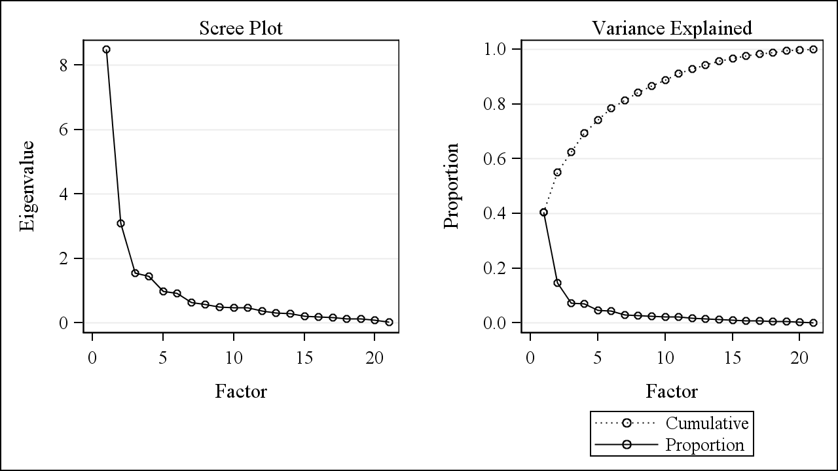

### Table 2: Factor loadings (with varimax rotation) and variance explained for 5 factors kept in the Full variables factor analysis (N=129002). (PC3)

**Highlighted values are loadings greater than 0.60 (if rounded to 2 decimal places)**

| **Variable** | **Factor1** | **Factor2** | **Factor3** | **Factor4** | **Factor5** |
| --- | --- | --- | --- | --- | --- |
| Educ_minBA_rev | 0.91785 | 0.14918 | -0.04525 | 0.13576 | -0.02595 |
| Occup_I_rev | 0.88320 | 0.22594 | 0.04179 | 0.12407 | -0.01959 |
| Educ_minHS_rev | 0.70509 | 0.28277 | 0.34760 | 0.29654 | 0.08353 |
| HUcost_medownval_cbrt | -0.65954 | -0.12335 | 0.40834 | -0.10531 | -0.39874 |
| inc_medHH_cbrt | -0.62266 | -0.46601 | 0.09082 | -0.41412 | -0.34982 |
| inc_HHge50k_rev | 0.61480 | 0.44536 | -0.08066 | 0.44674 | 0.34919 |
| race_blackNH_cbrt | 0.07939 | 0.77587 | -0.06525 | -0.18800 | 0.13642 |
| ownerocc_hh_rev | 0.01129 | 0.67928 | 0.27166 | 0.41516 | 0.28197 |
| vehicle_none_cbrt | 0.12917 | 0.65394 | 0.21300 | 0.35866 | 0.23855 |
| inc_IntDivRent_rev | 0.58629 | 0.64435 | 0.12482 | 0.06716 | -0.24275 |
| Pov_cbrt | 0.44291 | 0.63587 | 0.11210 | 0.42696 | 0.13181 |
| Unemployed_cbrt | 0.34903 | 0.62165 | 0.10085 | 0.15449 | -0.14307 |
| birth_foreign_cbrt | -0.18663 | 0.08022 | 0.90989 | -0.07099 | 0.00134 |
| race_hisp_cbrt | 0.21360 | 0.06185 | 0.85329 | -0.00716 | -0.03164 |
| crowd_gt1_ppr_cbrt | 0.43392 | 0.21026 | 0.64378 | 0.02761 | 0.27057 |
| NotInLaborForce | 0.26405 | 0.02961 | -0.00540 | 0.73212 | 0.02741 |
| HU_sampleocc_rev_cbrt | 0.09899 | 0.27340 | -0.24954 | 0.65426 | -0.11631 |
| samehouse_rev_cbrt | 0.05726 | 0.06611 | 0.12404 | -0.03794 | 0.90602 |
| phone_none_cbrt | 0.35267 | 0.53536 | -0.05071 | 0.28820 | -0.19303 |
| inc_pubass_cbrt | 0.46816 | 0.40168 | 0.15758 | 0.14649 | 0.24089 |
| race_asianNH_cbrt | -0.48276 | 0.00575 | 0.59321 | -0.21010 | 0.16438 |
|  |  |  |  |  |  |
| Eigenvalue | 8.49123871 | 3.08798933 | 1.54520902 | 1.45498514 | 0.97842252 |
| Difference | 5.40324938 | 1.54278031 | 0.09022387 | 0.47656263 | 0.06504813 |
| Variance Explained | 40.43% | 14.70% | 7.36% | 6.93% | 4.66% |
| Cumulative Variance Explained | 40.43% | 55.14% | 62.50% | 69.43% | 74.08% |
| Variance (Eigenvalue) explained after rotation | 4.9333263 | 3.8634528 | 2.8953197 | 2.1709400 | 1.6948059 |

### Table 3: Pearson Correlations of the 5 factors kept in the Full variables factor analysis (PC3).

**Note that all scales are uncorrelated from one another.**

|  | **Factor1** | **Factor2** | **Factor3** | **Factor4** | **Factor5** |
| --- | --- | --- | --- | --- | --- |
| **Factor1** | 1.00000  129002 | 0.00000 1.0000 129002 | 0.00000 1.0000 129002 | 0.00000 1.0000 129002 | 0.00000 1.0000 129002 |
| **Factor2** |  | 1.00000  129002 | 0.00000 1.0000 129002 | -0.00000 1.0000 129002 | 0.00000 1.0000 129002 |
| **Factor3** |  |  | 1.00000  129002 | 0.00000 1.0000 129002 | 0.00000 1.0000 129002 |
| **Factor4** |  |  |  | 1.00000  129002 | 0.00000 1.0000 129002 |
| **Factor5** |  |  |  |  | 1.00000  129002 |

### Figure 2: Plots of rotated factor patterns for Full Variables PCA (PC3)

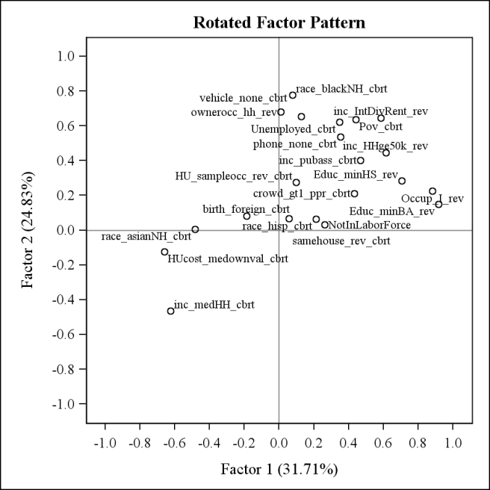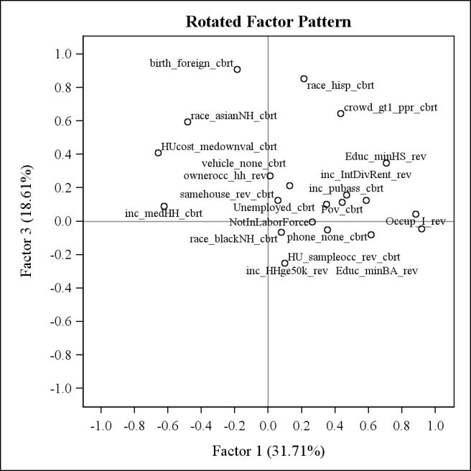

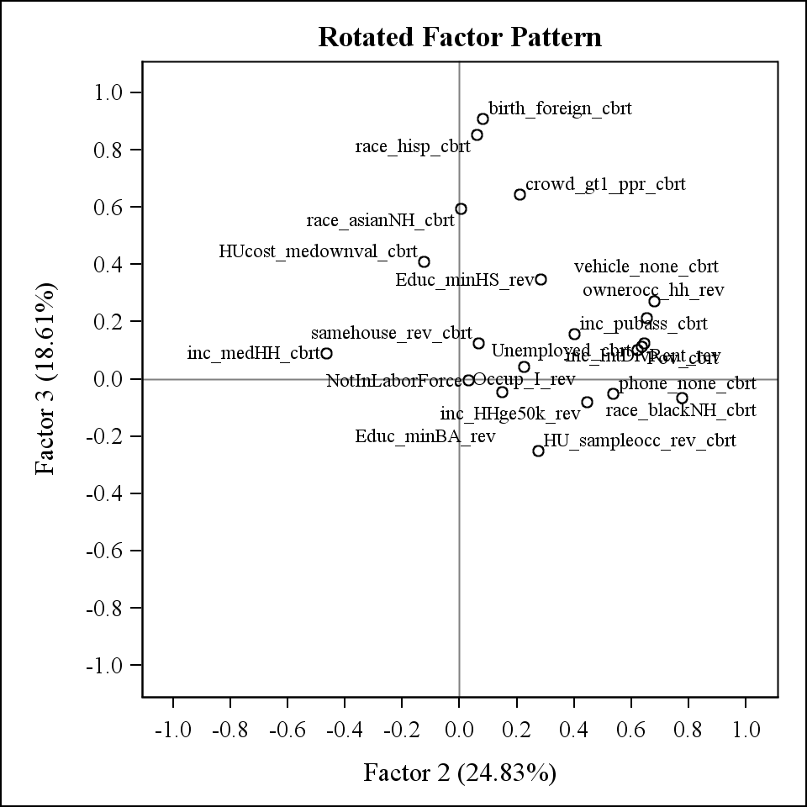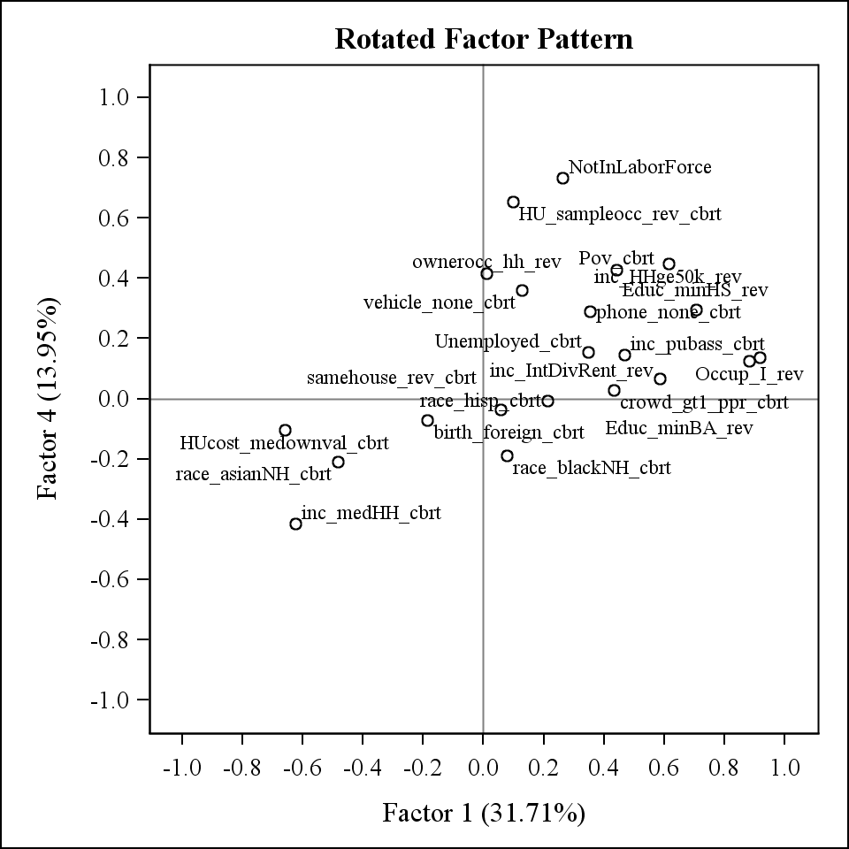

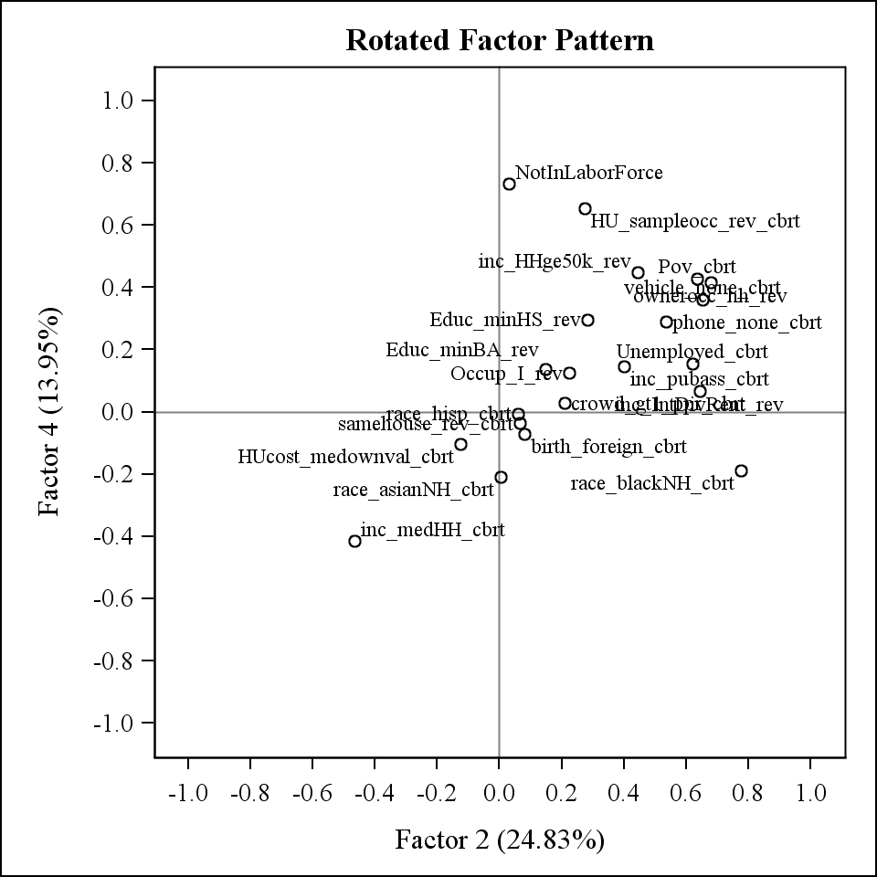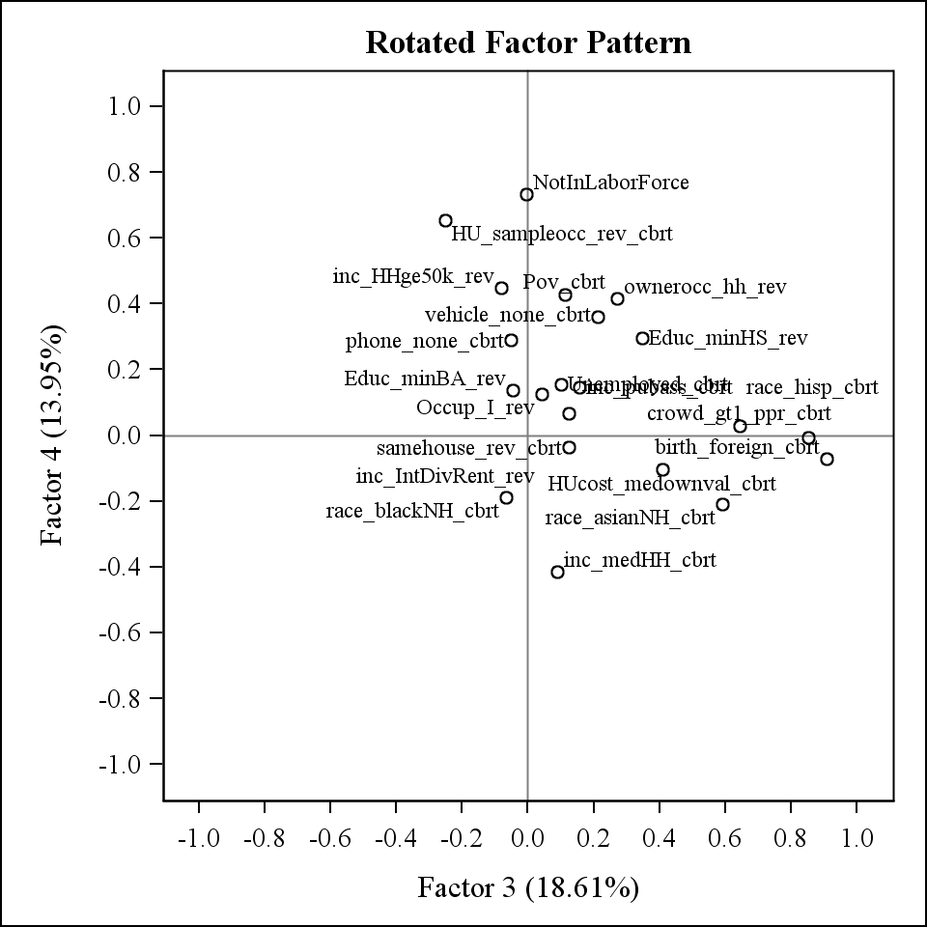

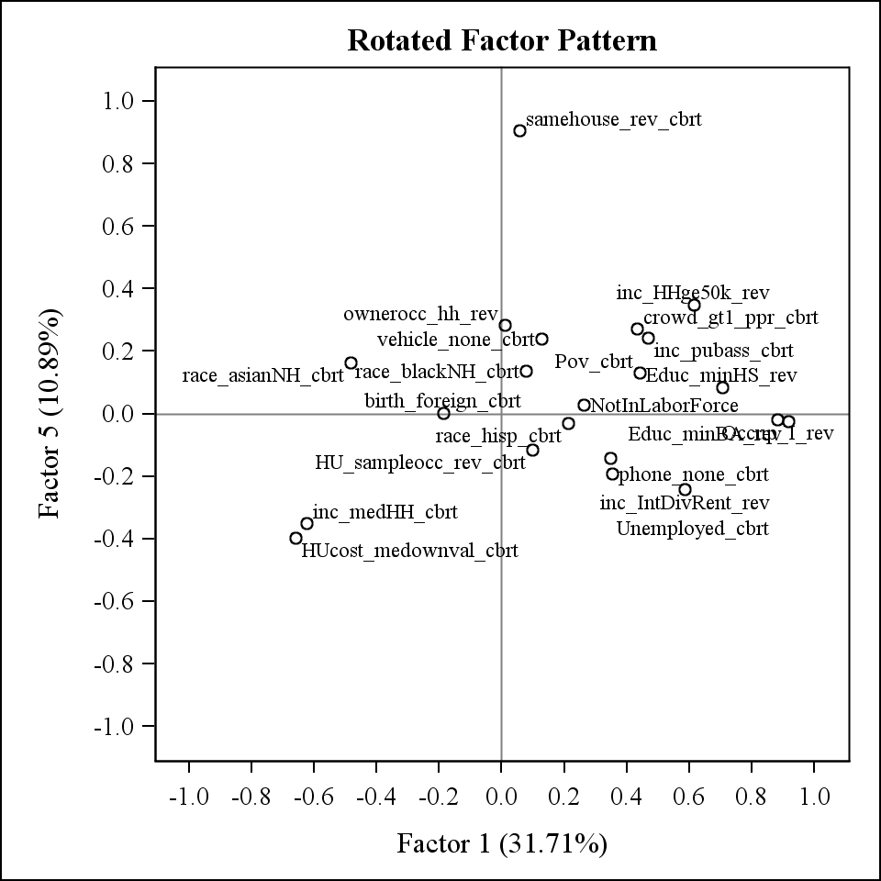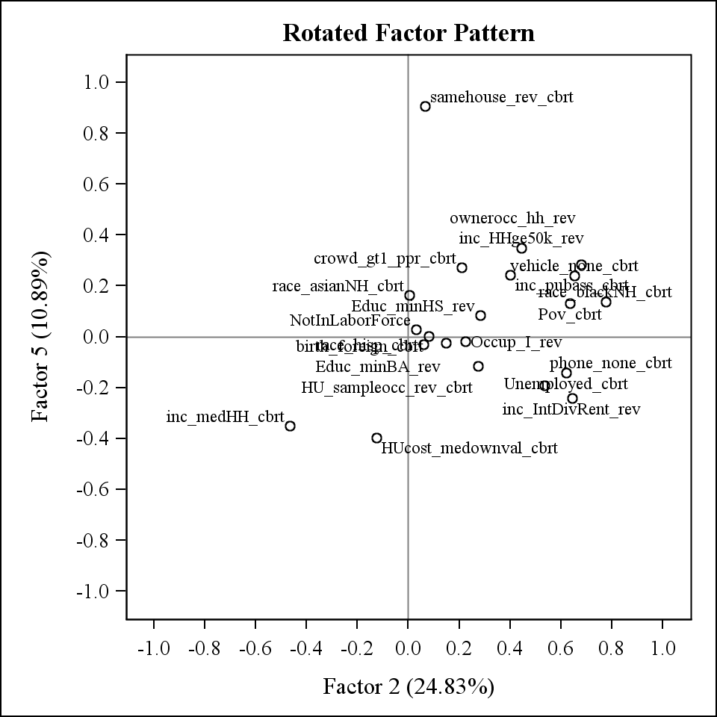

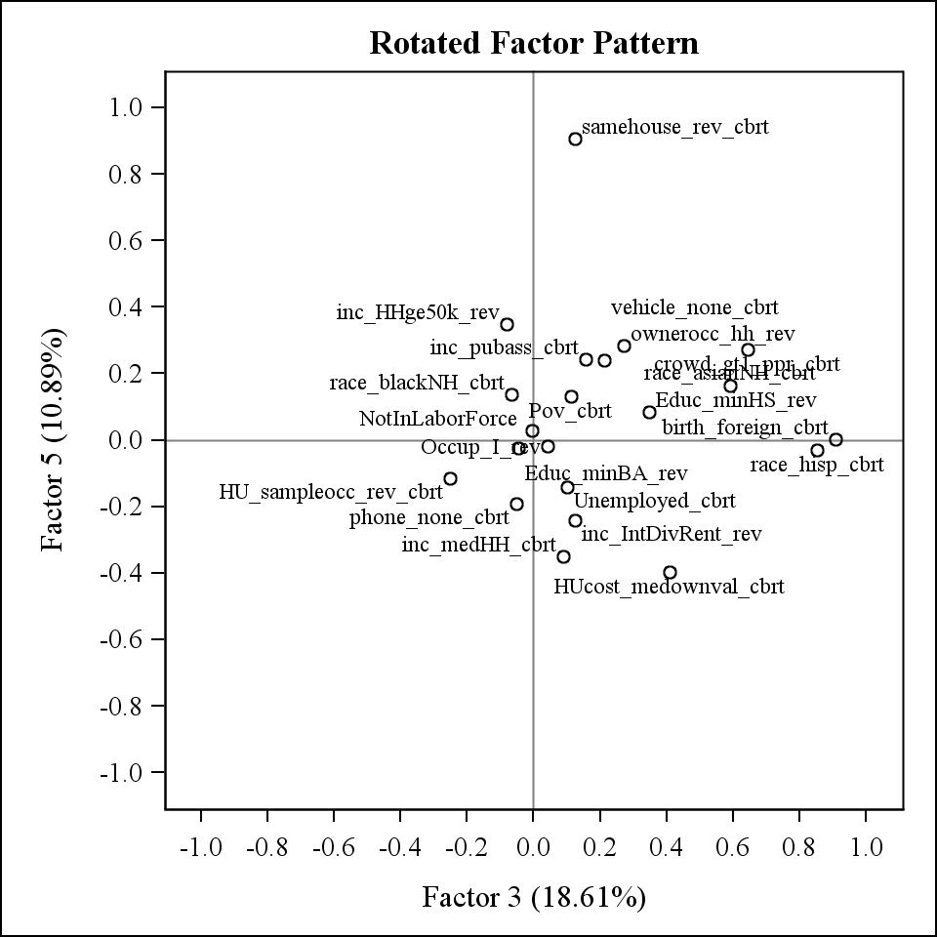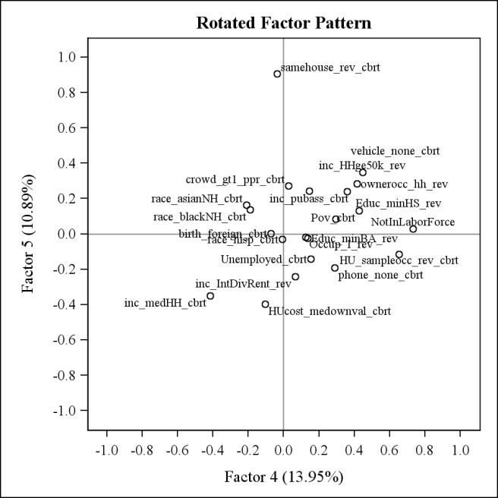

## II.B.2. RACE/ETHNICITY/CROWDING VARIABLES ANALYSIS

After running the previous PCA (PC3) with all of the variables, it was found that percent Black was loading more with SES variables and percent Asian was loading close being in Factor3. Because some analysts may wish not to combine dimensions of race/ethnicity and foreign born status with other SES features, we decided to do a separate PCA with only the variables that loaded in Factor3 in the full variables (percent foreign born, percent Hispanic, and percent crowding) along with the percent Black and percent Asian to parse out these race effects. This PCA will be referred to as PC1. Two factors were retained based on the criteria of having at least 70% of the variance explained. With two factors, 71.69% of the variance is explained (see Table 4). Figure 3 shows the Scree plot and Variance explained plot. Figure 4 shows the plots of the rotated factor patterns.

This PCA was also repeated on the Census 2000 and ACS datasets separated for comparison purposes. These were not included in any analyses or scales creation. See Appendix C for tables with results.

Factor scales variables are created for the 2 weighted factors using SAS PROC SCORE. This gives 2 variables with each one being more highly weighted on the variables that have higher loadings for that factor. This gives the following patterns:

Factor1 = Foreign born/Hispanic/Asian/Crowding

Factor2 = Black race

In addition to the weighted scales, “based” scales were also created. These scales take the variables that have loadings of at least 0.60 (when rounded to 2 decimal places), standardizes the variables using SAS PROC STDIZE, and sums together these standardized variables. Standardization was done both to just that year’s data (ie: only Census 2000 or ACS) for use in cross-sectional analysis and also standardized the both Census 2000 and ACS set together for use in longitudinal analysis. There are two versions of these based scales. The first version uses the untransformed variable in the standardization. The second version uses the transformed variable (transformations as indicated in Table 1) in the standardization. The variables used in each scale is as follows:

Factor1 = sum of standardized percent foreign born, percent Hispanic, percent Asian, and percent crowding

Factor2 = this was not created since there is only 1 variable (percent Black) with loading>=0.60

For all factor scales created, a higher value indicates a WORSE SES status.

See Appendix A for listing of variable names in the datasets.

### Figure 3. Scree Plot and Variance explained plot for the Race/Ethnicity/Crowding variables PCA (PC1)

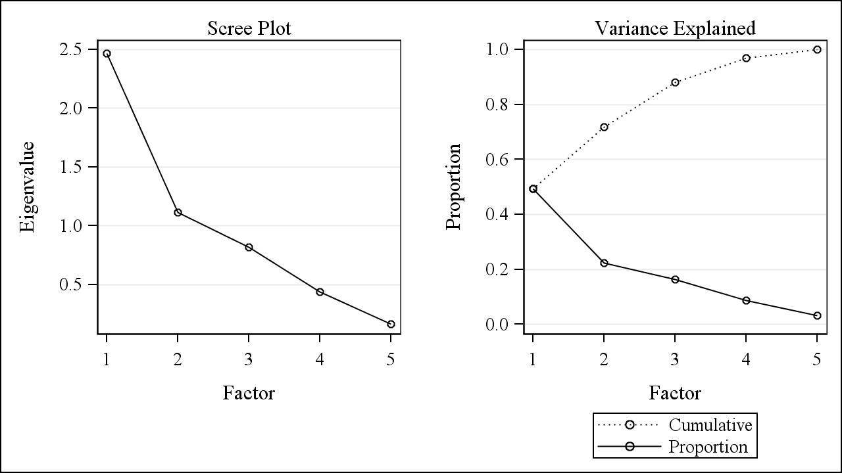

### Table 4: Factor loadings (with varimax rotation) and variance explained for 2 factors kept in the Race/Ethnicity/Crowding variables factor analysis (N=129875). (PC1)

**Highlighted values are loadings greater than 0.60 (if rounded to 2 decimal places)**

| **Variable** | **Factor1** | **Factor2** |
| --- | --- | --- |
| birth_foreign_cbrt | 0.93040 | 0.03021 |
| race_hisp_cbrt | 0.81957 | 0.24239 |
| race_asianNH_cbrt | 0.71197 | -0.30314 |
| crowd_gt1_ppr_cbrt | 0.59622 | 0.55965 |
| race_blackNH_cbrt | -0.06492 | 0.84605 |
|  |  |  |
| Eigenvalue | 2.46906247 | 1.11544981 |
| Difference | 1.35361265 | 0.29917871 |
| Variance Explained | 49.38% | 22.31% |
| Cumulative Variance Explained | 49.38% | 71.69% |
| Variance (Eigenvalue) explained after rotation | 2.4039392 | 1.1805731 |

### Table 5: Pearson Correlations of the 2 factors kept in the Race/Ethnicity/Crowding variables factor analysis (PC1).

**Note that all scales are uncorrelated from one another.**

|  | **Factor1** | **Factor2** |
| --- | --- | --- |
| **Factor1** | 1.00000  129875 | 0.00000 1.0000 129875 |
| **Factor2** |  | 1.00000  129875 |

### Figure 4: Plots of rotated factor patterns for Race/Ethnicity/Crowding Variables PCA (PC1)

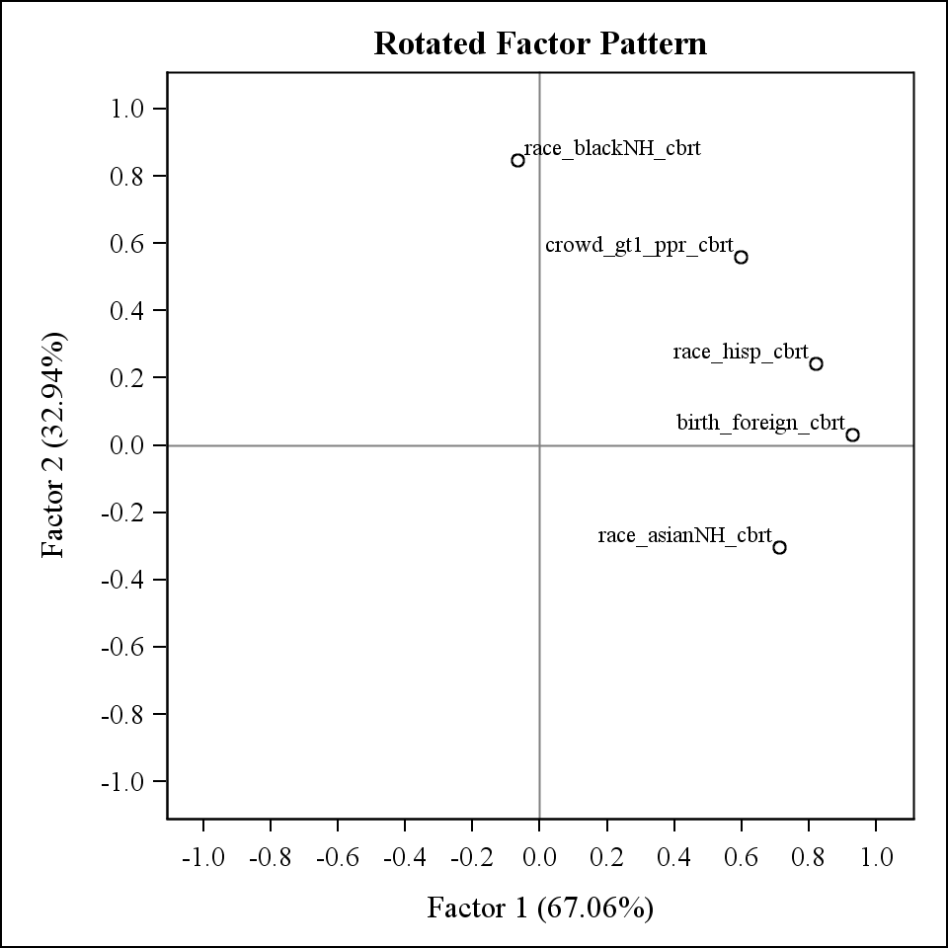

## II.B.3. OTHER SES VARIABLES ANALYSIS

A PCA was performed using only the other SES variables that were not included in the Race/Ethnicity/Crowding PCA to have SES scales independent of the race effects. This PCA will be referred to as PC2. Four factors were retained based on the criteria of having at least 70% of the variance explained. With two factors, 74.08% of the variance is explained (see Table 6). Figure 5 shows the Scree plot and Variance explained plot. Figure 6 shows the plots of the rotated factor patterns.

This PCA was also repeated on the Census 2000 and ACS datasets separated for comparison purposes. These were not included in any analyses or scales creation. See Appendix C for tables with results.

Factor scales variables are created for the 4 weighted factors using SAS PROC SCORE. This gives 4 variables with each one being more highly weighted on the variables that have higher loadings for that factor. This gives the following patterns:

Factor1 = Education/Occupation/Income

Factor2 = Wealth/Poverty/Unemployment/Owner occupied housing

Factor3 = Occupied housing

Factor4 = Residential stability

In addition to the weighted scales, “based” scales were also created. These scales take the variables that have loadings of at least 0.60 (when rounded to 2 decimal places), standardizes the variables using SAS PROC STDIZE, and sums together these standardized variables. Standardization was done both to just that year’s data (ie: only Census 2000 or ACS) for use in cross-sectional analysis and also standardized the both Census 2000 and ACS set together for use in longitudinal analysis. There are two versions of these based scales. The first version uses the untransformed variable in the standardization. The second version uses the transformed variable (transformations as indicated in Table 1) in the standardization. The variables used in each scale are as follows:

Factor1 = sum of standardized percent with at least Bachelor degree (reverse coded), percent with managerial/professional occupation (reverse coded), median housing value (reverse coded), percent with at least HS education (reverse coded), median household income (reverse coded), and percent with household income >$50,000 (reverse coded)

Factor2 = sum of standardized percent with no vehicle, percent owner occupied housing (reverse coded), percent below poverty level, and percent unemployed

Factor3 = this was not created since there is only 1 variable (percent occupied housing) with loading>=0.60

Factor4 = this was not created since there is only 1 variable (percent in same house) with loading>=0.60

The variables percent not in labor force, percent with interest/dividend/rental income, percent with no phone, and percent on public assistance were not included in any of the based scales since they did not load to at least 0.60 on any factor.

For all factor scales created, a higher value indicates a WORSE SES status.

See Appendix A for listing of variable names in the datasets.

### Figure 5. Scree Plot and Variance explained plot for the Other SES variables PCA (PC2)

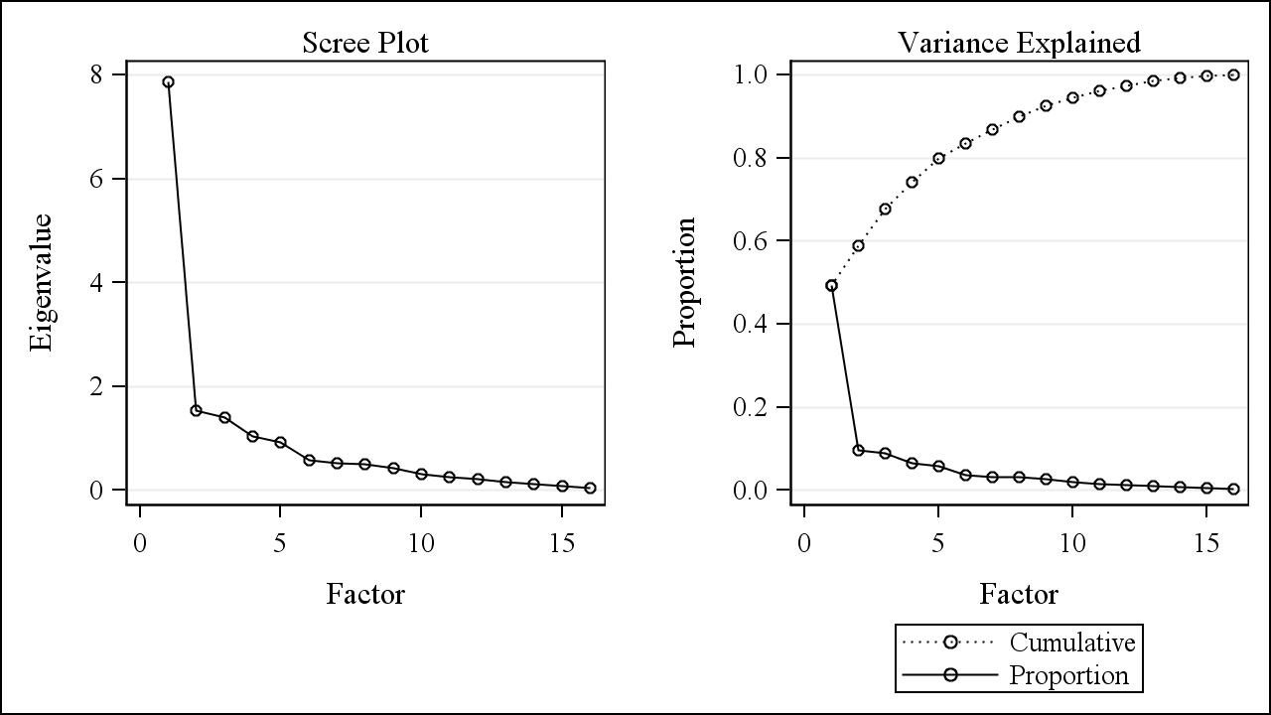

### Table 6: Factor loadings (with varimax rotation) and variance explained for 4 factors kept in the Other SES variables factor analysis (N=129002). (PC2)

**Highlighted values are loadings greater than 0.60 (if rounded to 2 decimal places)**

| **Variable** | **Factor1** | **Factor2** | **Factor3** | **Factor4** |
| --- | --- | --- | --- | --- |
| Educ_minBA_rev | 0.91755 | 0.16496 | 0.15918 | -0.06256 |
| Occup_I_rev | 0.87133 | 0.26515 | 0.13241 | -0.05829 |
| HUcost_medownval_cbrt | -0.71076 | 0.05583 | -0.34044 | -0.39213 |
| Educ_minHS_rev | 0.66140 | 0.50196 | 0.08343 | 0.04480 |
| inc_medHH_cbrt | -0.62527 | -0.49044 | -0.41809 | -0.32364 |
| inc_HHge50k_rev | 0.61361 | 0.48619 | 0.43509 | 0.32640 |
| vehicle_none_cbrt | 0.11515 | 0.80819 | 0.13655 | 0.19258 |
| ownerocc_hh_rev | -0.04461 | 0.79831 | 0.32963 | 0.26370 |
| Pov_cbrt | 0.41180 | 0.71819 | 0.35391 | 0.09089 |
| Unemployed_cbrt | 0.33751 | 0.64419 | 0.09722 | -0.20757 |
| HU_sampleocc_rev_cbrt | 0.06319 | 0.15144 | 0.87284 | -0.08170 |
| samehouse_rev_cbrt | 0.05833 | 0.14811 | -0.07385 | 0.89942 |
| NotInLaborForce | 0.29470 | 0.18045 | 0.48661 | 0.03175 |
| inc_IntDivRent_rev | 0.55181 | 0.59191 | 0.16336 | -0.29536 |
| phone_none_cbrt | 0.30892 | 0.47777 | 0.41505 | -0.21547 |
| inc_pubass_cbrt | 0.46158 | 0.56304 | -0.05548 | 0.17557 |
|  |  |  |  |  |
| Eigenvalue | 7.87351684 | 1.53794757 | 1.40834127 | 1.03263965 |
| Difference | 6.33556927 | 0.12960630 | 0.37570162 | 0.10812914 |
| Variance Explained | 49.21% | 9.61% | 8.80% | 6.45% |
| Cumulative Variance Explained | 49.21% | 58.82% | 67.62% | 74.08% |
| Variance (Eigenvalue) explained after rotation | 4.3171884 | 4.0238316 | 1.9979553 | 1.5134701 |

### Table 7: Pearson Correlations of the 4 factors kept in the Other SES variables factor analysis (PC2).

**Note that all scales are uncorrelated from one another.**

|  | **Factor1** | **Factor2** | **Factor3** | **Factor4** |
| --- | --- | --- | --- | --- |
| **Factor1** | 1.00000  129002 | 0.00000 1.0000 129002 | 0.00000 1.0000 129002 | 0.00000 1.0000 129002 |
| **Factor2** |  | 1.00000  129002 | 0.00000 1.0000 129002 | 0.00000 1.0000 129002 |
| **Factor3** |  |  | 1.00000  129002 | 0.00000 1.0000 129002 |
| **Factor4** |  |  |  | 1.00000  129002 |

### Figure 6: Plots of rotated factor patterns for Other SES Variables PCA (PC2)

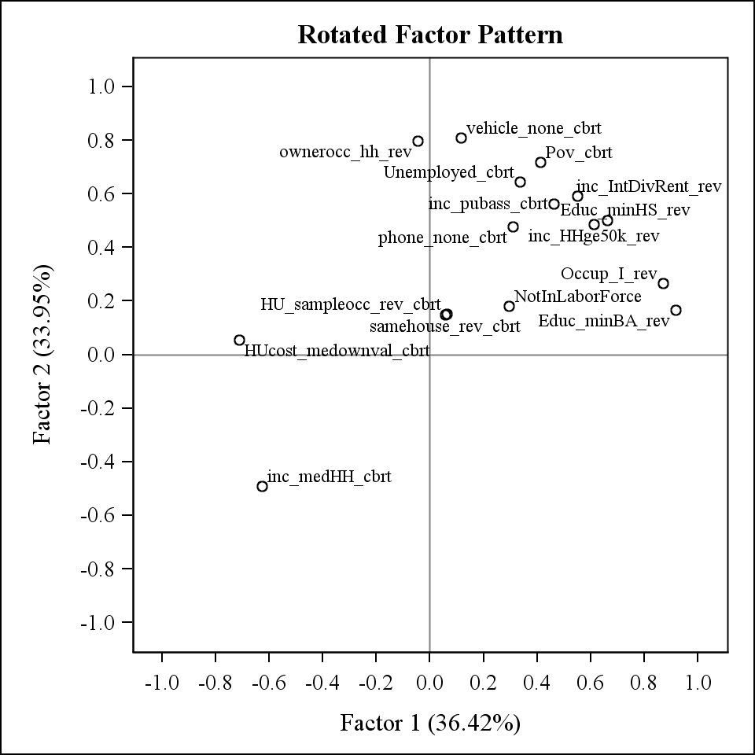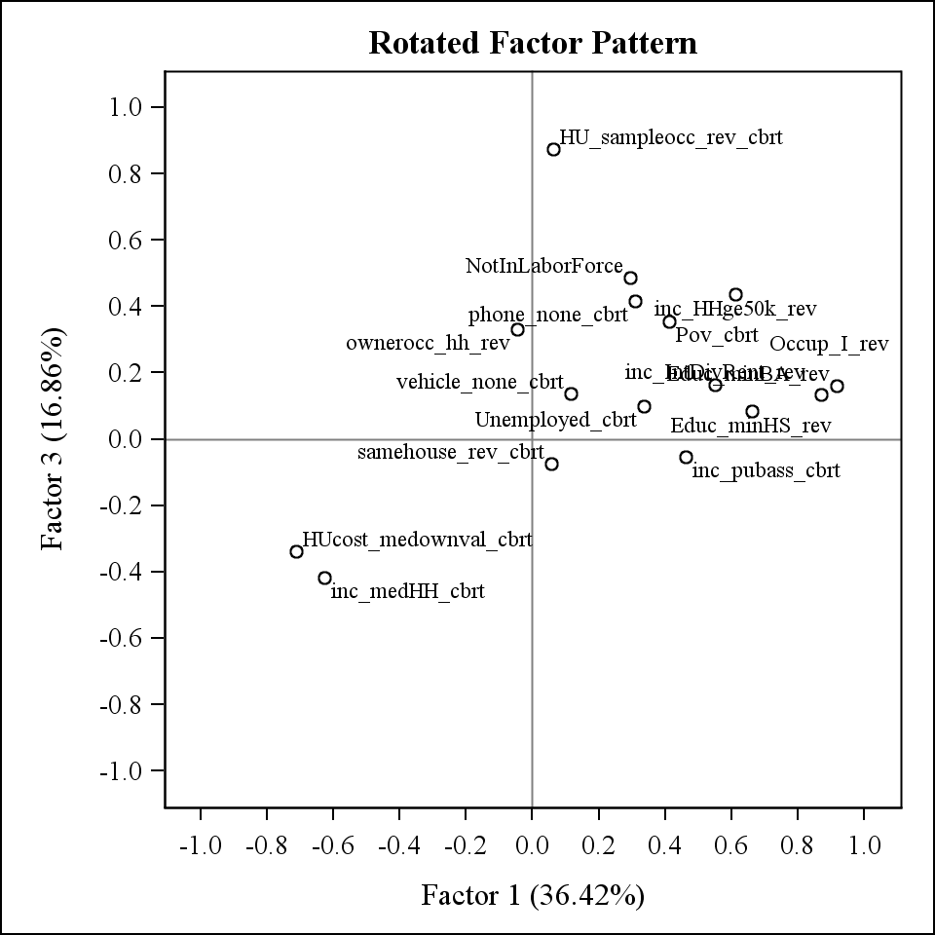

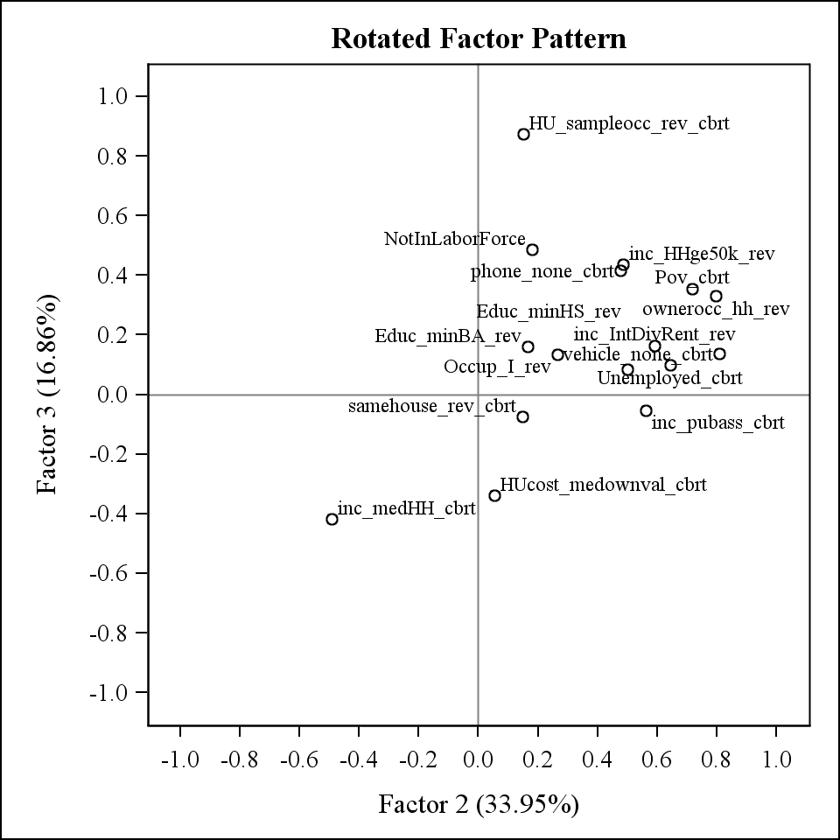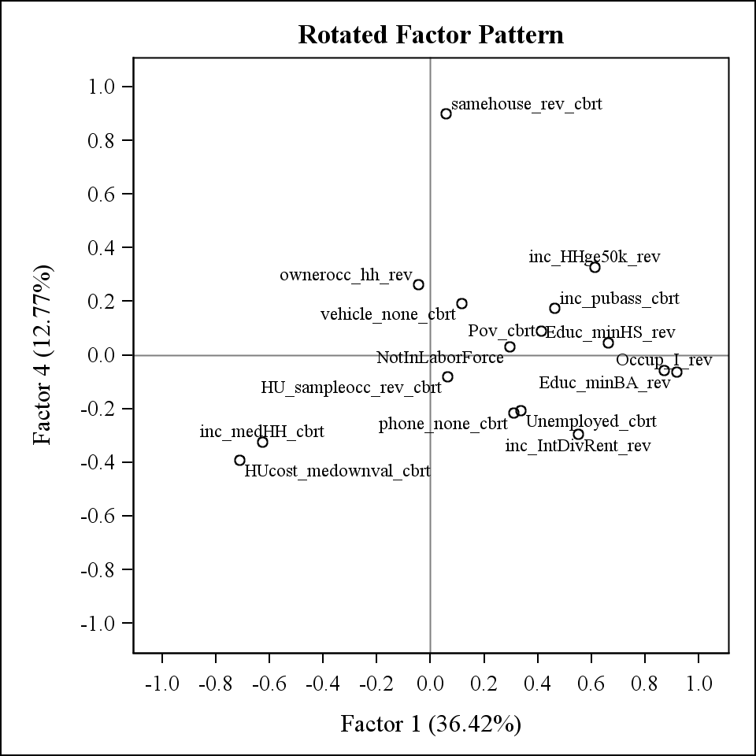

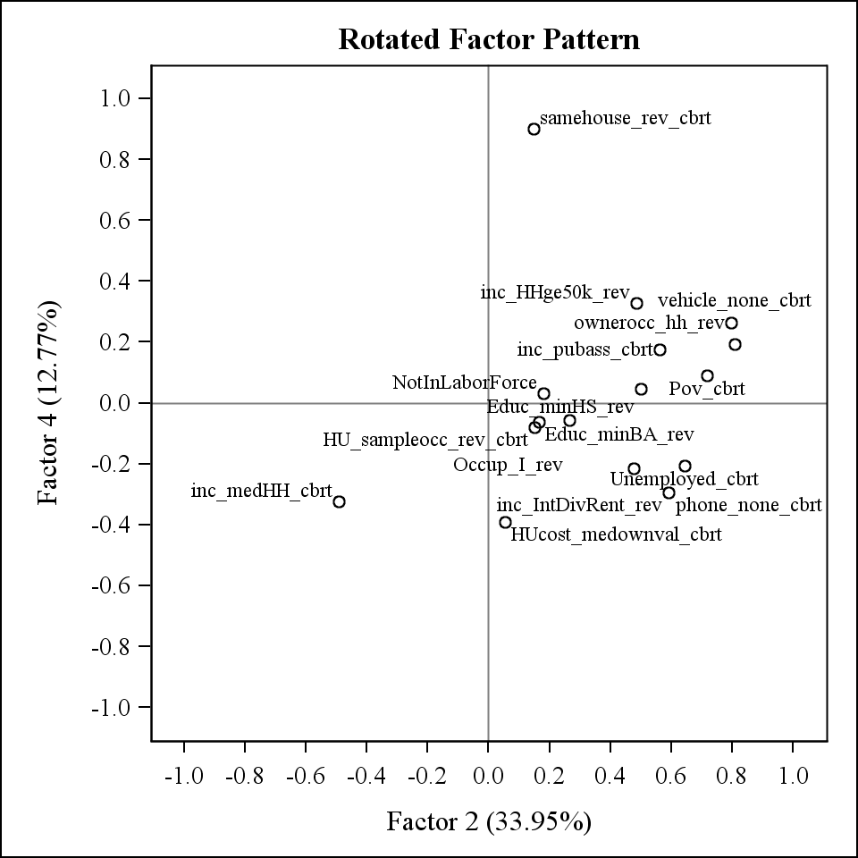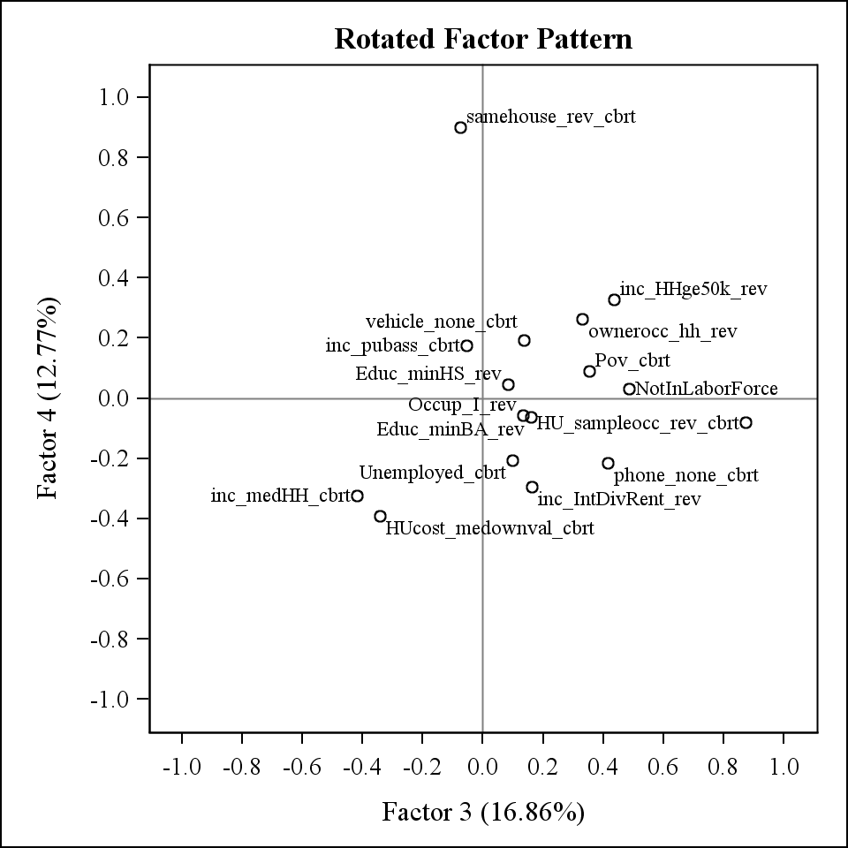

# III. SCALE CREATED BASED ON ANA DIEZ-ROUX CENSUS 1990 FACTOR ANALYSIS

A factor score was created using the results of a factor analysis performed by Dr. Ana Diez-Roux using the Census 1990 data. A principal factor analysis with orthogonal rotation on the census block groups was performed (results not available). From this, one factor score was created by summing the standardized variables with transformations described in Table 8. Standardization was done both to just that year’s data (ie: only Census 2000 or ACS) for use in cross-sectional analysis and also standardized the both Census 2000 and ACS set together for use in longitudinal analysis. This scale represents a basic SES score as one variable scale. This is only a based scale and is not weighted by any loadings. Note that this scale was performed on the Census 1990 data then applied to Census 2000 and ACS2005-2009 data. The interpretation of this scale is a higher value indicates a BETTER SES status.

For reference on how this was created see:

Diez Roux AV, Stein Merkin A, et al. Neighborhood of Residence and Incidence of Coronary Heart Disease. N Engl J Med 2001;345(2):99-106.

See Appendix A for listing of variable names in the datasets.

### Table 8: List of variables used in principal factor analysis to create scale based on Ana Diez-Roux Census 1990 analysis.

| **Domain** | **Variable** | **Description** | **Reverse coded** | **Transformation used** |
| --- | --- | --- | --- | --- |
| HOUSING | HUcost_medownval | Median value of occupied housing units | NO | Log |
| EDUCATION | Educ_minHS | Percent of person 25 or older with at least high school education | NO | NONE |
| EDUCATION | Educ_minBA | Percent of persons 25 or older with at least a Bachelor’s degree | NO | NONE |
| OCCUPATION | Occup_I | Percent with management, professional, and related occupation | NO | NONE |
| INCOME/ WEALTH | inc_medHH | Median household income | NO | Log |
| INCOME/ WEALTH | inc_IntDivRent | Percent of households with interest, dividends, or net rental income | NO | NONE |

# IV. SCALES CREATED FOR CENSUS BASED ON MAHASIN MUJAHID’S METHODS

The scales described in this section are scales created using methods used by Mahasin Mujahid in 2005 for the Census 2000 data using maximum likelihood factor analysis. These are the scales used in her papers. Scales are created as weighted scales using the factor weights and as based scales summing the standardized variables with high loadings for each component. These scales are only available for Census 2000 due to variables that are used here being unavailable for the ACS2005-2009 data.

## IV.A. VARIABLES USED

Variables were selected a priori from available census measures to reflect the racial/ethnic composition, family structure, housing, crowding, residential stability, education, employment, occupation, and income/wealth of the census tract. This includes a total of 19 variables. See Table 6 for a list of variables used.

Interpretation of the variables is designed to indicate a WORSE SES for HIGHER levels (ie: those close to 0 are better SES, close to maximum (usually 1) are a worse SES). To maintain consistency and reduce the number of negative loadings when running the factor analysis, variables that are interpreted as having a higher value being better SES are reverse coded. Correlations of all the variables were also examined. Many of these variables are highly correlated with one another. Reverse coding was used whenever possible to reduce the number of negative correlations. See Appendix B for tables with the correlations.

Factor analysis is based on multivariate normal data distributions. The variables to be included in the factor analysis were checked for skewness using SAS proc means. For those that had skewness>1.5, transformations of cube root were used. See Appendix B for the table with all of the skewness measures.

Median household income and median value owner units were not reverse coded despite a higher value indicating better SES due to normality transformations. When these variables are not reverse coded, a transformation with cube root gives skewness <1.5. When they are reverse coded, then a good transformation isn’t possible. We decided normality is more important than reverse coding. They will have negative loadings in the factor analysis and this will need to taken into account when creating factor based scales.

Description of variables used indicating whether reverse coding and/or transformations were used is in Table 9. Throughout the rest of this documentation file, variables will be referred to by variable name as specified in Table 9.

### Table 9: List of variables used in factor analysis to create SES scales based on Mahasin Mujahid’s methods.

| **Domain** | **Variable** | **Description** | **Reverse coded** | **Transformation used** |
| --- | --- | --- | --- | --- |
| RACE/ ETHNICITY | race_hisp | Percent Hispanic | NO | Cube root |
| RACE/ ETHNICITY | race_blackNH | Percent non-Hispanic black | NO | Cube root |
| RACE/ ETHNICITY | race_asianNH | Percent non-Hispanic Asian | NO | Cube root |
| RACE/ ETHNICITY | birth_foreign | Percent foreign born | NO | Cube root |
| CROWDING | crowd_gt1_ppr | Percent of occupied houses with more than 1 person per room | NO | Cube root |
| HOUSING | HU_vacantpercent_sf1 | Percent of vacant housing units | NO | Cube root |
| HOUSING | ownerocc_hh | Percent of housing units that are owner occupied out of total housing units | YES | NONE |
| HOUSING | phone_none | Percent of housing units without telephone | NO | Cube root |
| HOUSING | vehicle_none | Percent of housing units without vehicle | NO | Cube root |
| RESIDENTIAL STABILITY | samehouse | Percent living in same house in 1995 (Census 2000) or 1999 (ACS) | YES | NONE |
| EDUCATION | Educ_minHS | Percent of person 25 or older with at least high school education | YES | NONE |
| EDUCATION | Educ_minBA | Percent of persons 25 or older with at least a Bachelor’s degree | YES | NONE |
| EMPLOYMENT | unemployed | Percent unemployed among civilians 16 and over in the labor force | NO | Cube root |
| OCCUPATION | Occup_I | Percent with management, professional, and related occupation | YES | NONE |
| INCOME/ WEALTH | inc_medHH | Median household income | NO (due to transformation issues) | Cube root |
| INCOME/ WEALTH | inc_IntDivRent | Percent of households with interest, dividends, or net rental income | YES | NONE |
| INCOME/ WEALTH | inc_pubass | Percent of households with public assistance | NO | Cube root |
| INCOME/ WEALTH | pov | Percent of persons below the poverty level | NO | Cube root |
| FAMILY STRUCTURE | singleparent_fam | Percent of single parent families | NO | Cube root |

## IV.B. FACTOR ANALYSIS

Maximum likelihood factor analysis with a promax oblique rotation was used to create the final scales with prior communalities set to SMC (default in SAS for ML). This type of analysis allows for correlated factors. Analyses were performed using SAS PROC FACTOR.

When all 19 variables in Table 6 were retained in the factor model, there is a SAS error saying “Maximum iterations exceeded” after 30 iterations. After increasing the number of iterations to 100, this analysis still has an error that a communality is greater than 1. This can be corrected by accounting for a “Heywood case” in the options. A Heywood case occurs when there are bad prior communality estimates, too many common factors, too few common factors, not enough data to provide stable estimates, or the common factor model is not an appropriate model for the data. There is disagreement about whether or not a Heywood case can be considered as legitimate results (<http://support.sas.com/documentation/cdl/en/statug/63033/HTML/default/viewer.htm#statug_factor_sect022.htm>). As seen in Table 10, the first eigenvalue is infinity. The variable that appears to be causing the problem is percent of owner occupied housing (ownerocc_hh). This have a communality of 1 and weight of infinity (Table 11).

### Table 10: Eigenvalues of the Weighted Reduced Correlation Matrix for the ML factor analysis with Heywood case coding: Total=65.307581 Average=3.62819889

| **Number** | **Eigenvalue** | **Difference** | **Proportion** | **Cumulative** |
| --- | --- | --- | --- | --- |
| 1 | Infty | Infty |  |  |
| 2 | 44.6175692 | 31.4790125 | 0.6832 | 0.6832 |
| 3 | 13.1385567 | 7.8726964 | 0.2012 | 0.8844 |
| 4 | 5.2658603 | 2.9802616 | 0.0806 | 0.9650 |
| 5 | 2.2855987 | 1.3481125 | 0.0350 | 1.0000 |
| 6 | 0.9374862 | 0.2864176 | 0.0144 | 1.0144 |
| 7 | 0.6510687 | 0.2635651 | 0.0100 | 1.0243 |
| 8 | 0.3875036 | 0.1862341 | 0.0059 | 1.0303 |
| 9 | 0.2012694 | 0.1321233 | 0.0031 | 1.0333 |
| 10 | 0.0691461 | 0.0270882 | 0.0011 | 1.0344 |
| 11 | 0.0420579 | 0.0320568 | 0.0006 | 1.0350 |
| 12 | 0.0100011 | 0.1462950 | 0.0002 | 1.0352 |
| 13 | -0.1362939 | 0.0781597 | -0.0021 | 1.0331 |
| 14 | -0.2144536 | 0.0238885 | -0.0033 | 1.0298 |
| 15 | -0.2383421 | 0.1214872 | -0.0036 | 1.0262 |
| 16 | -0.3598292 | 0.0468575 | -0.0055 | 1.0207 |
| 17 | -0.4066867 | 0.0499149 | -0.0062 | 1.0144 |
| 18 | -0.4566016 | 0.0297292 | -0.0070 | 1.0074 |
| 19 | -0.4863308 |  | -0.0074 | 1.0000 |

### Table 11: Final communality estimates and variable weights for the ML factor analysis with Heywood case coding: Total communality: Weighted=84.073144 Unweighted=13.773993

|  |  |  |
| --- | --- | --- |
| **Variable** | **Communality** | **Weight** |
| Educ_minHS_rev | 0.78009029 | 4.5490051 |
| Educ_minBA_rev | 0.95644363 | 22.9574642 |
| race_hisp_cbrt | 0.73143483 | 3.7232337 |
| race_blackNH_cbrt | 0.57554186 | 2.3550657 |
| race_asianNH_cbrt | 0.58543024 | 2.4125970 |
| birth_foreign_cbrt | 0.90369142 | 10.3840159 |
| Unemployed_cbrt | 0.55089237 | 2.2265287 |
| inc_pubass_cbrt | 0.60262687 | 2.5168739 |
| Pov_cbrt | 0.91083943 | 11.2123394 |
| crowd_gt1_ppr_cbrt | 0.73549526 | 3.7803353 |
| phone_none_cbrt | 0.59577122 | 2.4743162 |
| vehicle_none_cbrt | 0.62723110 | 2.6829090 |
| singleparent_fam_cbrt | 0.81373102 | 5.3699168 |
| inc_medHH_cbrt | 0.86915463 | 7.6382036 |
| ownerocc_hh_rev | 1.00000000 | Infty |
| samehouse_rev | 0.37900949 | 1.6105963 |
| Occup_I_rev | 0.88579970 | 8.7569943 |
| inc_IntDivRent_rev | 0.82169021 | 5.6071738 |
| HU_vacantpercent_sf1_cbrt | 0.44911976 | 1.8155699 |

Based on these problems, the final decision was to perform this factor analysis removing percent owner occupied housing. This is a maximum likelihood factor analysis with a promax oblique rotation with prior communalities set to SMC (default in SAS for ML) with 18 variables. Five factors were retained based on a priori decisions. This keeps all factors with eigenvalue of at least 1. With five factors, 102.57% of the variance is explained (see Table 12). Figure 7 shows the Scree plot and Variance explained plot. Figure 8 shows the plots of the rotated factor patterns.

Factor scales variables are created for the 5 weighted factors using SAS PROC SCORE. This gives 5 variables with each one being more highly weighted on the variables that have higher loadings for that factor. This gives the following patterns:

Factor1 = Poverty/Income/Wealth/Vacant housing/Unemployment

Factor2 = Education/Occupation/Wealth

Factor3 = Race/Foreign Born/Crowding

Factor4 = Black race/Family structure

Factor5 = Housing stability

In addition to the weighted scales, “based” scales were also created. These scales take the variables that have loadings of at least 0.50 (when rounded to 2 decimal places), standardizes the variables using SAS PROC STDIZE, and sums together these standardized variables. There are two versions of these based scales. The first version uses the untransformed variable in the standardization. The second version uses the transformed variable (transformations as indicated in Table 1) in the standardization. The variables used in each scale is as follows:

Factor1 = sum of standardized percent below poverty level, median household income (reverse coded), percent with no vehicle, percent with no phone, percent vacant housing, and percent unemployed.

Factor2 = sum of standardized percent with at least Bachelor’s degree (reverse coded), percent with professional/managerial occupation (reverse coded), and percent with interest/dividend/rental income (reverse coded)

Factor3 = sum of standardized percent foreign born, percent Hispanic, percent with crowding, and percent Asian

Factor4 = sum of standardized percent Black and percent single parent families

Factor5 = this was not created since there is only 1 variable (percent in same house) with loading>=0.50

The variables percent with HS education and percent with public assistance were not included in any of the based scales since they did not load to at least 0.60 on any factor.

For all factor scales created, a higher value indicates a WORSE SES status.

See Appendix A for listing of variable names in the datasets.

### Figure 7. Scree Plot and Variance explained plot for the final ML factor analysis for Census 2000

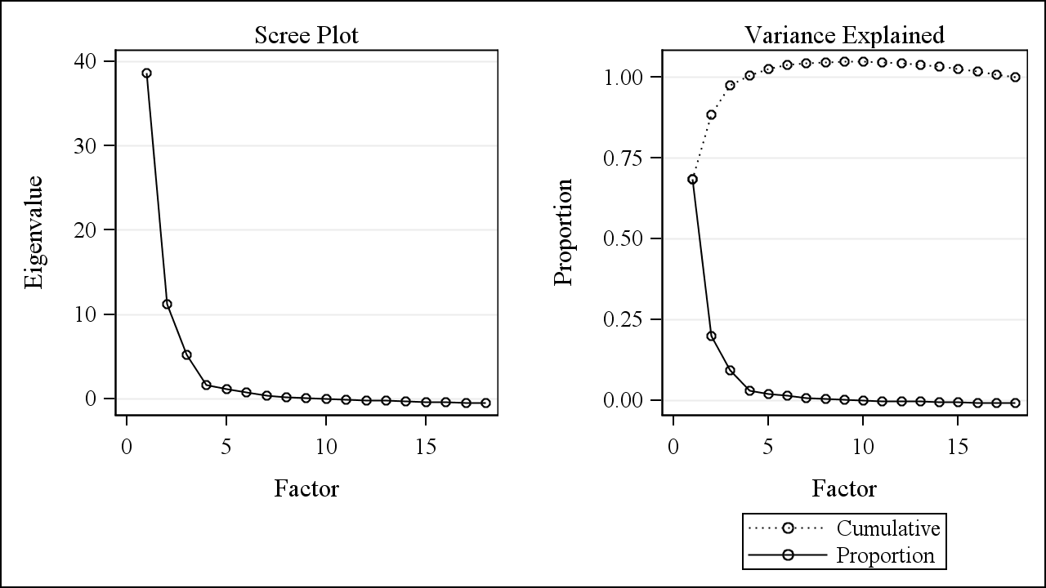

### Table 12: Factor loadings (with promax rotation) and variance explained for 5 factors kept in the final ML factor analysis for Census 2000 (N=64919).

**Highlighted values are loadings greater than 0.50 (if rounded to 2 decimal places)**

| **Variable** | **Factor1** | **Factor2** | **Factor3** | **Factor4** | **Factor5** |
| --- | --- | --- | --- | --- | --- |
| Pov_cbrt | 0.95318932 | -0.0727708 | 0.03255031 | 0.0571691 | 0.03052518 |
| inc_medHH_cbrt | -0.7389305 | -0.261845 | 0.16600135 | 0.0087992 | -0.1215493 |
| vehicle_none_cbrt | 0.69108833 | -0.200528 | 0.12840256 | 0.27798826 | -0.1220896 |
| phone_none_cbrt | 0.64367167 | 0.19697302 | -0.1356832 | -0.0110659 | 0.00462264 |
| HU_vacantpercent_sf1_cbrt | 0.6344637 | 0.00725283 | -0.331299 | -0.2137695 | 0.11899963 |
| Unemployed_cbrt | 0.55752541 | 0.05604277 | 0.06606939 | 0.19977742 | -0.043076 |
| Educ_minBA_rev | -0.0378788 | 1.00022942 | -0.0599198 | -0.0186743 | -0.0682536 |
| Occup_I_rev | 0.02340972 | 0.93226731 | -0.0037578 | -0.009147 | 0.01907235 |
| inc_IntDivRent_rev | 0.26684316 | 0.50884122 | 0.04632065 | 0.2927549 | 0.11548848 |
| birth_foreign_cbrt | -0.0483119 | -0.1437569 | 0.96534523 | -0.0723287 | 0.00332584 |
| race_hisp_cbrt | 0.04018309 | 0.19812841 | 0.85562268 | -0.1621068 | 0.09326422 |
| crowd_gt1_ppr_cbrt | 0.22682392 | 0.24687632 | 0.64358369 | 0.04851806 | 0.0157579 |
| race_asianNH_cbrt | -0.2315697 | -0.3286169 | 0.60700244 | 0.08324229 | 0.10058801 |
| race_blackNH_cbrt | 0.0057011 | -0.0408337 | -0.1532361 | 0.85917372 | -0.0101238 |
| singleparent_fam_cbrt | 0.23764371 | 0.19819856 | -0.0396803 | 0.59170034 | 0.1263179 |
| samehouse_rev | 0.02000507 | -0.0657816 | 0.14746862 | 0.02484137 | 0.88607237 |
| Educ_minHS_rev | 0.47201754 | 0.41799685 | 0.27541432 | -0.0253517 | -0.1651949 |
| inc_pubass_cbrt | 0.48008171 | 0.18726636 | 0.10178417 | 0.21215769 | -0.1030449 |
|  |  |  |  |  |  |
| Eigenvalue | 38.6539841 | 11.2372002 | 5.2288414 | 1.6701805 | 1.1390198 |
| Difference | 27.4167839 | 6.0083587 | 3.5586610 | 0.5311606 | 0.4073592 |
| Variance Explained | 68.44% | 19.90% | 9.26% | 2.96% | 2.02% |
| Cumulative Variance Explained | 68.44% | 88.34% | 97.60% | 100.55% | 102.57% |
| Variance (Eigenvalue) explained eliminating other factors after rotation – Weighted | 8.3821585 | 17.6159813 | 13.2686194 | 3.0369739 | 6.4686031 |
| Variance (Eigenvalue) explained eliminating other factors after rotation – Unweighted | 1.56132385 | 1.45564188 | 2.39459874 | 0.88236616 | 0.83843983 |
| Variance (Eigenvalue) explained ignoring other factors after rotation – Weighted | 43.6876036 | 48.1441192 | 17.1380860 | 20.7021874 | 9.3401851 |
| Variance (Eigenvalue) explained ignoring other factors after rotation – Unweighted | 7.19177607 | 5.94161839 | 3.17227588 | 4.16294893 | 1.22205920 |

### Table 13: Pearson correlations of factor loadings for 5 factors kept in the final ML factor analysis for Census 2000.

**Note that all scales can be correlated with one another.**

|  | **Factor1** | **Factor2** | **Factor3** | **Factor4** | **Factor5** |
| --- | --- | --- | --- | --- | --- |
| **Factor1** | 1.00000  64919 | 0.69615 <.0001 64919 | 0.21813 <.0001 64919 | 0.63925 <.0001 64919 | 0.14524 <.0001 64919 |
| **Factor2** |  | 1.00000  64919 | 0.07557 <.0001 64919 | 0.37660 <.0001 64919 | -0.08054 <.0001 64919 |
| **Factor3** |  |  | 1.00000  64919 | 0.37598 <.0001 64919 | 0.19749 <.0001 64919 |
| **Factor4** |  |  |  | 1.00000  64919 | 0.24914 <.0001 64919 |
| **Factor5** |  |  |  |  | 1.00000  64919 |

### Figure 8: Plots of rotated factor patterns for final ML factor analysis for Census 2000

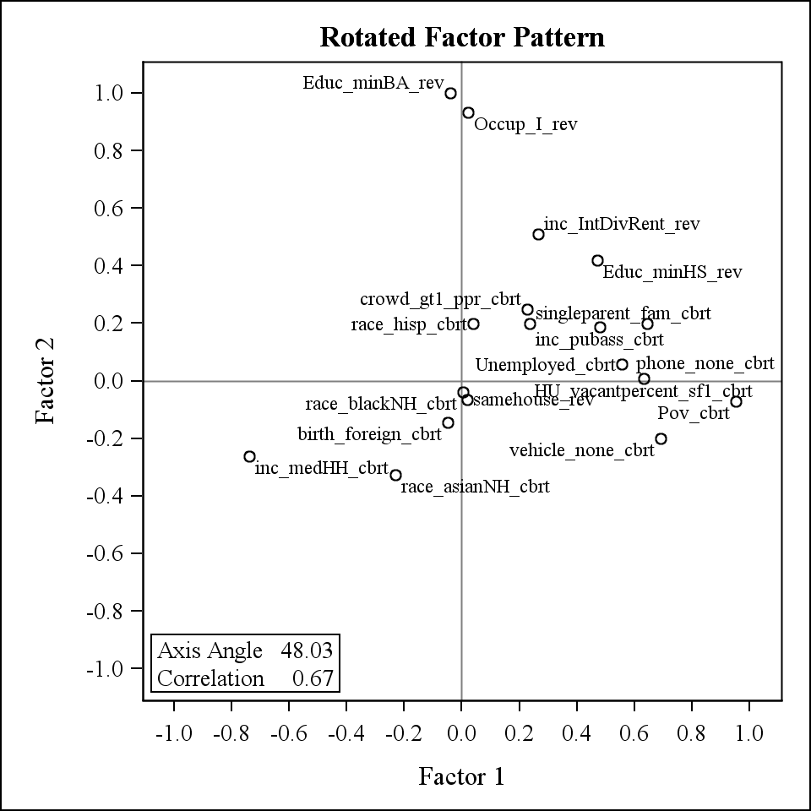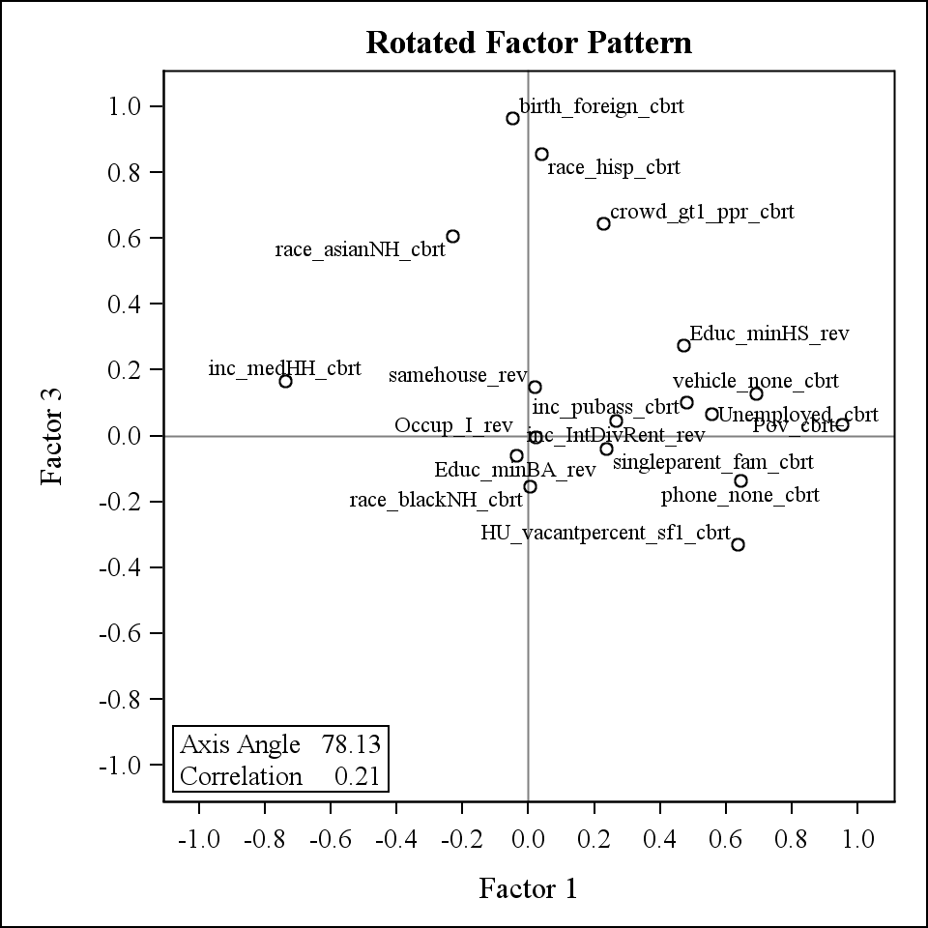

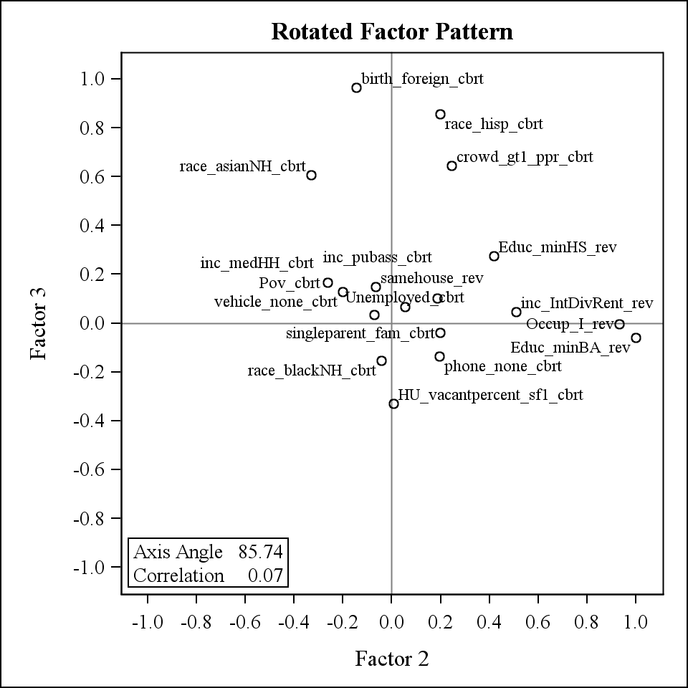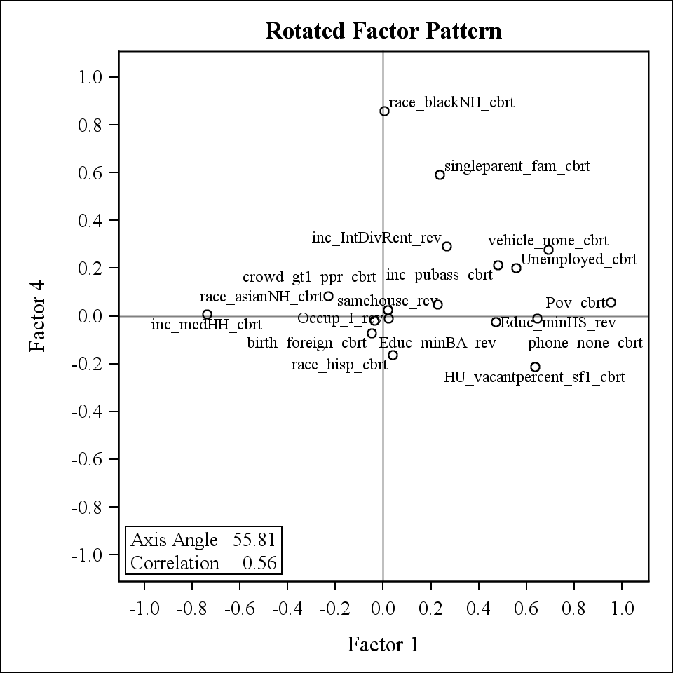

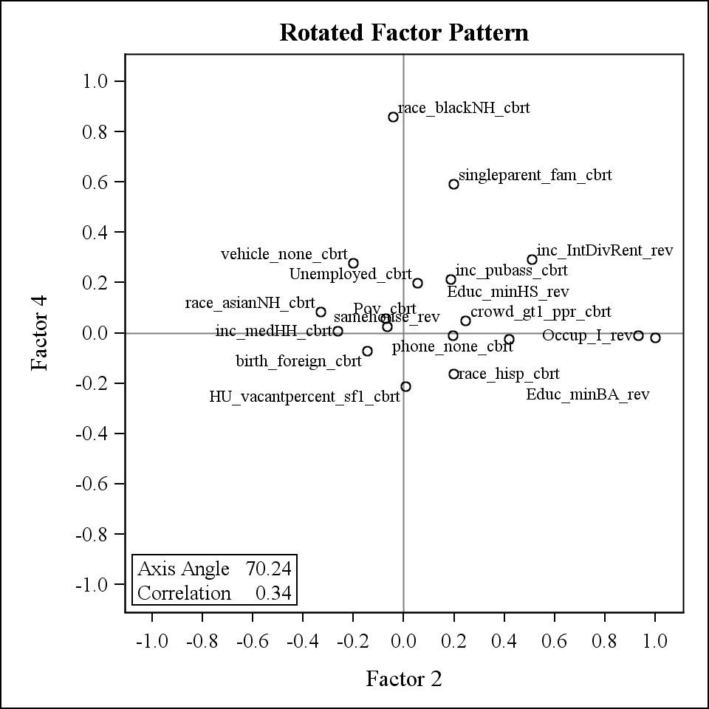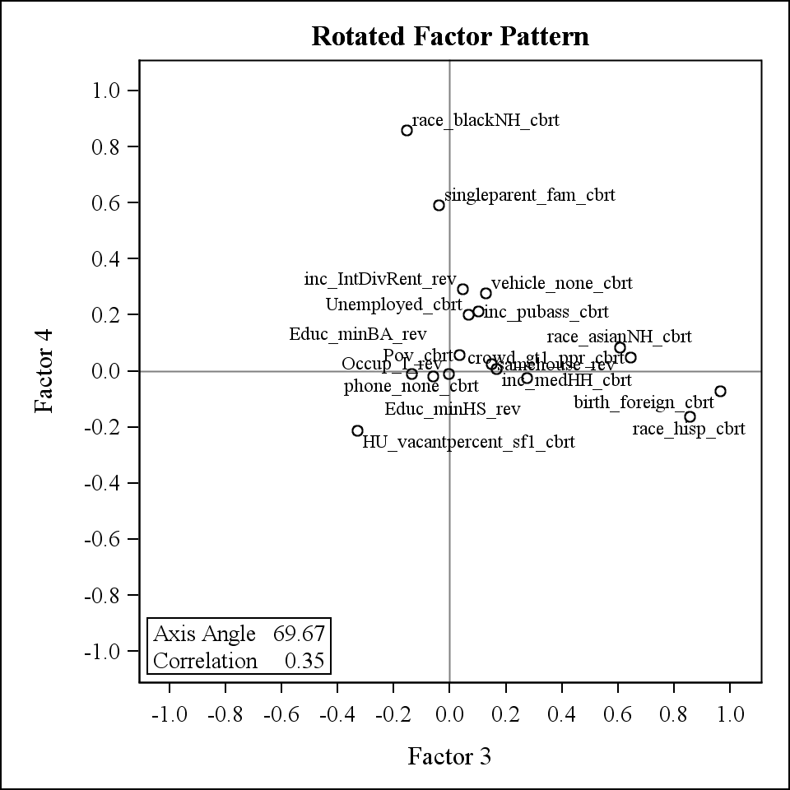

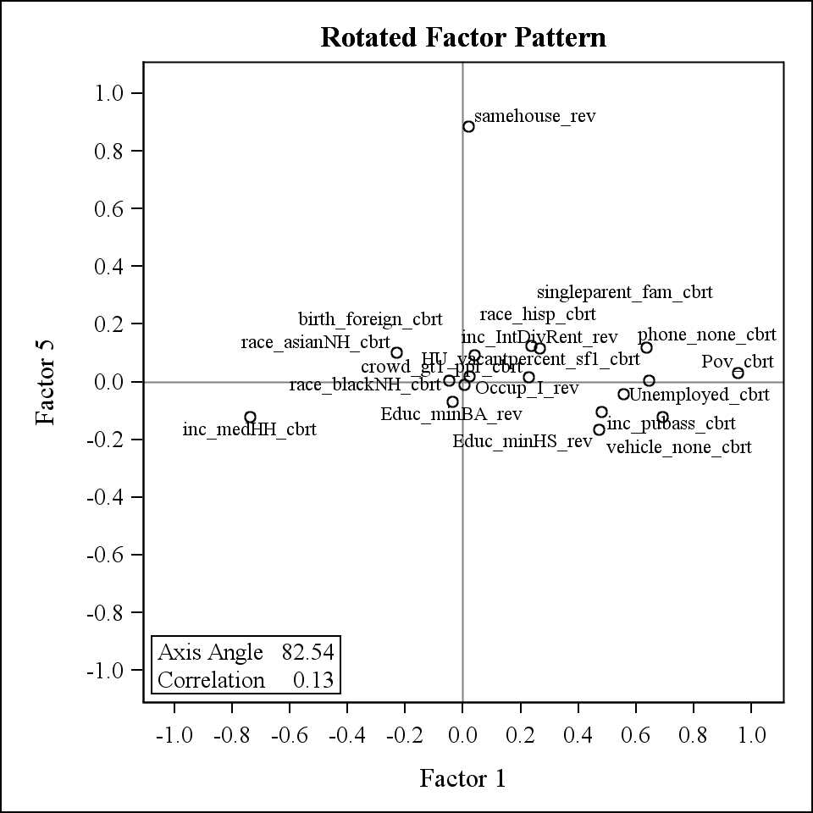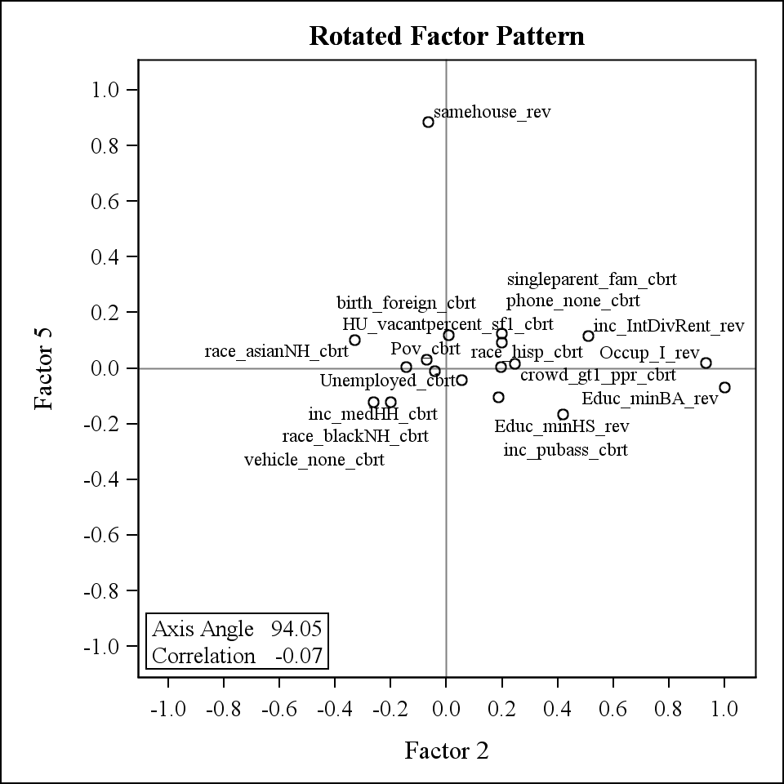

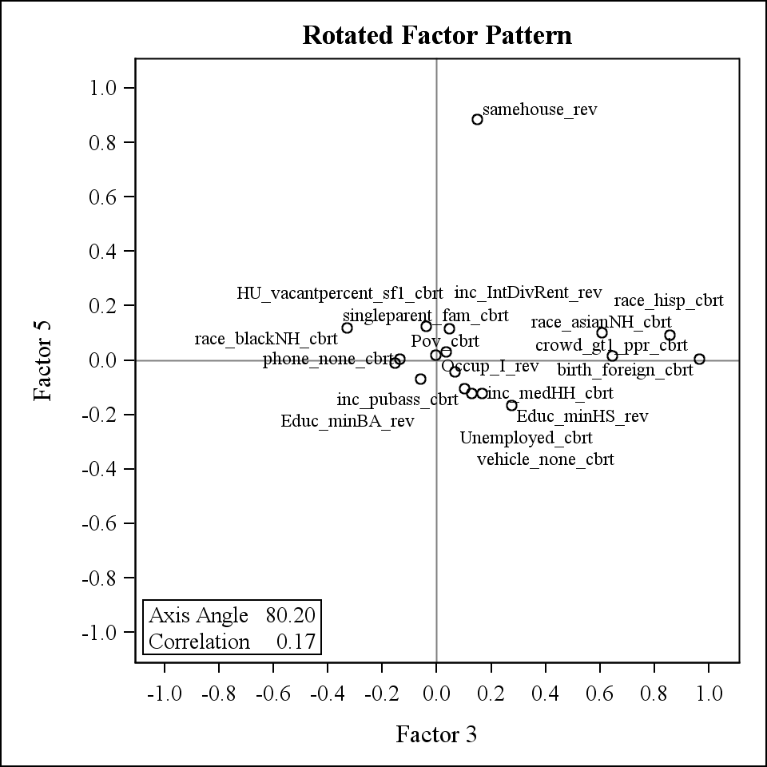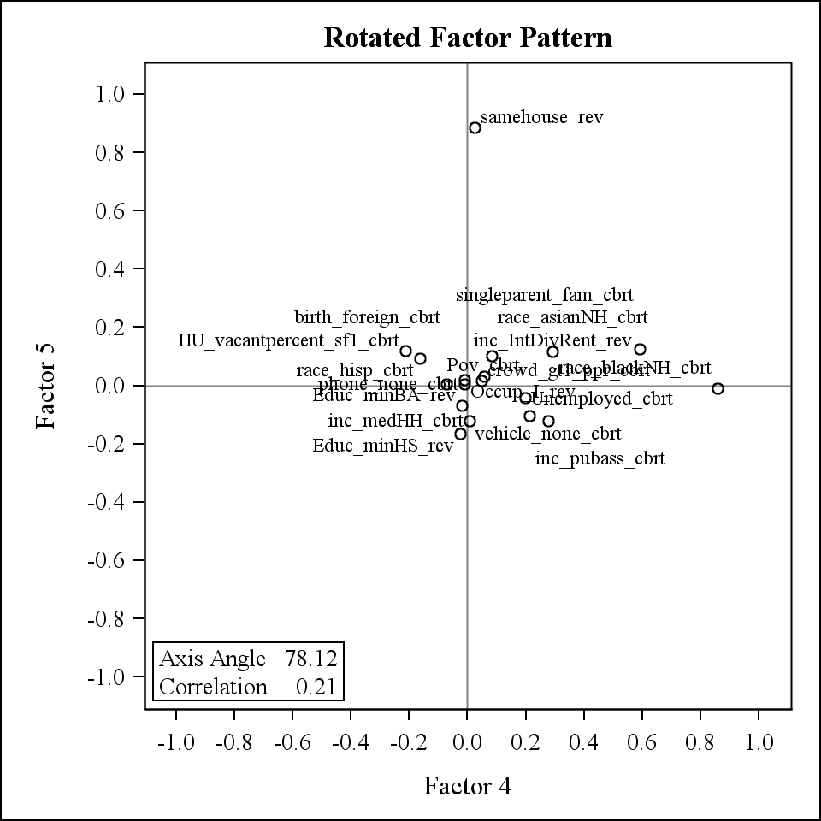

# V. COMPARISON OF VARIABLES FOR CENSUS 2000 AND ACS2005-2009

When looking at the correlations comparing different PCA methods, there are some of the factor scales that are highly correlated. When comparing the Full Variables (PC3) with the Race/Ethnicity/Crowding Variables (PC1), PC3 Factor3 is highly correlated with PC1 Factor1 (Table 14). These factors both take into account the percent crowding, percent foreign born, and percent Hispanic. PC3 Factor2 and PC1 Factor2 are also highly correlated. These both take percent Black into account. When comparing the Full Variables (PC3) with the Other SES Variables (PC2), PC3 Factor 1 is highly correlated with PC2 Factor1 (Table 15). These both represent percent with Bachelor’s degree, percent with managerial/professional occupation, percent with high school education, median home value, median household income, and percent household income >$50,000. PC3 Factor2 is highly correlated with PC2 Factor2. These both represent percent without a vehicle, percent owner occupied housing, percent poverty, and percent unemployed. PC3 Factor4 is highly correlated with PC2 Factor3. These both represent percent occupied housing. PC3 Factor5 is highly correlated with PC2 Factor5. These both represent housing stability. When comparing the Race/Ethnicity/Crowding Variables (PC1) with Other SES Variables (PC2), PC1 Factor2 and PC2 Factor2 are fairly correlated. These both represent percent Black.

### Table 14: Pearson Correlations comparing Full Variables PCA (PC3) with Race/Ethnicity/Crowding Variables PCA (PC1) for combined data.

|  | **PC3 Factor1** | **PC3 Factor2** | **PC3 Factor3** | **PC3 Factor4** | **PC3 Factor5** |
| --- | --- | --- | --- | --- | --- |
| **PC1 Factor1** | -0.09098 <.0001 129002 | 0.00439 0.1151 129002 | 0.97148 <.0001 129002 | -0.07380 <.0001 129002 | 0.08279 <.0001 129002 |
| **PC1 Factor2** | 0.44722 <.0001 129002 | 0.66752 <.0001 129002 | 0.06546 <.0001 129002 | -0.05294 <.0001 129002 | 0.15674 <.0001 129002 |

### Table 15: Pearson Correlations comparing Full Variables PCA (PC3) with Other SES PCA (PC2) for combined data.

|  | **PC3 Factor1** | **PC3 Factor2** | **PC3 Factor3** | **PC3 Factor4** | **PC3 Factor5** |
| --- | --- | --- | --- | --- | --- |
| **PC2 Factor1** | 0.97796 <.0001 129002 | 0.01224 <.0001 129002 | -0.09635 <.0001 129002 | -0.04164 <.0001 129002 | 0.03856 <.0001 129002 |
| **PC2 Factor2** | 0.05538 <.0001 129002 | 0.81047 <.0001 129002 | 0.42279 <.0001 129002 | 0.23063 <.0001 129002 | 0.06339 <.0001 129002 |
| **PC2 Factor3** | 0.00570 0.0407 129002 | 0.15480 <.0001 129002 | -0.39660 <.0001 129002 | 0.77158 <.0001 129002 | -0.05717 <.0001 129002 |
| **PC2 Factor4** | -0.02985 <.0001 129002 | -0.07222 <.0001 129002 | -0.02944 <.0001 129002 | 0.05620 <.0001 129002 | 0.98739 <.0001 129002 |

### Table 16: Pearson Correlations comparing Race/Ethnicity/Crowding Variables PCA (PC1) with Other SES PCA (PC2) for combined data.

|  | **PC1 Factor1** | **PC1 Factor2** |
| --- | --- | --- |
| **PC2 Factor1** | -0.16736 <.0001 129002 | 0.42671 <.0001 129002 |
| **PC2 Factor2** | 0.36066 <.0001 129002 | 0.51784 <.0001 129002 |
| **PC2 Factor3** | -0.38726 <.0001 129002 | 0.10040 <.0001 129002 |
| **PC2 Factor4** | 0.05147 <.0001 129002 | 0.09278 <.0001 129002 |

When looking at the difference between Census 2000 and ACS2005-2009 raw data (Table 17), percent Hispanic, percent Black, percent Asian, percent foreign born, percent with high school education, percent with Bachelor’s degree, percent with managerial/professional occupation, median household income, percent with median household income>$50,000, median home value, percent below poverty, percent unemployed, percent without a telephone, and percent in same house increase from Census 2000 to ACS. Percent White, percent with crowding, percent with interest/dividend/rental income, percent on public assistance, percent not in labor force, percent without a vehicle, percent without plumbing, percent of owner occupied housing, and percent occupied housing decrease from Census 2000 to ACS. Percent of other races does not change.

For the created factor scales (Table 17), Census 2000 is on average greater for both factors for race/ethnicity/crowding (PC1) factors suggesting that these are improving from 2000 to 2005-2009. For the Other SES (PC2) factors, Census 2000 is greater for Factor1 (education, occupation, housing value, income) and Factor4 (stability) suggesting that these aspects are improving from 2000 to 2005-2009. Census 2000 is less than ACS for Factor2 (wealth, owner occupied housing, poverty, unemployment) and Factor3 (occupied households) suggesting that these are getting worse from 2000 to 2005-2009. For the Full Variable (PC3) factors, Factor1 (education, occupation, housing value, income), Factor3 (foreign born, Hispanic, crowding), and Factor5 (stability) are greater for Census 2000 suggesting that these aspects are improving from 2000 to 2005-2009. Factor2 (wealth, owner occupied housing, poverty, unemployment, Black) and Factor4 (labor force, occupied households) Census 2000 is less than ACS suggesting that these aspects are getting worse from 2000 to 2005-2009.

### Table 17: Comparison of Census2000 to ACS2005-2009 Variables and Factor Scales. Difference is ACS-Census2000.

| **Variable** | **Brief Description** | **Census 2000 Mean (std)** | **Census 2000 Median (IQR)** | **ACS Mean (std)** | **ACS Median (IQR)** | **Difference Mean (std)** | **Difference Median (IQR)** | **Paired t-test p-value** | **Correlation** |
| --- | --- | --- | --- | --- | --- | --- | --- | --- | --- |
| race_hisp | % Hispanic | 0.115 (0.189) | 0.034 (0.012, 0.117) | 0.137 (0.204) | 0.049 (0.015, 0.159) | 0.022 (0.056) | 0.009  (-0.005, 0.039) | <.0001 | 0.88473 (<.0001) |
| race_whiteNH | % White | 0.688 (0.304) | 0.813 (0.512, 0.933) | 0.656 (0.306) | 0.767 (0.449, 0.913) | -0.032 (0.073) | -0.022  (-0.065, 0.004) | <.0001 | 0.96108 (<.0001) |
| race_blackNH | % Black | 0.135 (0.235) | 0.028 (0.006, 0.130) | 0.139 (0.233) | 0.034 (0.005, 0.146) | 0.004 (0.054) | -0.000  (-0.009, 0.017) | <.0001 | 0.90132 (<.0001) |
| race_asianNH | % Asian | 0.033 (0.072) | 0.010 (0.003, 0.031) | 0.040 (0.081) | 0.011 (0, 0.040) | 0.006 (0.030) | -0.000  (-0.004, 0.011) | <.0001 | 0.77299 (<.0001) |
| race_otherNH | % Other Races | 0.012 (0.052) | 0.004 (0.002, 0.008) | 0.012 (0.051) | 0.002 (0, 0.009) | 0.000 (0.018) | -0.002  (-0.004, 0.003) | <.0001 | 0.41975 (<.0001) |
| birth_foreign | % foreign born | 0.102 (0.132) | 0.049 (0.017, 0.130) | 0.115 (0.135) | 0.061 (0.020, 0.158) | 0.012 (0.048) | 0.006  (-0.008, 0.030) | <.0001 | 0.89404 (<.0001) |
| crowd_gt1_ppr | % crowding | 0.061 (0.090) | 0.029 (0.013, 0.068) | 0.033 (0.054) | 0.015 (0.003, 0.038) | -0.028 (0.054) | -0.013  (-0.038, -0.001) | <.0001 | 0.64737 (<.0001) |
| Educ_minHS | % high school education | 0.792 (0.140) | 0.822 (0.715, 0.897) | 0.835 (0.123) | 0.866 (0.775, 0.925) | 0.043 (0.065) | 0.037 (0.007, 0.073) | <.0001 | 0.88996 (<.0001) |
| Educ_minBA | % Bachelor’s degree | 0.232 (0.170) | 0.179 (0.106, 0.316) | 0.260 (0.180) | 0.209 (0.125, 0.354) | 0.028 (0.064) | 0.024  (-0.006, 0.058) | <.0001 | 0.91538 (<.0001) |
| Occup_I | % managerial, professional occupation | 0.318 (0.140) | 0.291 (0.219, 0.397) | 0.330 (0.147) | 0.308 (0.227, 0.415) | 0.011 (0.076) | 0.009  (-0.032, 0.051) | <.0001 | 0.84646 (<.0001) |
| inc_medHH | Median HH income | 43920 (21029) | 39727 (30518, 52880) | 53806 (26502) | 48107 (36098, 65472) | 9578 (10516) | 8040 (3185, 14107) | <.0001 | 0.92100 (<.0001) |
| inc_HHge50k | % HH income > $50,000 | 0.405 (0.194) | 0.376 (0.256, 0.539) | 0.489 (0.196) | 0.480 (0.345, 0.636) | 0.084 (0.083) | 0.083 (0.033, 0.132) | <.0001 | 0.91542 (<.0001) |
| HUcost_medownval | Median home value | 134350 (110946) | 104600 (71800, 161600) | 236316 (190701) | 168800 (101100, 315300) | 99969 (114687) | 54500 (24400, 145600) | <.0001 | 0.89267 (<.0001) |
| inc_IntDivRent | % with interest, Dividend, Rental income | 0.348 (0.162) | 0.343 (0.228, 0.457) | 0.240 (0.136) | 0.227 (0.139, 0.322) | -0.108 (0.077) | -0.108  (-0.155, -0.062) | <.0001 | 0.88949 (<.0001) |
| inc_pubass | % on public assistance | 0.039 (0.047) | 0.024 (0.011, 0.048) | 0.028 (0.037) | 0.017 (0.006, 0.035) | -0.011 (0.038) | -0.007  (-0.022, 0.005) | <.0001 | 0.53923 (<.0001) |
| pov | % poverty | 0.135 (0.117) | 0.100 (0.052, 0.180) | 0.145 (0.122) | 0.111 (0.058, 0.193) | 0.010 (0.071) | 0.008  (-0.021, 0.040) | <.0001 | 0.82392 (<.0001) |
| unemployed | % unemployed | 0.065 (0.060) | 0.049 (0.031, 0.079) | 0.079 (0.058) | 0.066 (0.044, 0.098) | 0.014 (0.059) | 0.015  (-0.008, 0.039) | <.0001 | 0.50408 (<.0001) |
| NotInLaborForce | % not in labor force | 0.368 (0.104) | 0.358 (0.302, 0.423) | 0.358 (0.106) | 0.346 (0.291, 0.409) | -0.010 (0.071) | -0.008  (-0.046, 0.028) | <.0001 | 0.74892 (<.0001) |
| phone_none | % no phone | 0.028 (0.042) | 0.015 (0.004, 0.038) | 0.045 (0.048) | 0.033 (0.014, 0.062) | 0.017 (0.045) | 0.012  (-0.002, 0.034) | <.0001 | 0.48600 (<.0001) |
| vehicle_none | % no vehicle | 0.113 (0.138) | 0.065 (0.034, 0.129) | 0.100 (0.131) | 0.055 (0.026, 0.116) | -0.012 (0.055) | -0.009  (-0.031, 0.011) | <.0001 | 0.81911 (<.0001) |
| plumbing_lack | % no plumbing | 0.007 (0.018) | 0.004 (0, 0.009) | 0.006 (0.017) | 0 (0, 0.006) | -0.002 (0.017) | 0  (-0.006, 0) | <.0001 | 0.17038 (<.0001) |
| ownerocc_hh | % owner occupied households | 0.600 (0.223) | 0.642 (0.464, 0.768) | 0.583 (0.220) | 0.615 (0.442, 0.749) | -0.018 (0.069) | -0.016  (-0.054, 0.019) | <.0001 | 0.94570 (<.0001) |
| samehouse | % in same house | 0.549 (0.133) | 0.567 (0.477, 0.642) | 0.796 (0.100) | 0.815 (0.751, 0.863) | 0.247 (0.101) | 0.242 (0.186, 0.304) | <.0001 | 0.63199 (<.0001) |
| HU_sampleocc | % occupied housing | 0.907 (0.118) | 0.940 (0.895, 0.966) | 0.884 (0.103) | 0.911 (0.851, 0.950) | -0.029 (0.067) | -0.024  (-0.056, 0.003) | <.0001 | 0.70866 (<.0001) |
| HU_vacantpercent_sf1 | % vacant housing | 0.087 (0.090) | 0.060 (0.035, 0.104) |  |  |  |  |  |  |
| singleparent_fam | % single parent families | 0.146 (0.095) | 0.120 (0.081, 0.185) |  |  |  |  |  |  |
| F1_PC1 | Race/Ethnicity PCA weighted Factor1 | 0.042 (0.953) | -0.171 (-0.689, 0.623) | -0.042 (1.043) | -0.154  (-0.802, 0.657) | -0.086 (0.424) | -0.061  (-0.328, 0.184) | <.0001 | 0.90100 (<.0001) |
| F2_PC1 | Race/Ethnicity PCA weighted Factor2 | 0.115 (0.957) | -0.133 (-0.587, 0.670) | -0.115 (1.029) | -0.261  (-0.851, 0.522) | -0.229 (0.497) | -0.216  (-0.536, 0.087) | <.0001 | 0.84641 (<.0001) |
| F1_PC1_BR | Race/Ethnicity raw vars based Factor1 std to both years | 0.046 (3.274) | -1.311 (-1.955, 0.573) | -0.045 (2.928) | -1.242  (-1.994, 0.796) | -0.091 (1.037) | -0.023  (-0.398, 0.358) | <.0001 | 0.88790 (<.0001) |
| F1_PC1_BT | Race/Ethnicity transformed vars based Factor1 std to both years | 0.258 (2.993) | -0.491 (-2.035, 2.032) | -0.252 (3.197) | -0.700  (-2.609, 1.887) | -0.512 (1.386) | -0.442  (-1.315, 0.375) | <.0001 | 0.87607 (<.0001) |
| F1_PC1_BR_ind | Race/Ethnicity raw vars based Factor1 std to year only | 0.001 (3.193) | -1.334 (-1.967, 0.544) | 0.001 (3.068) | -1.237  (-2.002, 0.819) | 0.001 (0.972) | -0.014  (-0.362, 0.399) | 0.8247 | 0.88964 (<.0001) |
| F1_PC1_BT_ind | Race/Ethnicity transformed vars based Factor1 std to year only | 0.005 (3.226) | -0.798 (-2.472, 1.927) | 0.001 (3.048) | -0.441  (-2.240, 2.027) | -0.007 (1.393) | 0.030  (-0.876, 0.904) | 0.1877 | 0.87578 (<.0001) |
| F1_PC2 | Other SES PCA weighted Factor1 | 0.172 (0.961) | 0.372  (-0.349, 0.857) | -0.174 (1.008) | 0.032  (-0.725, 0.555) | -0.343 (0.383) | -0.322  (-0.545, -0.112) | <.0001 | 0.90795 (<.0001) |
| F2_PC2 | Other SES PCA weighted Factor2 | -0.134 (1.026) | -0.334 (-0.874, 0.462) | 0.135 (0.954) | -0.034  (-0.548, 0.698) | 0.280 (0.493) | 0.294  (-0.005, 0.579) | <.0001 | 0.85298 (<.0001) |
| F3_PC2 | Other SES PCA weighted Factor3 | -0.141 (0.922) | -0.220 (-0.757, 0.390) | 0.142 (1.054) | 0.118  (-0.514, 0.784) | 0.289 (0.687) | 0.299  (-0.079, 0.687) | <.0001 | 0.76774 (<.0001) |
| F4_PC2 | Other SES PCA weighted Factor4 | 0.793 (0.585) | 0.746 (0.408, 1.113) | -0.804 (0.619) | -0.837  (-1.213, -0.422) | -1.582 (0.536) | -1.585  (-1.919, -1.248) | <.0001 | 0.56269 (<.0001) |
| F1_PC2_BR | Other SES raw vars based Factor1 std to both years | 0.976 (4.733) | 1.762  (-1.791, 4.307) | -1.046 (5.192) | -0.178  (-4.119, 2.639) | -1.984 (1.651) | -1.844  (-2.862, -0.944) | <.0001 | 0.94064 (<.0001) |
| F2_PC2_BR | Other SES raw vars based Factor2 std to both years | -0.163 (3.325) | -1.047 (-2.440, 1.104) | 0.141 (3.149) | -0.642  (-2.058, 1.475) | 0.312 (1.466) | 0.350  (-0.283, 0.989) | <.0001 | 0.90923 (<.0001) |
| F1_PC2_BT | Other SES transformed vars based Factor1 std to both years | 0.964 (4.863) | 1.617  (-2.101, 4.395) | -1.086 (5.003) | -0.474  (-4.353, 2.502) | -1.988 (1.584) | -1.906  (-2.815, -1.035) | <.0001 | 0.94434 (<.0001) |
| F2_PC2_BT | Other SES transformed vars based Factor2 std to both years | -0.155 (3.337) | -0.587 (-2.516, 1.780) | 0.146 (3.183) | -0.202  (-2.093, 2.072) | 0.301 (1.552) | 0.368  (-0.527, 1.225) | <.0001 | 0.88767 (<.0001) |
| F1_PC2_BR_ind | Other SES raw vars based Factor1 std to year only | -0.031 (5.134) | 0.892  (-2.940, 3.581) | -0.035 (5.023) | 0.746  (-3.054, 3.527) | 0.039 (1.565) | 0.075  (-0.798, 0.945) | <.0001 | 0.94612 (<.0001) |
| F2_PC2_BR_ind | Other SES raw vars based Factor2 std to year only | -0.014 (3.311) | -0.893 (-2.285, 1.251) | -0.007 (3.177) | -0.799  (-2.223, 1.334) | 0.014 (1.467) | 0.041  (-0.593, 0.686) | 0.0135 | 0.90864 (<.0001) |
| F1_PC2_BT_ind | Other SES transformed vars based Factor1 std to year only | -0.079 (5.001) | 0.614  (-3.213, 3.453) | -0.039 (5.062) | 0.551  (-3.360, 3.587) | 0.105 (1.593) | 0.172  (-0.726, 1.056) | <.0001 | 0.94603 (<.0001) |
| F2_PC2_BT_ind | Other SES transformed vars based Factor2 std to year only | -0.007 (3.376) | -0.443 (-2.397, 1.949) | -0.002 (3.171) | -0.348  (-2.234, 1.916) | 0.005 (1.569) | 0.077  (-0.835, 0.940) | 0.4088 | 0.88700 (<.0001) |
| F1_PC3 | Full Vars PCA weighted Factor1 | 0.142 (0.966) | 0.317  (-0.407, 0.807) | -0.144 (1.013) | 0.033  (-0.724, 0.566) | -0.285 (0.377) | -0.265  (-0.492, -0.052) | <.0001 | 0.90953 (<.0001) |
| F2_PC3 | Full Vars PCA weighted Factor2 | -0.224 (0.972) | -0.437 (-0.920, 0.332) | 0.227 (0.977) | 0.067  (-0.478, 0.820) | 0.464 (0.467) | 0.473 (0.187, 0.756) | <.0001 | 0.85517 (<.0001) |
| F3_PC3 | Full Vars PCA weighted Factor3 | 0.007 (0.961) | -0.258 (-0.712, 0.511) | -0.007 (1.038) | -0.187  (-0.758, 0.627) | -0.014 (0.396) | 0.011  (-0.242, 0.241) | <.0001 | 0.89922 (<.0001) |
| F4_PC3 | Full Vars PCA weighted Factor4 | -0.052 (0.977) | -0.117 (-0.692, 0.524) | 0.052 (1.020) | -0.007  (-0.615, 0.645) | 0.108 (0.590) | 0.108  (-0.237, 0.457) | <.0001 | 0.81004 (<.0001) |
| F5_PC3 | Full Vars PCA weighted Factor5 | 0.803 (0.565) | 0.753 (0.427, 1.112) | -0.814 (0.611) | -0.843  (-1.215, -0.436) | -1.603 (0.518) | -1.601  (-1.928, -1.277) | <.0001 | 0.57521 (<.0001) |
| F1_PC3_BR | Full Vars raw vars based Factor1 std to both years | 0.976 (4.733) | 1.762  (-1.791, 4.307) | -1.046 (5.192) | -0.178  (-4.119, 2.639) | -1.984 (1.651) | -1.844  (-2.862, -0.944) | <.0001 | 0.94064 (<.0001) |
| F2_PC3_BR | Full Vars raw vars based Factor2 std to both years | -0.514 (4.695) | -1.655 (-3.760, 1.538) | 0.488 (4.357) | -0.519  (-2.534, 2.466) | 1.009 (1.674) | 1.121 (0.308, 1.870) | <.0001 | 0.93786 (<.0001) |
| F3_PC3_BR | Full Vars raw vars based Factor3 std to both years | 0.086 (2.839) | -1.065 (-1.578, 0.399) | -0.085 (2.418) | -1.074  (-1.623, 0.454) | -0.171 (0.930) | -0.056  (-0.391, 0.234) | <.0001 | 0.87283 (<.0001) |
| F4_PC3_BR | Full Vars raw vars based Factor4 std to both years | -0.101 (1.525) | -0.380 (-1.078, 0.553) | 0.045 (1.535) | -0.270  (-0.989, 0.738) | 0.167 (0.885) | 0.149  (-0.289, 0.602) | <.0001 | 0.80324 (<.0001) |
| F1_PC3_BT | Full Vars transformed vars based Factor1 std to both years | 0.964 (4.863) | 1.617  (-2.101, 4.395) | -1.086 (5.003) | -0.474  (-4.353, 2.502) | -1.988 (1.584) | -1.906  (-2.815, -1.035) | <.0001 | 0.94434 (<.0001) |
| F2_PC3_BT | Full Vars transformed vars based Factor2 std to both years | -0.472 (4.705) | -1.136 (-3.872, 2.375) | 0.460 (4.419) | -0.069  (-2.703, 3.172) | 0.933 (1.802) | 1.017  (-0.050, 2.023) | <.0001 | 0.92156 (<.0001) |
| F3_PC3_BT | Full Vars transformed vars based Factor3 std to both years | 0.199 (2.501) | -0.477 (-1.639, 1.519) | -0.197 (2.588) | -0.690  (-2.064, 1.390) | -0.398 (1.140) | -0.345  (-1.049, 0.320) | <.0001 | 0.85372 (<.0001) |
| F4_PC3_BT | Full Vars transformed vars based Factor4 std to both years | -0.105 (1.550) | -0.300 (-1.154, 0.768) | 0.071 (1.600) | -0.072  (-0.947, 0.986) | 0.189 (1.030) | 0.224  (-0.321, 0.756) | <.0001 | 0.78807 (<.0001) |
| F1_PC3_BR_ind | Full vars raw vars based Factor1 std to year only | -0.031 (5.134) | 0.892  (-2.940, 3.581) | -0.035 (5.023) | 0.746  (-3.054, 3.527) | 0.039 (1.565) | 0.075  (-0.798, 0.945) | <.0001 | 0.94612 (<.0001) |
| F2_PC3_BR_ind | Full vars raw vars based Factor2 std to year only | -0.017 (4.665) | -1.152 (-3.246, 2.021) | -0.009 (4.495) | -1.014  (-3.117, 2.062) | 0.015 (1.673) | 0.072  (-0.732, 0.864) | 0.0197 | 0.93747 (<.0001) |
| F3_PC3_BR_ind | Full vars raw vars based Factor3 std to year only | 0.000 (2.713) | -1.108 (-1.600, 0.313) | 0.001 (2.611) | -1.044  (-1.627, 0.527) | 0 (0.856) | -0.012  (-0.300, 0.333) | 0.8850 | 0.87287 (<.0001) |
| F4_PC3_BR_ind | Full vars raw vars based Factor4 std to year only | -0.043 (1.494) | -0.308 (-1.003, 0.611) | -0.013 (1.590) | -0.346  (-1.082, 0.696) | 0.050 (0.910) | 0.017  (-0.430, 0.496) | <.0001 | 0.79971 (<.0001) |
| F1_PC3_BT_ind | Full vars transformed vars based Factor1 std to year only | -0.079 (5.001) | 0.614  (-3.213, 3.453) | -0.039 (5.062) | 0.551  (-3.360, 3.587) | 0.105 (1.593) | 0.172  (-0.726, 1.056) | <.0001 | 0.94603 (<.0001) |
| F2_PC3_BT_ind | Full vars transformed vars based Factor2 std to year only | -0.009 (4.761) | -0.695 (-3.451, 2.867) | -0.004 (4.489) | -0.517  (-3.210, 2.767) | 0.005 (1.818) | 0.091  (-0.979, 1.106) | 0.4481 | 0.92296 (<.0001) |
| F3_PC3_BT_ind | Full vars transformed vars based Factor3 std to year only | 0.003 (2.645) | -0.716 (-1.939, 1.397) | 0 (2.518) | -0.480  (-1.821, 1.540) | -0.005 (1.169) | 0.037  (-0.717, 0.751) | 0.3038 | 0.85053 (<.0001) |
| F4_PC3_BT_ind | Full vars transformed vars based Factor4 std to year only | -0.024 (1.596) | -0.227 (-1.106, 0.876) | -0.011 (1.568) | -0.154  (-1.012, 0.885) | 0.026 (1.029) | 0.059  (-0.493, 0.595) | <.0001 | 0.78873 (<.0001) |
| factor_ana | Diez-Roux based scale std to both years | -0.189 (4.500) | -0.477 (-3.198, 2.639) | 0.395 (4.175) | -0.026  (-2.533, 2.999) | 0.492 (1.520) | 0.367  (-0.351, 1.135) | <.0001 | 0.94146 (<.0001) |
| factor_ana_ind | Diez-Roux based scale std to year only | 0.133 (4.290) | -0.175 (-2.779, 2.823) | 0.040 (5.001) | -0.437  (-3.476, 3.194) | -0.171 (1.818) | -0.284  (-1.325, 0.853) | <.0001 | 0.93616 (<.0001) |
| F1_orig | 2000 ML weighted Factor1 | 0.000 (0.977) | -0.046 (-0.702, 0.637) |  |  |  |  |  |  |
| F2_orig | 2000 ML weighted Factor2 | 0.000 (0.986) | 0.235  (-0.537, 0.713) |  |  |  |  |  |  |
| F3_orig | 2000 ML weighted Factor3 | 0.000 (0.968) | -0.239 (-0.724, 0.546) |  |  |  |  |  |  |
| F4_orig | 2000 ML weighted Factor4 | 0.000 (0.917) | -0.162 (-0.670, 0.508) |  |  |  |  |  |  |
| F5_orig | 2000 ML weighted Factor5 | 0.000 (0.936) | -0.129 (-0.644, 0.494) |  |  |  |  |  |  |
| F1_BR_orig | 2000 ML raw vars based Factor1 | -0.030 (4.296) | -0.847 (-2.976, 2.040) |  |  |  |  |  |  |
| F2_BR_orig | 2000 ML raw vars based Factor2 | -0.002 (2.775) | 0.481  (-1.607, 2.032) |  |  |  |  |  |  |
| F3_BR_orig | 2000 ML raw vars based Factor3 | 0.001 (3.193) | -1.334 (-1.967, 0.544) |  |  |  |  |  |  |
| F4_BR_orig | 2000 ML raw vars based Factor4 | -0.002 (1.822) | -0.650 (-1.167, 0.379) |  |  |  |  |  |  |
| F1_BT_orig | 2000 ML transformed vars based Factor1 | -0.044 (4.594) | -0.190 (-3.321, 2.964) |  |  |  |  |  |  |
| F2_BT_orig | 2000 ML transformed vars based Factor2 | -0.002 (2.775) | 0.481  (-1.607, 2.032) |  |  |  |  |  |  |
| F3_BT_orig | 2000 ML transformed vars based Factor3 | 0.005 (3.226) | -0.798 (-2.472, 1.927) |  |  |  |  |  |  |
| F4_BT_orig | 2000 ML transformed vars based Factor4 | -0.001 (1.793) | -0.407 (-1.302, 0.944) |  |  |  |  |  |  |

# VI. ADDITIONAL METHODS TRIED WITH CENSUS 2000 AND ACS2005-2009

In addition to the scales that were created in the previous sections, we tried a few additional methods which we did not use the results to create scales.

We originally performed a maximum likelihood factor analysis with promax oblique rotation with prior communalities set to SMC (default in SAS for ML) on all 21 variables listed in Table 1 (in Section II) for Census 2000 and ACS data separately and also combined. Five factors were kept as an a priori decision. After performing this initial analysis on all 21 variables, it was found that percent occupied housing and percent receiving public assistance did not load to any factor for any of the years so these were removed. By removing these, it didn’t change the patterns of the other variables. Percent unemployed also did not load to any factor for any year but this was kept in the model since when it was removed, the patterns within the factors changes so we decided that it was important in helping to determine the patterns even though it didn’t load to any factor. See Appendix D for results from these analyses. We decided not to use this method for the final scales since we wanted to have factor scales that are not correlated to use in modeling adjustments.

# VII. NOTES FOR CREATION AND LOCATION OF FINAL DATASETS

All principal components and factor analyses were performed using SAS PROC FACTOR. For the weighted scales created, these were done using SAS PROC SCORE after outputting the factor weights datasets from the PCA or FA analyses.

The weighted scales for the PCAs for Full Variables (PC3), Race/Ethnicity/Crowding (PC1), and Other SES (PC2) were created for both Census 2000 and ACS datasets set together and then applying the weights using PROC SCORE. For the ML (Mahasin’s) analysis for Census 2000, these were created only using the Census 2000 data and applying the weights using PROC SCORE (not the combined dataset). If any of the variables in the factor analysis was missing, then these scales will be missing for that census tract.

For the based scales and the scale based on Ana Diez-Roux’s PCA analysis, these were created in two ways. The first way, the datasets for Census 2000 and ACS were combined together, then the variables were standardized using PROC STDIZE to create standardizations. This was done for both the untransformed and transformed (where needed) variables. The variables were then summed together as appropriate based on the factor in question. These are appropriate for looking at the longitudinal change. The variables were then standardized on the datasets separately (ie: not the combined dataset) using PROC STDIZE and summed as described above. These are appropriate for looking at cross-sectional data. If any of the variables was missing for these, then the based scale will be missing for that census tract.

For the based scales using the ML (Mahasin’s) analysis for Census 2000, these were created be standardizing the variables using PROC STDIZE for Census 2000 dataset only. These standardized variables were then summed together. If any of the variables was missing for these, then the based scale will be missing for that census tract.

All variables were then separated into separate datasets for Census 2000 and ACS. There is one dataset containing all the created scales as well as raw variables that were used in the factor analysis for each year. See Table 18 for names of datasets, location, and sample size. The SAS program to perform all data manipulation, factor analyses, and creation of scales and datasets is “U:\SECURE\Diezroux\Projects\Census\Census_Factor_Data\Code\ create dataset with factor scores for census2010_060811.sas”.

### Table 18: Name, Location, and Sample size of final datasets

| **Description** | **Dataset Name** | **Folder Location** | **Sample Size** |
| --- | --- | --- | --- |
| Census 2000 dataset with factor scales | census2000.sas7bdat | U:\SECURE\Diezroux\Projects\Census\Census_Factor_Data\Data | 65443 |
| ACS2005-2009 dataset with factor scales | acs0509.sas7bdat | U:\SECURE\Diezroux\Projects\Census\Census_Factor_Data\Data | 65461 |

# APPENDIX A: VARIABLES IN CENSUS FACTOR SCALES DATASETS

Table A1: List of variables in Census 2000 (census2000.sas7bdat) and ACS2005-2009 (acs0509.sas7bdat) datasets. **Variable names are the same in both datasets. See notes column for details if the variable is not available in one of the datasets.**

| **Variable Name** | **Type** | **Description** | **Notes** |
| --- | --- | --- | --- |
| StCoTrk | Char | Census tract ID |  |
| race_hisp | Num | Percent Hispanic |  |
| race_whiteNH | Num | Percent Non-Hispanic White |  |
| race_blackNH | Num | Percent Non-Hispanic Black |  |
| race_asianNH | Num | Percent Non-Hispanic Asian |  |
| race_otherNH | Num | Percent Other Non-Hispanic races |  |
| birth_foreign | Num | Percent foreign born |  |
| crowd_gt1_ppr | Num | Percent of households with crowding > 1 person per room |  |
| Educ_minHS | Num | Percent of persons age 25+ with at least a high school education |  |
| Educ_minBA | Num | Percent of persons age 25+ with at least a Bachelor’s degree |  |
| Occup_I | Num | Percent with managerial, professional, or related occupation among those 16+ in the labor force |  |
| HUcost_medownval | Num | Median housing value of owner units |  |
| inc_medHH | Num | Median household income |  |
| inc_HHge50k | Num | Percent of households with household income >$50,000 |  |
| inc_IntDivRent | Num | Percent of households with interest, dividend, or net rental income |  |
| inc_pubass | Num | Percent of households with public assistance |  |
| pov | Num | Percent of persons below poverty level |  |
| unemployed | Num | Percent unemployed among civilians 16+ in the labor force |  |
| NotInLaborForce | Num | Percent not in labor force, among persons 16 and over |  |
| phone_none | Num | Percent of households without a telephone |  |
| vehicle_none | Num | Percent of households without a vehicle |  |
| plumbing_lack | Num | Percent of households lacking plumbing |  |
| ownerocc_hh | Num | Percent housing units owner occupied, among total housing units |  |
| samehouse | Num | Percent of persons living in the same house since last census |  |
| HU_sampleocc | Num | Percent of occupied housing units |  |
| HU_vacantpercent_sf1 | Num | Percent of vacant housing units | This variable is only available in Census 2000. |
| singleparent_fam | Num | Percent of single parent families among households >= 2 persons | This variable is only available in Census 2000. |
| F1_PC1 | Num | Weighted Factor1 scale from the Race/Ethnicity/Crowding PCA (PC1). This is highly weighted on % foreign born, % Hispanic, % Asian, and % crowding. This is weighted to both datasets combined. A higher value indicates a worse SES. This will be missing if any variables are missing. |  |
| F2_PC1 | Num | Weighted Factor2 scale from the Race/Ethnicity/Crowding PCA (PC1). This is highly weighted on % Black. This is weighted to both datasets combined. A higher value indicates a worse SES. This will be missing if any variables are missing. |  |
| F1_PC1_BR | Num | Factor1 based scale from Race/Ethnicity/Crowding PCA (PC1). This is based on the standardized to both datasets combined raw variables summed together. The variables are: % foreign born, % Hispanic, % Asian, and % crowding. A higher value indicates a worse SES. This will be missing if any variables are missing. |  |
| F1_PC1_BT | Num | Factor1 based scale from Race/Ethnicity/Crowding PCA (PC1). This is based on the standardized to both datasets combined transformed variables summed together. The variables are: % foreign born cube root, % Hispanic cube root, % Asian cube root, % crowding cube root. A higher value indicates a worse SES. This will be missing if any variables are missing. |  |
| F1_PC1_BR_ind | Num | Factor1 based scale from Race/Ethnicity/Crowding PCA (PC1). This is based on the standardized to that year only raw variables summed together. The variables are: % foreign born, % Hispanic, % Asian, and % crowding. A higher value indicates a worse SES. This will be missing if any variables are missing. |  |
| F1_PC1_BT_ind | Num | Factor1 based scale from Race/Ethnicity/Crowding PCA (PC1). This is based on the standardized to that year only transformed variables summed together. The variables are: % foreign born cube root, % Hispanic cube root, % Asian cube root, % crowding cube root. A higher value indicates a worse SES. This will be missing if any variables are missing. |  |
| F1_PC2 | Num | Weighted Factor1 scale from the Other SES PCA (PC2). This is highly weighted on % Bachelor degree, % managerial occupation, median home value, % HS education, median household income, and % HH income >$50,000. This is weighted to both datasets combined. A higher value indicates a worse SES. This will be missing if any variables are missing. |  |
| F2_PC2 | Num | Weighted Factor2 scale from the Other SES PCA (PC2). This is highly weighted on % no vehicle, % owner occupied housing, % poverty, and % unemployed. This is weighted to both datasets combined. A higher value indicates a worse SES. This will be missing if any variables are missing. |  |
| F3_PC2 | Num | Weighted Factor3 scale from the Other SES PCA (PC2). This is highly weighted on % occupied households. This is weighted to both datasets combined. A higher value indicates a worse SES. This will be missing if any variables are missing. |  |
| F4_PC2 | Num | Weighted Factor4 scale from the Other SES PCA (PC2). This is highly weighted on % in same house. This is weighted to both datasets combined. A higher value indicates a worse SES. This will be missing if any variables are missing. |  |
| F1_PC2_BR | Num | Factor1 based scale from Other SES PCA (PC2). This is based on the standardized to both datasets combined raw variables summed together. The variables are: % Bachelor degree reverse coded, % managerial occupation reverse coded, median home value reverse coded, % HS education reverse coded, median household income reverse coded, and % HH income >$50,000 reverse coded. A higher value indicates a worse SES. This will be missing if any variables are missing. |  |
| F2_PC2_BR | Num | Factor2 based scale from Other SES PCA (PC2). This is based on the standardized to both datasets combined raw variables summed together. The variables are: % no vehicle, % owner occupied housing reverse coded, % poverty, and % unemployed. A higher value indicates a worse SES. This will be missing if any variables are missing. |  |
| F1_PC2_BT | Num | Factor1 based scale from Other SES PCA (PC2). This is based on the standardized to both datasets combined transformed variables summed together. The variables are: % Bachelor degree reverse coded, % managerial occupation reverse coded, median home value reverse coded cube root, % HS education reverse coded, median household income reverse coded cube root, and % HH income >$50,000 reverse coded. A higher value indicates a worse SES. This will be missing if any variables are missing. |  |
| F2_PC2_BT | Num | Factor2 based scale from Other SES PCA (PC2). This is based on the standardized to both datasets combined transformed variables summed together. The variables are: % no vehicle cube root, % owner occupied housing reverse coded, % poverty cube root, and % unemployed cube root. A higher value indicates a worse SES. This will be missing if any variables are missing. |  |
| F1_PC2_BR_ind | Num | Factor1 based scale from Other SES PCA (PC2). This is based on the standardized to that year only raw variables summed together. The variables are: % Bachelor degree reverse coded, % managerial occupation reverse coded, median home value reverse coded, % HS education reverse coded, median household income reverse coded, and % HH income >$50,000 reverse coded. A higher value indicates a worse SES. This will be missing if any variables are missing. |  |
| F2_PC2_BR_ind | Num | Factor2 based scale from Other SES PCA (PC2). This is based on the standardized to that year only raw variables summed together. The variables are: % no vehicle, % owner occupied housing reverse coded, % poverty, and % unemployed. A higher value indicates a worse SES. This will be missing if any variables are missing. |  |
| F1_PC2_BT_ind | Num | Factor1 based scale from Other SES PCA (PC2). This is based on the standardized to that year only transformed variables summed together. The variables are: % Bachelor degree reverse coded, % managerial occupation reverse coded, median home value reverse coded cube root, % HS education reverse coded, median household income reverse coded cube root, and % HH income >$50,000 reverse coded. A higher value indicates a worse SES. This will be missing if any variables are missing. |  |
| F2_PC2_BT_ind | Num | Factor2 based scale from Other SES PCA (PC2). This is based on the standardized to that year only transformed variables summed together. The variables are: % no vehicle cube root, % owner occupied housing reverse coded, % poverty cube root, and % unemployed cube root. A higher value indicates a worse SES. This will be missing if any variables are missing. |  |
| F1_PC3 | Num | Weighted Factor1 scale from the Full Variables PCA (PC3). This is highly weighted on % Bachelor degree, % managerial occupation, % HS education, median home value, median HH income, and % HH income >$50,000. This is weighted to both datasets combined. A higher value indicates a worse SES. This will be missing if any variables are missing. |  |
| F2_PC3 | Num | Weighted Factor2 scale from the Full Variables PCA (PC3). This is highly weighted on % Black, % owner occupied housing, % no vehicle, % interest/dividend income, % poverty, and % unemployed. This is weighted to both datasets combined. A higher value indicates a worse SES. This will be missing if any variables are missing. |  |
| F3_PC3 | Num | Weighted Factor3 scale from the Full Variables PCA (PC3). This is highly weighted on % foreign born, % Hispanic, and % crowding. This is weighted to both datasets combined. A higher value indicates a worse SES. This will be missing if any variables are missing. |  |
| F4_PC3 | Num | Weighted Factor4 scale from the Full Variables PCA (PC3). This is highly weighted on % not in labor force and % occupied housing. This is weighted to both datasets combined. A higher value indicates a worse SES. This will be missing if any variables are missing. |  |
| F5_PC3 | Num | Weighted Factor5 scale from the Full Variables PCA (PC3). This is highly weighted on % in same house. This is weighted to both datasets combined. A higher value indicates a worse SES. This will be missing if any variables are missing. |  |
| F1_PC3_BR | Num | Factor1 based scale from Full Variables PCA (PC3). This is based on the standardized to both datasets combined raw variables summed together. The variables are: % Bachelor degree reverse coded, % managerial occupation reverse coded, % HS education reverse coded, median home value reverse coded, median HH income reverse coded, and % HH income >$50,000 reverse coded. A higher value indicates a worse SES. This will be missing if any variables are missing. |  |
| F2_PC3_BR | Num | Factor2 based scale from Full Variables PCA (PC3). This is based on the standardized to both datasets combined raw variables summed together. The variables are: % Black, % owner occupied housing reverse coded, % no vehicle, % interest/dividend income reverse coded, % poverty, and % unemployed. A higher value indicates a worse SES. This will be missing if any variables are missing. |  |
| F3_PC3_BR | Num | Factor3 based scale from Full Variables PCA (PC3). This is based on the standardized to both datasets combined raw variables summed together. The variables are: % foreign born, % Hispanic, and % crowding. A higher value indicates a worse SES. This will be missing if any variables are missing. |  |
| F4_PC3_BR | Num | Factor4 based scale from Full Variables PCA (PC3). This is based on the standardized to both datasets combined raw variables summed together. The variables are: % not in labor force and % occupied housing reverse coded. A higher value indicates a worse SES. This will be missing if any variables are missing. |  |
| F1_PC3_BT | Num | Factor1 based scale from Full Variables PCA (PC3). This is based on the standardized to both datasets combined transformed variables summed together. The variables are: % Bachelor degree reverse coded, % managerial occupation reverse coded, % HS education reverse coded, median home value reverse coded cube root, median HH income reverse coded cube root, and % HH income >$50,000 reverse coded. A higher value indicates a worse SES. This will be missing if any variables are missing. |  |
| F2_PC3_BT | Num | Factor2 based scale from Full Variables PCA (PC3). This is based on the standardized to both datasets combined transformed variables summed together. The variables are: % Black cube root, % owner occupied housing reverse coded, % no vehicle cube root, % interest/dividend income reverse coded, % poverty cube root, and % unemployed cube root. A higher value indicates a worse SES. This will be missing if any variables are missing. |  |
| F3_PC3_BT | Num | Factor3 based scale from Full Variables PCA (PC3). This is based on the standardized to both datasets combined transformed variables summed together. The variables are: % foreign born cube root, % Hispanic cube root, and % crowding cube root. A higher value indicates a worse SES. This will be missing if any variables are missing. |  |
| F4_PC3_BT | Num | Factor4 based scale from Full Variables PCA (PC3). This is based on the standardized to both datasets combined transformed variables summed together. The variables are: % not in labor force and % occupied housing reverse coded cube root. A higher value indicates a worse SES. This will be missing if any variables are missing. |  |
| F1_PC3_BR_ind | Num | Factor1 based scale from Full Variables PCA (PC3). This is based on the standardized to that year only raw variables summed together. The variables are: % Bachelor degree reverse coded, % managerial occupation reverse coded, % HS education reverse coded, median home value reverse coded, median HH income reverse coded, and % HH income >$50,000 reverse coded. A higher value indicates a worse SES. This will be missing if any variables are missing. |  |
| F2_PC3_BR_ind | Num | Factor2 based scale from Full Variables PCA (PC3). This is based on the standardized to that year only raw variables summed together. The variables are: % Black, % owner occupied housing reverse coded, % no vehicle, % interest/dividend income reverse coded, % poverty, and % unemployed. A higher value indicates a worse SES. This will be missing if any variables are missing. |  |
| F3_PC3_BR_ind | Num | Factor3 based scale from Full Variables PCA (PC3). This is based on the standardized to that year only raw variables summed together. The variables are: % foreign born, % Hispanic, and % crowding. A higher value indicates a worse SES. This will be missing if any variables are missing. |  |
| F4_PC3_BR_ind | Num | Factor4 based scale from Full Variables PCA (PC3). This is based on the standardized to that year only raw variables summed together. The variables are: % not in labor force and % occupied housing reverse coded. A higher value indicates a worse SES. This will be missing if any variables are missing. |  |
| F1_PC3_BT_ind | Num | Factor1 based scale from Full Variables PCA (PC3). This is based on the standardized to that year only transformed variables summed together. The variables are: % Bachelor degree reverse coded, % managerial occupation reverse coded, % HS education reverse coded, median home value reverse coded cube root, median HH income reverse coded cube root, and % HH income >$50,000 reverse coded. A higher value indicates a worse SES. This will be missing if any variables are missing. |  |
| F2_PC3_BT_ind | Num | Factor2 based scale from Full Variables PCA (PC3). This is based on the standardized to that year only transformed variables summed together. The variables are: % Black cube root, % owner occupied housing reverse coded, % no vehicle cube root, % interest/dividend income reverse coded, % poverty cube root, and % unemployed cube root. A higher value indicates a worse SES. This will be missing if any variables are missing. |  |
| F3_PC3_BT_ind | Num | Factor3 based scale from Full Variables PCA (PC3). This is based on the standardized to that year only transformed variables summed together. The variables are: % foreign born cube root, % Hispanic cube root, and % crowding cube root. A higher value indicates a worse SES. This will be missing if any variables are missing. |  |
| F4_PC3_BT_ind | Num | Factor4 based scale from Full Variables PCA (PC3). This is based on the standardized to that year only transformed variables summed together. The variables are: % not in labor force and % occupied housing reverse coded cube root. A higher value indicates a worse SES. This will be missing if any variables are missing. |  |
| factor_ana | Num | Factor based scale from Ana Diez-Roux 1990 census PCA methods. This is based on the standardized to both datasets combined transformed variables summed together. The variables are: median housing value log, % HS education, % Bachelor’s degree, % managerial occupation, median HH income log, and % interest/dividend income. A higher value indicates a better SES. This will be missing if any variables are missing. |  |
| factor_ana_ind | Num | Factor based scale from Ana Diez-Roux 1990 census PCA methods. This is based on the standardized to that year only transformed variables summed together. The variables are: median housing value log, % HS education, % Bachelor’s degree, % managerial occupation, median HH income log, and % interest/dividend income. A higher value indicates a better SES. This will be missing if any variables are missing. |  |
| F1_orig | Num | Weighted Factor1 scale from the Mahasin’s ML methods. This is highly weighted on % poverty, median HH income, % no vehicle, % no phone, % vacant housing, and % unemployed. A higher value indicates a worse SES. This will be missing if any variables are missing. | This variable is only available in Census 2000. |
| F2_orig | Num | Weighted Factor2 scale from the Mahasin’s ML methods. This is highly weighted on % Bachelor’s degree, % managerial occupation, and % interest/dividend income. A higher value indicates a worse SES. This will be missing if any variables are missing. | This variable is only available in Census 2000. |
| F3_orig | Num | Weighted Factor3 scale from the Mahasin’s ML methods. This is highly weighted on % foreign born, % Hispanic, % crowding, and % Asian. A higher value indicates a worse SES. This will be missing if any variables are missing. | This variable is only available in Census 2000. |
| F4_orig | Num | Weighted Factor4 scale from the Mahasin’s ML methods. This is highly weighted on % Black and % single parent families. A higher value indicates a worse SES. This will be missing if any variables are missing. | This variable is only available in Census 2000. |
| F5_orig | Num | Weighted Factor5 scale from the Mahasin’s ML methods. This is highly weighted on % in same house. A higher value indicates a worse SES. This will be missing if any variables are missing. | This variable is only available in Census 2000. |
| F1_BR_orig | Num | Factor1 based scale from Mahasin’s ML methods. This is based on the standardized to census 2000 only raw variables summed together. The variables are: % poverty, median HH income reverse coded, % no vehicle, % no phone, % vacant housing, and % unemployed. A higher value indicates a worse SES. This will be missing if any variables are missing. | This variable is only available in Census 2000. |
| F2_BR_orig | Num | Factor2 based scale from Mahasin’s ML methods. This is based on the standardized to census 2000 only raw variables summed together. The variables are: % Bachelor’s degree reverse coded, % managerial occupation reverse coded, and % interest/dividend income reverse coded. A higher value indicates a worse SES. This will be missing if any variables are missing. | This variable is only available in Census 2000. |
| F3_BR_orig | Num | Factor3 based scale from Mahasin’s ML methods. This is based on the standardized to census 2000 only raw variables summed together. The variables are: % foreign born, % Hispanic, % crowding, and % Asian. A higher value indicates a worse SES. This will be missing if any variables are missing. | This variable is only available in Census 2000. |
| F4_BR_orig | Num | Factor4 based scale from Mahasin’s ML methods. This is based on the standardized to census 2000 only raw variables summed together. The variables are: % Black and % single parent families. A higher value indicates a worse SES. This will be missing if any variables are missing. | This variable is only available in Census 2000. |
| F1_BT_orig | Num | Factor1 based scale from Mahasin’s ML methods. This is based on the standardized to census 2000 only transformed variables summed together. The variables are: % poverty cube root, median HH income reverse coded cube root, % no vehicle cube root, % no phone cube root, % vacant housing cube root, and % unemployed cube root. A higher value indicates a worse SES. This will be missing if any variables are missing. | This variable is only available in Census 2000. |
| F2_BT_orig | Num | Factor2 based scale from Mahasin’s ML methods. This is based on the standardized to census 2000 only transformed variables summed together. The variables are: % Bachelor’s degree reverse coded, % managerial occupation reverse coded, and % interest/dividend income reverse coded. A higher value indicates a worse SES. This will be missing if any variables are missing. | This variable is only available in Census 2000. |
| F3_BT_orig | Num | Factor3 based scale from Mahasin’s ML methods. This is based on the standardized to census 2000 only transformed variables summed together. The variables are: % foreign born cube root, % Hispanic cube root, % crowding cube root, and % Asian cube root. A higher value indicates a worse SES. This will be missing if any variables are missing. | This variable is only available in Census 2000. |
| F4_BT_orig | Num | Factor4 based scale from Mahasin’s ML methods. This is based on the standardized to census 2000 only transformed variables summed together. The variables are: % Black cube root and % single parent families cube root. A higher value indicates a worse SES. This will be missing if any variables are missing. | This variable is only available in Census 2000. |

# APPENDIX B: ADDITIONAL TABLES OF DESCRIPTIVE STATISTICS

### Table B1: Skewness statistics for variables used in principal components analysis or factor analysis

| **Variable** | **Census 2000 non-transformed skewness (min, max)** | **Census 2000 transformed skewness (min,max)** | **ACS non-transformed skewness (min, max)** | **ACS transformed skewness (min,max)** | **Census 2000+ACS non-transformed skewness (min, max)** | **Census 2000+ACS transformed skewness (min,max)** |
| --- | --- | --- | --- | --- | --- | --- |
| race_hisp | 2.532 (0, 1) | LOG: 2.189 (0, 0.693)  SQRT: 1.503 (0, 1)  CBRT: 1.096 (0, 1) | 2.188 (0, 1) | LOG: 1.859 (0, 0.693)  SQRT: 1.094 (0, 1)  CBRT: 0.440 (0, 1) | 2.347 (0, 1) | LOG: 2.013 (0, 0.693)  SQRT: 1.284 (0, 1)  CBRT: 0.716 (0, 1) |
| race_blackNH | 2.274 (0, 1) | LOG: 2.000 (0, 0.693)  SQRT: 1.386 (0, 1)  CBRT: 0.943 (0, 1) | 2.221 (0, 1) | LOG: 1.931 (0, 0.693)  SQRT: 1.195 (0, 1)  CBRT: 0.552 (0, 1) | 2.248 (0, 1) | LOG: 1.965 (0, 0.693)  SQRT: 1.287 (0, 1)  CBRT: 0.714 (0, 1) |
| race_asianNH | 5.005 (0, 1) | LOG: 4.293 (0, 0.693)  SQRT: 2.161 (0, 1)  CBRT: 1.230 (0, 1) | 4.430 (0, 1) | LOG: 3.757 (0, 0.693)  SQRT: 1.606 (0, 1)  CBRT: 0.591 (0, 1) | 4.695 (0, 1) | LOG: 4.003 (0, 0.693)  SQRT: 1.836 (0, 1)  CBRT: 0.761 (0, 1) |
| ownerocc_hh_rev | 0.679 (0, 1) |  | 0.558 (0, 1) |  | 0.617 (0, 1) |  |
| birth_foreign | 2.077 (0, 1) | LOG: 1.782 (0, 0.693)  SQRT: 0.981 (0, 1)  CBRT: 0.469 (0, 1) | 1.778 (0, 1) | LOG: 1.500 (0, 0.693)  SQRT: 0.706 (0, 1)  CBRT: 0.130 (0, 1) | 1.920 (0, 1) | LOG: 1.633 (0, 0.693)  SQRT: 0.839 (0, 1)  CBRT: 0.292 (0, 1) |
| samehouse_rev | 0.865 (0, 1) | LOG: 0.539 (0, 0.693)  SQRT: 0.163 (0, 1)  CBRT: -0.553 (0, 1) | 1.793 (0, 1) | LOG: 1.302 (0, 0.693)  SQRT: 0.592 (0, 1)  CBRT: -0.083 (0, 1) | 0.674 (0, 1) | LOG: 0.386 (0, 0.693)  SQRT: 0.059 (0, 1)  CBRT: -0.269 (0, 1) |
| Educ_minHS_rev | 1.108 (0, 1) |  | 1.318 (0, 1) |  | 1.215 (0, 1) |  |
| Educ_minBA_rev | -1.221 (0, 1) |  | -1.097 (0, 1) |  | -1.158 (0, 1) |  |
| unemployed | 4.397 (0, 1) | LOG: 3.253 (0, 0.693)  SQRT: 1.393 (0, 1)  CBRT: 0.505 (0, 1) | 2.989 (0, 1) | LOG: 2.262 (0, 0.693)  SQRT: 0.722 (0, 1)  CBRT: -0.259 (0, 1) | 3.650 (0, 1) | LOG: 2.701(0, 0.693)  SQRT: 1.024 (0, 1)  CBRT: 0.120 (0, 1) |
| NotInLaborForce | 1.181 (0, 1) |  | 1.340 (0, 1) |  | 1.256 (0, 1) |  |
| Occup_I_rev | -0.799 (0, 1) |  | -0.643 (0, 1) |  | -0.720 (0, 1) |  |
| inc_HHge50k_rev | -0.458 (0, 1) |  | -0.062 (0, 1) |  | -0.246 (0, 1) |  |
| inc_medHH | 1.625 (0, 200001) | LOG: -8.298 (0, 12.206)  SQRT: 0.158 (0, 447.215)  CBRT: -1.070 (0, 58.480) | 1.636 (2499, 250001) | LOG: -0.193 (7.824, 12.429)  SQRT: 0.703 (49.990, 500)  CBRT: 0.414 (13.570, 62.996) | 1.696 (0, 250001) | LOG: -8.716 (0, 12.429)  SQRT: 0.485 (0, 500)  CBRT: -0.349 (0, 62.996) |
| inc_IntDivRent_rev | -0.295 (0, 1) |  | -0.697 (0, 1) |  | -0.530 (0, 1) |  |
| inc_pubass | 3.923 (0, 1) | LOG: 3.010 (0, 0.693)  SQRT: 0.974 (0, 1)  CBRT: -0.047 (0, 1) | 5.008 (0, 1) | LOG: 3.597 (0, 0.693)  SQRT: 0.787 (0, 1)  CBRT: -0.217 (0, 1) | 4.345 (0, 1) | LOG: 3.266 (0, 0.693)  SQRT: 0.868 (0, 1)  CBRT: -0.187 (0, 1) |
| pov | 1.830 (0, 1) | LOG: 1.434 (0, 0.693)  SQRT: 0.677 (0, 1)  CBRT: 0.214 (0, 1) | 1.863 (0, 1) | LOG: 1.414 (0, 0.693)  SQRT: 0.594 (0, 1)  CBRT: 0.060 (0, 1) | 1.850 (0, 1) | LOG: 1.424 (0, 0.693)  SQRT: 0.635 (0, 1)  CBRT: 0.137 (0, 1) |
| crowd_gt1_ppr | 3.225 (0, 1) | LOG: 2.750 (0, 0.693)  SQRT: 1.362 (0, 1)  CBRT: 0.457 (0, 1) | 3.923 (0, 1) | LOG: 3.334 (0, 0.693)  SQRT: 1.153 (0, 1)  CBRT: 0.177 (0, 1) | 3.689 (0, 1) | LOG: 3.130 (0, 0.693)  SQRT: 1.291 (0, 1)  CBRT: 0.245 (0, 1) |
| phone_none | 6.129 (0, 1) | LOG: 4.250 (0, 0.693)  SQRT: 0.910 (0, 1)  CBRT: -0.076 (0, 1) | 3.946 (0, 1) | LOG: 2.751 (0, 0.693)  SQRT: 0.419 (0, 1)  CBRT: -0.541 (0, 1) | 4.675 (0, 1) | LOG: 3.257 (0, 0.693)  SQRT: 0.627 (0, 1)  CBRT: -0.293 (0, 1) |
| vehicle_none | 2.725 (0, 1) | LOG: 2.271 (0, 0.693)  SQRT: 1.305 (0, 1)  CBRT: 0.608 (0, 1) | 2.867 (0, 1) | LOG: 2.387 (0, 0.693)  SQRT: 1.256 (0, 1)  CBRT: 0.432 (0, 1) | 2.791 (0, 1) | LOG: 2.324 (0, 0.693)  SQRT: 1.269 (0, 1)  CBRT: 0.494 (0, 1) |
| HUcost_medownval | 3.297 (0, 1000001) | LOG: -5.437 (0, 13.816)  SQRT: 1.014 (0, 1000)  CBRT: -0.296 (0, 100) | 1.721 (6200, 1000001) | LOG: 0.142 (8.732, 13.816)  SQRT: 0.930 (78.740, 1000)  CBRT: 0.673 (18.371, 100) | 2.283 (0, 1000001) | LOG: -5.958 (0, 13.816)  SQRT: 1.092 (0, 1000)  CBRT: 0.368 (0, 100) |
| HU_sampleocc_rev | 4.593 (0, 1) | LOG: 3.572 (0, 0.693)  SQRT: 1.904 (0, 1)  CBRT: 0.889 (0, 1) | 2.406 (0, 1) | LOG: 1.845 (0, 0.693)  SQRT: 0.545 (0, 1)  CBRT: -0.447 (0, 1) | 3.645 (0, 1) | LOG: 2.710 (0, 0.693)  SQRT: 1.182 (0, 1)  CBRT: 0.167 (0, 1) |
| singleparent_fam | 1.695 (0, 1) | LOG: 1.371 (0, 0.693)  SQRT: 0.668 (0, 1)  CBRT: 0.080 (0, 1) | NA | NA | NA | NA |
| HU_vacantpercent_sf1 | 3.345 (0, 1) | LOG: 2.702 (0, 0.693)  SQRT: 1.448 (0, 1)  CBRT: 0.833 (0, 1) | NA | NA | NA | NA |

### Table B2: Pearson Correlations of all variables with one another

| **Variable1** | **Variable2** | **Census 2000 Correlation w/o reverse coding** | **Census 2000 Correlation w/reverse coding where needed** | **ACS Correlation w/o reverse coding** | **ACS Correlation w/reverse coding where needed** | **Census 2000+ACS Correlation w/o reverse coding** | **Census 2000+ACS Correlation w/reverse coding where needed** |
| --- | --- | --- | --- | --- | --- | --- | --- |
| Educ_minHS | Educ_minBA | 0.69854 <.0001 65075 | 0.69854 <.0001 65075 | 0.65871 <.0001 65063 | 0.65871 <.0001 65063 | 0.67819 <.0001 130138 | 0.67819 <.0001 130138 |
| HU_sampleocc | Educ_minBA | 0.20823 <.0001 65075 | 0.30032 <.0001 65075 | 0.22038 <.0001 64919 | 0.26470 <.0001 64919 | 0.20034 <.0001 129994 | 0.26483 <.0001 129994 |
| HUcost_medownval_cbrt | Educ_minBA | 0.59596 <.0001 65075 | -0.59596 <.0001 65075 | 0.63564 <.0001 64077 | -0.63564 <.0001 64077 | 0.60634 <.0001 129152 | -0.60634 <.0001 129152 |
| NotInLaborForce | Educ_minBA | -0.39262 <.0001 65075 | 0.39262 <.0001 65075 | -0.30136 <.0001 65063 | 0.30136 <.0001 65063 | -0.34757 <.0001 130138 | 0.34757 <.0001 130138 |
| Occup_I | Educ_minBA | 0.91220 <.0001 64969 | 0.91220 <.0001 64969 | 0.87638 <.0001 64925 | 0.87638 <.0001 64925 | 0.89286 <.0001 129894 | 0.89286 <.0001 129894 |
| birth_foreign_cbrt | Educ_minBA | 0.19747 <.0001 65075 | -0.19747 <.0001 65075 | 0.19889 <.0001 65063 | -0.19889 <.0001 65063 | 0.20092 <.0001 130138 | -0.20092 <.0001 130138 |
| crowd_gt1_ppr_cbrt | Educ_minBA | -0.37467 <.0001 64958 | 0.37467 <.0001 64958 | -0.35320 <.0001 64910 | 0.35320 <.0001 64910 | -0.37057 <.0001 129868 | 0.37057 <.0001 129868 |
| inc_HHge50k | Educ_minBA | 0.68508 <.0001 64954 | 0.68508 <.0001 64954 | 0.65553 <.0001 64910 | 0.65553 <.0001 64910 | 0.66945 <.0001 129864 | 0.66945 <.0001 129864 |
| inc_IntDivRent | Educ_minBA | 0.70827 <.0001 64954 | 0.70827 <.0001 64954 | 0.70758 <.0001 64910 | 0.70758 <.0001 64910 | 0.63131 <.0001 129864 | 0.63131 <.0001 129864 |
| inc_medHH_cbrt | Educ_minBA | 0.66116 <.0001 65075 | -0.66116 <.0001 65075 | 0.68866 <.0001 64810 | -0.68866 <.0001 64810 | 0.67612 <.0001 129885 | -0.67612 <.0001 129885 |
| inc_pubass_cbrt | Educ_minBA | -0.54566 <.0001 64954 | 0.54566 <.0001 64954 | -0.41305 <.0001 64910 | 0.41305 <.0001 64910 | -0.47952 <.0001 129864 | 0.47952 <.0001 129864 |
| ownerocc_hh | Educ_minBA | 0.15503 <.0001 65022 | 0.15503 <.0001 65022 | 0.19584 <.0001 64919 | 0.19584 <.0001 64919 | 0.17186 <.0001 129941 | 0.17186 <.0001 129941 |
| phone_none_cbrt | Educ_minBA | -0.56680 <.0001 64958 | 0.56680 <.0001 64958 | -0.29384 <.0001 64910 | 0.29384 <.0001 64910 | -0.39696 <.0001 129868 | 0.39696 <.0001 129868 |
| Pov_cbrt | Educ_minBA | -0.50651 <.0001 65000 | 0.50651 <.0001 65000 | -0.49595 <.0001 64945 | 0.49595 <.0001 64945 | -0.49543 <.0001 129945 | 0.49543 <.0001 129945 |
| race_asianNH_cbrt | Educ_minBA | 0.44642 <.0001 65075 | -0.44642 <.0001 65075 | 0.44026 <.0001 65063 | -0.44026 <.0001 65063 | 0.43370 <.0001 130138 | -0.43370 <.0001 130138 |
| race_blackNH_cbrt | Educ_minBA | -0.19340 <.0001 65075 | 0.19340 <.0001 65075 | -0.18628 <.0001 65063 | 0.18628 <.0001 65063 | -0.19085 <.0001 130138 | 0.19085 <.0001 130138 |
| race_hisp_cbrt | Educ_minBA | -0.14451 <.0001 65075 | 0.14451 <.0001 65075 | -0.12219 <.0001 65063 | 0.12219 <.0001 65063 | -0.12901 <.0001 130138 | 0.12901 <.0001 130138 |
| Samehouse | Educ_minBA | -0.18457 <.0001 65075 | -0.18457 <.0001 65075 | 0.02471 <.0001 65063 | 0.02471 <.0001 65063 | -0.00375 0.1767 130138 | -0.00375 0.1767 130138 |
| Unemployed_cbrt | Educ_minBA | -0.44424 <.0001 64987 | 0.44424 <.0001 64987 | -0.39964 <.0001 64933 | 0.39964 <.0001 64933 | -0.40299 <.0001 129920 | 0.40299 <.0001 129920 |
| vehicle_none_cbrt | Educ_minBA | -0.31451 <.0001 64958 | 0.31451 <.0001 64958 | -0.23566 <.0001 64910 | 0.23566 <.0001 64910 | -0.27764 <.0001 129868 | 0.27764 <.0001 129868 |
| singleparent_fam_cbrt | Educ_minBA | -0.46381 <.0001 64994 | 0.46381 <.0001 64994 | NA | NA | NA | NA |
| HU_vacantpercent_sf1_cbrt | Educ_minBA | -0.31362 <.0001 65022 | 0.31362 <.0001 65022 | NA | NA | NA | NA |
| HU_sampleocc | Educ_minHS | 0.17051 <.0001 65075 | 0.24785 <.0001 65075 | 0.16716 <.0001 64919 | 0.20758 <.0001 64919 | 0.14135 <.0001 129994 | 0.19656 <.0001 129994 |
| HUcost_medownval_cbrt | Educ_minHS | 0.43724 <.0001 65075 | -0.43724 <.0001 65075 | 0.33495 <.0001 64077 | -0.33495 <.0001 64077 | 0.40923 <.0001 129152 | -0.40923 <.0001 129152 |
| NotInLaborForce | Educ_minHS | -0.54867 <.0001 65075 | 0.54867 <.0001 65075 | -0.35747 <.0001 65063 | 0.35747 <.0001 65063 | -0.45875 <.0001 130138 | 0.45875 <.0001 130138 |
| Occup_I | Educ_minHS | 0.71632 <.0001 64969 | 0.71632 <.0001 64969 | 0.67307 <.0001 64925 | 0.67307 <.0001 64925 | 0.68947 <.0001 129894 | 0.68947 <.0001 129894 |
| birth_foreign_cbrt | Educ_minHS | -0.16607 <.0001 65075 | 0.16607 <.0001 65075 | -0.19922 <.0001 65063 | 0.19922 <.0001 65063 | -0.17158 <.0001 130138 | 0.17158 <.0001 130138 |
| crowd_gt1_ppr_cbrt | Educ_minHS | -0.61910 <.0001 64958 | 0.61910 <.0001 64958 | -0.53665 <.0001 64910 | 0.53665 <.0001 64910 | -0.59266 <.0001 129868 | 0.59266 <.0001 129868 |
| inc_HHge50k | Educ_minHS | 0.66944 <.0001 64954 | 0.66944 <.0001 64954 | 0.62297 <.0001 64910 | 0.62297 <.0001 64910 | 0.65733 <.0001 129864 | 0.65733 <.0001 129864 |
| inc_IntDivRent | Educ_minHS | 0.74691 <.0001 64954 | 0.74691 <.0001 64954 | 0.65838 <.0001 64910 | 0.65838 <.0001 64910 | 0.60271 <.0001 129864 | 0.60271 <.0001 129864 |
| inc_medHH_cbrt | Educ_minHS | 0.65529 <.0001 65075 | -0.65529 <.0001 65075 | 0.61320 <.0001 64810 | -0.61320 <.0001 64810 | 0.64291 <.0001 129885 | -0.64291 <.0001 129885 |
| inc_pubass_cbrt | Educ_minHS | -0.63251 <.0001 64954 | 0.63251 <.0001 64954 | -0.39176 <.0001 64910 | 0.39176 <.0001 64910 | -0.52607 <.0001 129864 | 0.52607 <.0001 129864 |
| ownerocc_hh | Educ_minHS | 0.40284 <.0001 65022 | 0.40284 <.0001 65022 | 0.39879 <.0001 64919 | 0.39879 <.0001 64919 | 0.38814 <.0001 129941 | 0.38814 <.0001 129941 |
| phone_none_cbrt | Educ_minHS | -0.62445 <.0001 64958 | 0.62445 <.0001 64958 | -0.32242 <.0001 64910 | 0.32242 <.0001 64910 | -0.42921 <.0001 129868 | 0.42921 <.0001 129868 |
| Pov_cbrt | Educ_minHS | -0.71321 <.0001 65000 | 0.71321 <.0001 65000 | -0.61593 <.0001 64945 | 0.61593 <.0001 64945 | -0.64915 <.0001 129945 | 0.64915 <.0001 129945 |
| race_asianNH_cbrt | Educ_minHS | 0.23050 <.0001 65075 | -0.23050 <.0001 65075 | 0.20885 <.0001 65063 | -0.20885 <.0001 65063 | 0.20221 <.0001 130138 | -0.20221 <.0001 130138 |
| race_blackNH_cbrt | Educ_minHS | -0.33013 <.0001 65075 | 0.33013 <.0001 65075 | -0.25997 <.0001 65063 | 0.25997 <.0001 65063 | -0.29375 <.0001 130138 | 0.29375 <.0001 130138 |
| race_hisp_cbrt | Educ_minHS | -0.43750 <.0001 65075 | 0.43750 <.0001 65075 | -0.41757 <.0001 65063 | 0.41757 <.0001 65063 | -0.41239 <.0001 130138 | 0.41239 <.0001 130138 |
| Samehouse | Educ_minHS | -0.04527 <.0001 65075 | -0.04527 <.0001 65075 | 0.13469 <.0001 65063 | 0.13469 <.0001 65063 | 0.13482 <.0001 130138 | 0.13482 <.0001 130138 |
| Unemployed_cbrt | Educ_minHS | -0.58060 <.0001 64987 | 0.58060 <.0001 64987 | -0.40315 <.0001 64933 | 0.40315 <.0001 64933 | -0.46090 <.0001 129920 | 0.46090 <.0001 129920 |
| vehicle_none_cbrt | Educ_minHS | -0.57192 <.0001 64958 | 0.57192 <.0001 64958 | -0.44665 <.0001 64910 | 0.44665 <.0001 64910 | -0.51425 <.0001 129868 | 0.51425 <.0001 129868 |
| singleparent_fam_cbrt | Educ_minHS | -0.52433 <.0001 64994 | 0.52433 <.0001 64994 | NA | NA | NA | NA |
| HU_vacantpercent_sf1_cbrt | Educ_minHS | -0.26248 <.0001 65022 | 0.26248 <.0001 65022 | NA | NA | NA | NA |
| HUcost_medownval_cbrt | HU_sampleocc | 0.38699 <.0001 65443 | -0.40382 <.0001 65443 | 0.27222 <.0001 64077 | -0.34016 <.0001 64077 | 0.27106 <.0001 129520 | -0.29817 <.0001 129520 |
| NotInLaborForce | HU_sampleocc | -0.33795 <.0001 65081 | 0.34243 <.0001 65081 | -0.31398 <.0001 64924 | 0.26827 <.0001 64924 | -0.31434 <.0001 130005 | 0.29078 <.0001 130005 |
| Occup_I | HU_sampleocc | 0.20139 <.0001 64974 | 0.28897 <.0001 64974 | 0.21656 <.0001 64877 | 0.26016 <.0001 64877 | 0.20104 <.0001 129851 | 0.26368 <.0001 129851 |
| birth_foreign_cbrt | HU_sampleocc | 0.23727 <.0001 65081 | -0.29209 <.0001 65081 | 0.21643 <.0001 64924 | -0.20570 <.0001 64924 | 0.21770 <.0001 130005 | -0.23540 <.0001 130005 |
| crowd_gt1_ppr_cbrt | HU_sampleocc | 0.00247 0.5287 64960 | 0.03988 <.0001 64960 | -0.01972 <.0001 64915 | 0.07095 <.0001 64915 | 0.03288 <.0001 129875 | 0.01325 <.0001 129875 |
| inc_HHge50k | HU_sampleocc | 0.34956 <.0001 64956 | 0.48382 <.0001 64956 | 0.37326 <.0001 64915 | 0.43136 <.0001 64915 | 0.31671 <.0001 129871 | 0.40736 <.0001 129871 |
| inc_IntDivRent | HU_sampleocc | 0.17377 <.0001 64956 | 0.28427 <.0001 64956 | 0.17883 <.0001 64915 | 0.25342 <.0001 64915 | 0.21420 <.0001 129871 | 0.29759 <.0001 129871 |
| inc_medHH_cbrt | HU_sampleocc | 0.54847 <.0001 65443 | -0.55432 <.0001 65443 | 0.36223 <.0001 64812 | -0.42230 <.0001 64812 | 0.42882 <.0001 130255 | -0.44388 <.0001 130255 |
| inc_pubass_cbrt | HU_sampleocc | -0.16625 <.0001 64956 | 0.26255 <.0001 64956 | -0.09960 <.0001 64915 | 0.15711 <.0001 64915 | -0.09637 <.0001 129871 | 0.16918 <.0001 129871 |
| ownerocc_hh | HU_sampleocc | 0.30186 <.0001 65117 | 0.33357 <.0001 65117 | 0.42514 <.0001 64940 | 0.43296 <.0001 64940 | 0.36567 <.0001 130057 | 0.38648 <.0001 130057 |
| phone_none_cbrt | HU_sampleocc | -0.33506 <.0001 64960 | 0.46236 <.0001 64960 | -0.19243 <.0001 64915 | 0.27763 <.0001 64915 | -0.28416 <.0001 129875 | 0.38297 <.0001 129875 |
| Pov_cbrt | HU_sampleocc | -0.27484 <.0001 65004 | 0.39423 <.0001 65004 | -0.30074 <.0001 64919 | 0.36956 <.0001 64919 | -0.29103 <.0001 129923 | 0.38169 <.0001 129923 |
| race_asianNH_cbrt | HU_sampleocc | 0.29904 <.0001 65174 | -0.39353 <.0001 65174 | 0.27761 <.0001 64924 | -0.28411 <.0001 64924 | 0.28863 <.0001 130098 | -0.33152 <.0001 130098 |
| race_blackNH_cbrt | HU_sampleocc | -0.03673 <.0001 65174 | 0.09783 <.0001 65174 | -0.11655 <.0001 64924 | 0.15831 <.0001 64924 | -0.07419 <.0001 130098 | 0.12633 <.0001 130098 |
| race_hisp_cbrt | HU_sampleocc | 0.11300 <.0001 65174 | -0.12893 <.0001 65174 | 0.13236 <.0001 64924 | -0.09982 <.0001 64924 | 0.11772 <.0001 130098 | -0.10676 <.0001 130098 |
| Samehouse | HU_sampleocc | 0.03297 <.0001 65081 | 0.05290 <.0001 65081 | 0.09821 <.0001 64924 | 0.13883 <.0001 64924 | -0.06048 <.0001 130005 | -0.04392 <.0001 130005 |
| Unemployed_cbrt | HU_sampleocc | -0.20597 <.0001 64992 | 0.26991 <.0001 64992 | -0.15689 <.0001 64886 | 0.20655 <.0001 64886 | -0.19820 <.0001 129878 | 0.25218 <.0001 129878 |
| vehicle_none_cbrt | HU_sampleocc | -0.11604 <.0001 64960 | 0.20461 <.0001 64960 | -0.15823 <.0001 64915 | 0.21141 <.0001 64915 | -0.12432 <.0001 129875 | 0.19283 <.0001 129875 |
| singleparent_fam_cbrt | HU_sampleocc | -0.02967 <.0001 65047 | 0.17643 <.0001 65047 | NA | NA | NA | NA |
| HU_vacantpercent_sf1_cbrt | HU_sampleocc | -0.78048 <.0001 65117 | 0.89793 <.0001 65117 | NA | NA | NA | NA |
| NotInLaborForce | HUcost_medownval_cbrt | -0.30051 <.0001 65081 | -0.30051 <.0001 65081 | -0.23933 <.0001 64077 | -0.23933 <.0001 64077 | -0.27079 <.0001 129158 | -0.27079 <.0001 129158 |
| Occup_I | HUcost_medownval_cbrt | 0.57340 <.0001 64974 | -0.57340 <.0001 64974 | 0.56793 <.0001 64074 | -0.56793 <.0001 64074 | 0.54876 <.0001 129048 | -0.54876 <.0001 129048 |
| birth_foreign_cbrt | HUcost_medownval_cbrt | 0.35211 <.0001 65081 | 0.35211 <.0001 65081 | 0.51918 <.0001 64077 | 0.51918 <.0001 64077 | 0.43193 <.0001 129158 | 0.43193 <.0001 129158 |
| crowd_gt1_ppr_cbrt | HUcost_medownval_cbrt | -0.11372 <.0001 64960 | -0.11372 <.0001 64960 | 0.00201 0.6108 64077 | 0.00201 0.6108 64077 | -0.13695 <.0001 129037 | -0.13695 <.0001 129037 |
| inc_HHge50k | HUcost_medownval_cbrt | 0.65559 <.0001 64956 | -0.65559 <.0001 64956 | 0.65401 <.0001 64077 | -0.65401 <.0001 64077 | 0.67223 <.0001 129033 | -0.67223 <.0001 129033 |
| inc_IntDivRent | HUcost_medownval_cbrt | 0.54343 <.0001 64956 | -0.54343 <.0001 64956 | 0.50702 <.0001 64077 | -0.50702 <.0001 64077 | 0.34298 <.0001 129033 | -0.34298 <.0001 129033 |
| inc_medHH_cbrt | HUcost_medownval_cbrt | 0.71135 <.0001 65443 | 0.71135 <.0001 65443 | 0.67443 <.0001 64077 | 0.67443 <.0001 64077 | 0.70632 <.0001 129520 | 0.70632 <.0001 129520 |
| inc_pubass_cbrt | HUcost_medownval_cbrt | -0.34896 <.0001 64956 | -0.34896 <.0001 64956 | -0.24661 <.0001 64077 | -0.24661 <.0001 64077 | -0.33198 <.0001 129033 | -0.33198 <.0001 129033 |
| ownerocc_hh | HUcost_medownval_cbrt | 0.23490 <.0001 65117 | -0.23490 <.0001 65117 | 0.09062 <.0001 64077 | -0.09062 <.0001 64077 | 0.14011 <.0001 129194 | -0.14011 <.0001 129194 |
| phone_none_cbrt | HUcost_medownval_cbrt | -0.47945 <.0001 64960 | -0.47945 <.0001 64960 | -0.37350 <.0001 64077 | -0.37350 <.0001 64077 | -0.30774 <.0001 129037 | -0.30774 <.0001 129037 |
| Pov_cbrt | HUcost_medownval_cbrt | -0.46111 <.0001 65004 | -0.46111 <.0001 65004 | -0.45471 <.0001 64077 | -0.45471 <.0001 64077 | -0.41531 <.0001 129081 | -0.41531 <.0001 129081 |
| race_asianNH_cbrt | HUcost_medownval_cbrt | 0.45241 <.0001 65174 | 0.45241 <.0001 65174 | 0.55675 <.0001 64077 | 0.55675 <.0001 64077 | 0.46447 <.0001 129251 | 0.46447 <.0001 129251 |
| race_blackNH_cbrt | HUcost_medownval_cbrt | -0.24501 <.0001 65174 | -0.24501 <.0001 65174 | -0.18485 <.0001 64077 | -0.18485 <.0001 64077 | -0.20850 <.0001 129251 | -0.20850 <.0001 129251 |
| race_hisp_cbrt | HUcost_medownval_cbrt | 0.05468 <.0001 65174 | 0.05468 <.0001 65174 | 0.21973 <.0001 64077 | 0.21973 <.0001 64077 | 0.15091 <.0001 129251 | 0.15091 <.0001 129251 |
| Samehouse | HUcost_medownval_cbrt | 0.00609 0.1206 65081 | -0.00609 0.1206 65081 | 0.14489 <.0001 64077 | -0.14489 <.0001 64077 | 0.29143 <.0001 129158 | -0.29143 <.0001 129158 |
| Unemployed_cbrt | HUcost_medownval_cbrt | -0.35081 <.0001 64992 | -0.35081 <.0001 64992 | -0.26803 <.0001 64076 | -0.26803 <.0001 64076 | -0.23158 <.0001 129068 | -0.23158 <.0001 129068 |
| vehicle_none_cbrt | HUcost_medownval_cbrt | -0.26973 <.0001 64960 | -0.26973 <.0001 64960 | -0.10250 <.0001 64077 | -0.10250 <.0001 64077 | -0.19498 <.0001 129037 | -0.19498 <.0001 129037 |
| singleparent_fam_cbrt | HUcost_medownval_cbrt | -0.35365 <.0001 65047 | -0.35365 <.0001 65047 | NA | NA | NA | NA |
| HU_vacantpercent_sf1_cbrt | HUcost_medownval_cbrt | -0.33444 <.0001 65117 | -0.33444 <.0001 65117 | NA | NA | NA | NA |
| Occup_I | NotInLaborForce | -0.35367 <.0001 64974 | 0.35367 <.0001 64974 | -0.23798 <.0001 64938 | 0.23798 <.0001 64938 | -0.29566 <.0001 129912 | 0.29566 <.0001 129912 |
| birth_foreign_cbrt | NotInLaborForce | -0.04317 <.0001 65081 | -0.04317 <.0001 65081 | -0.17423 <.0001 65079 | -0.17423 <.0001 65079 | -0.11279 <.0001 130160 | -0.11279 <.0001 130160 |
| crowd_gt1_ppr_cbrt | NotInLaborForce | 0.19294 <.0001 64960 | 0.19294 <.0001 64960 | 0.02208 <.0001 64915 | 0.02208 <.0001 64915 | 0.11548 <.0001 129875 | 0.11548 <.0001 129875 |
| inc_HHge50k | NotInLaborForce | -0.49456 <.0001 64956 | 0.49456 <.0001 64956 | -0.42779 <.0001 64915 | 0.42779 <.0001 64915 | -0.46076 <.0001 129871 | 0.46076 <.0001 129871 |
| inc_IntDivRent | NotInLaborForce | -0.30619 <.0001 64956 | 0.30619 <.0001 64956 | -0.11763 <.0001 64915 | 0.11763 <.0001 64915 | -0.18808 <.0001 129871 | 0.18808 <.0001 129871 |
| inc_medHH_cbrt | NotInLaborForce | -0.51331 <.0001 65081 | -0.51331 <.0001 65081 | -0.40731 <.0001 64812 | -0.40731 <.0001 64812 | -0.45973 <.0001 129893 | -0.45973 <.0001 129893 |
| inc_pubass_cbrt | NotInLaborForce | 0.37268 <.0001 64956 | 0.37268 <.0001 64956 | 0.15682 <.0001 64915 | 0.15682 <.0001 64915 | 0.26389 <.0001 129871 | 0.26389 <.0001 129871 |
| ownerocc_hh | NotInLaborForce | -0.23755 <.0001 65026 | 0.23755 <.0001 65026 | -0.15195 <.0001 64924 | 0.15195 <.0001 64924 | -0.19260 <.0001 129950 | 0.19260 <.0001 129950 |
| phone_none_cbrt | NotInLaborForce | 0.36625 <.0001 64960 | 0.36625 <.0001 64960 | 0.07324 <.0001 64915 | 0.07324 <.0001 64915 | 0.20360 <.0001 129875 | 0.20360 <.0001 129875 |
| Pov_cbrt | NotInLaborForce | 0.48948 <.0001 65004 | 0.48948 <.0001 65004 | 0.37335 <.0001 64951 | 0.37335 <.0001 64951 | 0.42756 <.0001 129955 | 0.42756 <.0001 129955 |
| race_asianNH_cbrt | NotInLaborForce | -0.22536 <.0001 65081 | -0.22536 <.0001 65081 | -0.21906 <.0001 65079 | -0.21906 <.0001 65079 | -0.21663 <.0001 130160 | -0.21663 <.0001 130160 |
| race_blackNH_cbrt | NotInLaborForce | 0.20677 <.0001 65081 | 0.20677 <.0001 65081 | 0.11429 <.0001 65079 | 0.11429 <.0001 65079 | 0.15874 <.0001 130160 | 0.15874 <.0001 130160 |
| race_hisp_cbrt | NotInLaborForce | 0.09053 <.0001 65081 | 0.09053 <.0001 65081 | -0.09170 <.0001 65079 | -0.09170 <.0001 65079 | -0.00950 0.0006 130160 | -0.00950 0.0006 130160 |
| Samehouse | NotInLaborForce | 0.15835 <.0001 65081 | -0.15835 <.0001 65081 | -0.04061 <.0001 65079 | 0.04061 <.0001 65079 | 0.01446 <.0001 130160 | -0.01446 <.0001 130160 |
| Unemployed_cbrt | NotInLaborForce | 0.39157 <.0001 64992 | 0.39157 <.0001 64992 | 0.20049 <.0001 64947 | 0.20049 <.0001 64947 | 0.28493 <.0001 129939 | 0.28493 <.0001 129939 |
| vehicle_none_cbrt | NotInLaborForce | 0.42287 <.0001 64960 | 0.42287 <.0001 64960 | 0.25157 <.0001 64915 | 0.25157 <.0001 64915 | 0.33710 <.0001 129875 | 0.33710 <.0001 129875 |
| singleparent_fam_cbrt | NotInLaborForce | 0.15937 <.0001 64996 | 0.15937 <.0001 64996 | NA | NA | NA | NA |
| HU_vacantpercent_sf1_cbrt | NotInLaborForce | 0.35257 <.0001 65026 | 0.35257 <.0001 65026 | NA | NA | NA | NA |
| birth_foreign_cbrt | Occup_I | 0.11728 <.0001 64974 | -0.11728 <.0001 64974 | 0.07847 <.0001 64938 | -0.07847 <.0001 64938 | 0.09842 <.0001 129912 | -0.09842 <.0001 129912 |
| crowd_gt1_ppr_cbrt | Occup_I | -0.43454 <.0001 64933 | 0.43454 <.0001 64933 | -0.40449 <.0001 64872 | 0.40449 <.0001 64872 | -0.41345 <.0001 129805 | 0.41345 <.0001 129805 |
| inc_HHge50k | Occup_I | 0.71264 <.0001 64930 | 0.71264 <.0001 64930 | 0.67702 <.0001 64872 | 0.67702 <.0001 64872 | 0.68627 <.0001 129802 | 0.68627 <.0001 129802 |
| inc_IntDivRent | Occup_I | 0.73638 <.0001 64930 | 0.73638 <.0001 64930 | 0.71398 <.0001 64872 | 0.71398 <.0001 64872 | 0.66404 <.0001 129802 | 0.66404 <.0001 129802 |
| inc_medHH_cbrt | Occup_I | 0.69583 <.0001 64974 | -0.69583 <.0001 64974 | 0.69662 <.0001 64799 | -0.69662 <.0001 64799 | 0.68908 <.0001 129773 | -0.68908 <.0001 129773 |
| inc_pubass_cbrt | Occup_I | -0.55846 <.0001 64930 | 0.55846 <.0001 64930 | -0.41107 <.0001 64872 | 0.41107 <.0001 64872 | -0.47799 <.0001 129802 | 0.47799 <.0001 129802 |
| ownerocc_hh | Occup_I | 0.24818 <.0001 64959 | 0.24818 <.0001 64959 | 0.29222 <.0001 64877 | 0.29222 <.0001 64877 | 0.26846 <.0001 129836 | 0.26846 <.0001 129836 |
| phone_none_cbrt | Occup_I | -0.57869 <.0001 64933 | 0.57869 <.0001 64933 | -0.32709 <.0001 64872 | 0.32709 <.0001 64872 | -0.43028 <.0001 129805 | 0.43028 <.0001 129805 |
| Pov_cbrt | Occup_I | -0.56567 <.0001 64958 | 0.56567 <.0001 64958 | -0.54838 <.0001 64897 | 0.54838 <.0001 64897 | -0.55409 <.0001 129855 | 0.55409 <.0001 129855 |
| race_asianNH_cbrt | Occup_I | 0.38671 <.0001 64974 | -0.38671 <.0001 64974 | 0.36287 <.0001 64938 | -0.36287 <.0001 64938 | 0.36754 <.0001 129912 | -0.36754 <.0001 129912 |
| race_blackNH_cbrt | Occup_I | -0.22281 <.0001 64974 | 0.22281 <.0001 64974 | -0.20538 <.0001 64938 | 0.20538 <.0001 64938 | -0.21414 <.0001 129912 | 0.21414 <.0001 129912 |
| race_hisp_cbrt | Occup_I | -0.20131 <.0001 64974 | 0.20131 <.0001 64974 | -0.20252 <.0001 64938 | 0.20252 <.0001 64938 | -0.20022 <.0001 129912 | 0.20022 <.0001 129912 |
| Samehouse | Occup_I | -0.07041 <.0001 64974 | -0.07041 <.0001 64974 | 0.12771 <.0001 64938 | 0.12771 <.0001 64938 | 0.03962 <.0001 129912 | 0.03962 <.0001 129912 |
| Unemployed_cbrt | Occup_I | -0.48676 <.0001 64974 | 0.48676 <.0001 64974 | -0.41924 <.0001 64938 | 0.41924 <.0001 64938 | -0.44082 <.0001 129912 | 0.44082 <.0001 129912 |
| vehicle_none_cbrt | Occup_I | -0.36153 <.0001 64933 | 0.36153 <.0001 64933 | -0.28783 <.0001 64872 | 0.28783 <.0001 64872 | -0.32467 <.0001 129805 | 0.32467 <.0001 129805 |
| singleparent_fam_cbrt | Occup_I | -0.52670 <.0001 64942 | 0.52670 <.0001 64942 | NA | NA | NA | NA |
| HU_vacantpercent_sf1_cbrt | Occup_I | -0.30342 <.0001 64959 | 0.30342 <.0001 64959 | NA | NA | NA | NA |
| crowd_gt1_ppr_cbrt | birth_foreign_cbrt | 0.56122 <.0001 64960 | 0.56122 <.0001 64960 | 0.41923 <.0001 64915 | 0.41923 <.0001 64915 | 0.45616 <.0001 129875 | 0.45616 <.0001 129875 |
| inc_HHge50k | birth_foreign_cbrt | 0.14821 <.0001 64956 | -0.14821 <.0001 64956 | 0.16423 <.0001 64915 | -0.16423 <.0001 64915 | 0.16190 <.0001 129871 | -0.16190 <.0001 129871 |
| inc_IntDivRent | birth_foreign_cbrt | -0.04678 <.0001 64956 | 0.04678 <.0001 64956 | -0.03136 <.0001 64915 | 0.03136 <.0001 64915 | -0.05161 <.0001 129871 | 0.05161 <.0001 129871 |
| inc_medHH_cbrt | birth_foreign_cbrt | 0.15439 <.0001 65081 | 0.15439 <.0001 65081 | 0.17611 <.0001 64812 | 0.17611 <.0001 64812 | 0.17144 <.0001 129893 | 0.17144 <.0001 129893 |
| inc_pubass_cbrt | birth_foreign_cbrt | 0.09170 <.0001 64956 | 0.09170 <.0001 64956 | 0.00945 0.0160 64915 | 0.00945 0.0160 64915 | 0.03851 <.0001 129871 | 0.03851 <.0001 129871 |
| ownerocc_hh | birth_foreign_cbrt | -0.29854 <.0001 65026 | 0.29854 <.0001 65026 | -0.22428 <.0001 64924 | 0.22428 <.0001 64924 | -0.26178 <.0001 129950 | 0.26178 <.0001 129950 |
| phone_none_cbrt | birth_foreign_cbrt | -0.15726 <.0001 64960 | -0.15726 <.0001 64960 | -0.05652 <.0001 64915 | -0.05652 <.0001 64915 | -0.09347 <.0001 129875 | -0.09347 <.0001 129875 |
| Pov_cbrt | birth_foreign_cbrt | 0.06291 <.0001 65004 | 0.06291 <.0001 65004 | -0.01473 0.0002 64951 | -0.01473 0.0002 64951 | 0.02443 <.0001 129955 | 0.02443 <.0001 129955 |
| race_asianNH_cbrt | birth_foreign_cbrt | 0.66191 <.0001 65081 | 0.66191 <.0001 65081 | 0.60559 <.0001 65079 | 0.60559 <.0001 65079 | 0.62148 <.0001 130160 | 0.62148 <.0001 130160 |
| race_blackNH_cbrt | birth_foreign_cbrt | 0.02764 <.0001 65081 | 0.02764 <.0001 65081 | 0.04124 <.0001 65079 | 0.04124 <.0001 65079 | 0.03382 <.0001 130160 | 0.03382 <.0001 130160 |
| race_hisp_cbrt | birth_foreign_cbrt | 0.74510 <.0001 65081 | 0.74510 <.0001 65081 | 0.72561 <.0001 65079 | 0.72561 <.0001 65079 | 0.73387 <.0001 130160 | 0.73387 <.0001 130160 |
| Samehouse | birth_foreign_cbrt | -0.28084 <.0001 65081 | 0.28084 <.0001 65081 | -0.11942 <.0001 65079 | 0.11942 <.0001 65079 | -0.11069 <.0001 130160 | 0.11069 <.0001 130160 |
| Unemployed_cbrt | birth_foreign_cbrt | 0.08011 <.0001 64992 | 0.08011 <.0001 64992 | -0.01320 0.0008 64947 | -0.01320 0.0008 64947 | 0.03845 <.0001 129939 | 0.03845 <.0001 129939 |
| vehicle_none_cbrt | birth_foreign_cbrt | 0.21699 <.0001 64960 | 0.21699 <.0001 64960 | 0.16825 <.0001 64915 | 0.16825 <.0001 64915 | 0.18690 <.0001 129875 | 0.18690 <.0001 129875 |
| singleparent_fam_cbrt | birth_foreign_cbrt | 0.07038 <.0001 64996 | 0.07038 <.0001 64996 | NA | NA | NA | NA |
| HU_vacantpercent_sf1_cbrt | birth_foreign_cbrt | -0.30191 <.0001 65026 | -0.30191 <.0001 65026 | NA | NA | NA | NA |
| inc_HHge50k | crowd_gt1_ppr_cbrt | -0.38815 <.0001 64956 | 0.38815 <.0001 64956 | -0.28982 <.0001 64915 | 0.28982 <.0001 64915 | -0.37519 <.0001 129871 | 0.37519 <.0001 129871 |
| inc_IntDivRent | crowd_gt1_ppr_cbrt | -0.59370 <.0001 64956 | 0.59370 <.0001 64956 | -0.45020 <.0001 64915 | 0.45020 <.0001 64915 | -0.38090 <.0001 129871 | 0.38090 <.0001 129871 |
| inc_medHH_cbrt | crowd_gt1_ppr_cbrt | -0.39182 <.0001 64960 | -0.39182 <.0001 64960 | -0.29247 <.0001 64812 | -0.29247 <.0001 64812 | -0.37335 <.0001 129772 | -0.37335 <.0001 129772 |
| inc_pubass_cbrt | crowd_gt1_ppr_cbrt | 0.53202 <.0001 64956 | 0.53202 <.0001 64956 | 0.30121 <.0001 64915 | 0.30121 <.0001 64915 | 0.43763 <.0001 129871 | 0.43763 <.0001 129871 |
| ownerocc_hh | crowd_gt1_ppr_cbrt | -0.47536 <.0001 64960 | 0.47536 <.0001 64960 | -0.33896 <.0001 64915 | 0.33896 <.0001 64915 | -0.37937 <.0001 129875 | 0.37937 <.0001 129875 |
| phone_none_cbrt | crowd_gt1_ppr_cbrt | 0.37891 <.0001 64960 | 0.37891 <.0001 64960 | 0.21007 <.0001 64915 | 0.21007 <.0001 64915 | 0.21365 <.0001 129875 | 0.21365 <.0001 129875 |
| Pov_cbrt | crowd_gt1_ppr_cbrt | 0.55614 <.0001 64960 | 0.55614 <.0001 64960 | 0.38110 <.0001 64915 | 0.38110 <.0001 64915 | 0.43644 <.0001 129875 | 0.43644 <.0001 129875 |
| race_asianNH_cbrt | crowd_gt1_ppr_cbrt | 0.22790 <.0001 64960 | 0.22790 <.0001 64960 | 0.11428 <.0001 64915 | 0.11428 <.0001 64915 | 0.17037 <.0001 129875 | 0.17037 <.0001 129875 |
| race_blackNH_cbrt | crowd_gt1_ppr_cbrt | 0.28327 <.0001 64960 | 0.28327 <.0001 64960 | 0.13920 <.0001 64915 | 0.13920 <.0001 64915 | 0.20517 <.0001 129875 | 0.20517 <.0001 129875 |
| race_hisp_cbrt | crowd_gt1_ppr_cbrt | 0.69618 <.0001 64960 | 0.69618 <.0001 64960 | 0.52424 <.0001 64915 | 0.52424 <.0001 64915 | 0.56954 <.0001 129875 | 0.56954 <.0001 129875 |
| Samehouse | crowd_gt1_ppr_cbrt | -0.22749 <.0001 64960 | 0.22749 <.0001 64960 | -0.16379 <.0001 64915 | 0.16379 <.0001 64915 | -0.32841 <.0001 129875 | 0.32841 <.0001 129875 |
| Unemployed_cbrt | crowd_gt1_ppr_cbrt | 0.48146 <.0001 64937 | 0.48146 <.0001 64937 | 0.26475 <.0001 64881 | 0.26475 <.0001 64881 | 0.31155 <.0001 129818 | 0.31155 <.0001 129818 |
| vehicle_none_cbrt | crowd_gt1_ppr_cbrt | 0.45403 <.0001 64960 | 0.45403 <.0001 64960 | 0.28708 <.0001 64915 | 0.28708 <.0001 64915 | 0.37376 <.0001 129875 | 0.37376 <.0001 129875 |
| singleparent_fam_cbrt | crowd_gt1_ppr_cbrt | 0.49964 <.0001 64947 | 0.49964 <.0001 64947 | NA | NA | NA | NA |
| HU_vacantpercent_sf1_cbrt | crowd_gt1_ppr_cbrt | 0.03548 <.0001 64960 | 0.03548 <.0001 64960 | NA | NA | NA | NA |
| inc_IntDivRent | inc_HHge50k | 0.74947 <.0001 64956 | 0.74947 <.0001 64956 | 0.70851 <.0001 64915 | 0.70851 <.0001 64915 | 0.59669 <.0001 129871 | 0.59669 <.0001 129871 |
| inc_medHH_cbrt | inc_HHge50k | 0.96383 <.0001 64956 | -0.96383 <.0001 64956 | 0.95801 <.0001 64812 | -0.95801 <.0001 64812 | 0.96092 <.0001 129768 | -0.96092 <.0001 129768 |
| inc_pubass_cbrt | inc_HHge50k | -0.61869 <.0001 64956 | 0.61869 <.0001 64956 | -0.44570 <.0001 64915 | 0.44570 <.0001 64915 | -0.54593 <.0001 129871 | 0.54593 <.0001 129871 |
| ownerocc_hh | inc_HHge50k | 0.58844 <.0001 64956 | 0.58844 <.0001 64956 | 0.62324 <.0001 64915 | 0.62324 <.0001 64915 | 0.58318 <.0001 129871 | 0.58318 <.0001 129871 |
| phone_none_cbrt | inc_HHge50k | -0.69187 <.0001 64956 | 0.69187 <.0001 64956 | -0.49406 <.0001 64915 | 0.49406 <.0001 64915 | -0.51749 <.0001 129871 | 0.51749 <.0001 129871 |
| Pov_cbrt | inc_HHge50k | -0.81773 <.0001 64956 | 0.81773 <.0001 64956 | -0.81732 <.0001 64915 | 0.81732 <.0001 64915 | -0.78951 <.0001 129871 | 0.78951 <.0001 129871 |
| race_asianNH_cbrt | inc_HHge50k | 0.37521 <.0001 64956 | -0.37521 <.0001 64956 | 0.37445 <.0001 64915 | -0.37445 <.0001 64915 | 0.35068 <.0001 129871 | -0.35068 <.0001 129871 |
| race_blackNH_cbrt | inc_HHge50k | -0.31154 <.0001 64956 | 0.31154 <.0001 64956 | -0.33446 <.0001 64915 | 0.33446 <.0001 64915 | -0.32124 <.0001 129871 | 0.32124 <.0001 129871 |
| race_hisp_cbrt | inc_HHge50k | -0.12383 <.0001 64956 | 0.12383 <.0001 64956 | -0.06130 <.0001 64915 | 0.06130 <.0001 64915 | -0.08112 <.0001 129871 | 0.08112 <.0001 129871 |
| Samehouse | inc_HHge50k | 0.12531 <.0001 64956 | 0.12531 <.0001 64956 | 0.34801 <.0001 64915 | 0.34801 <.0001 64915 | 0.30001 <.0001 129871 | 0.30001 <.0001 129871 |
| Unemployed_cbrt | inc_HHge50k | -0.58032 <.0001 64934 | 0.58032 <.0001 64934 | -0.47615 <.0001 64881 | 0.47615 <.0001 64881 | -0.47809 <.0001 129815 | 0.47809 <.0001 129815 |
| vehicle_none_cbrt | inc_HHge50k | -0.59981 <.0001 64956 | 0.59981 <.0001 64956 | -0.56016 <.0001 64915 | 0.56016 <.0001 64915 | -0.58150 <.0001 129871 | 0.58150 <.0001 129871 |
| singleparent_fam_cbrt | inc_HHge50k | -0.63005 <.0001 64943 | 0.63005 <.0001 64943 | NA | NA | NA | NA |
| HU_vacantpercent_sf1_cbrt | inc_HHge50k | -0.50489 <.0001 64956 | 0.50489 <.0001 64956 | NA | NA | NA | NA |
| inc_medHH_cbrt | inc_IntDivRent | 0.76647 <.0001 64956 | -0.76647 <.0001 64956 | 0.74309 <.0001 64812 | -0.74309 <.0001 64812 | 0.61885 <.0001 129768 | -0.61885 <.0001 129768 |
| inc_pubass_cbrt | inc_IntDivRent | -0.64570 <.0001 64956 | 0.64570 <.0001 64956 | -0.42955 <.0001 64915 | 0.42955 <.0001 64915 | -0.43211 <.0001 129871 | 0.43211 <.0001 129871 |
| ownerocc_hh | inc_IntDivRent | 0.52379 <.0001 64956 | 0.52379 <.0001 64956 | 0.51202 <.0001 64915 | 0.51202 <.0001 64915 | 0.49910 <.0001 129871 | 0.49910 <.0001 129871 |
| phone_none_cbrt | inc_IntDivRent | -0.64256 <.0001 64956 | 0.64256 <.0001 64956 | -0.44132 <.0001 64915 | 0.44132 <.0001 64915 | -0.58124 <.0001 129871 | 0.58124 <.0001 129871 |
| Pov_cbrt | inc_IntDivRent | -0.75121 <.0001 64956 | 0.75121 <.0001 64956 | -0.66323 <.0001 64915 | 0.66323 <.0001 64915 | -0.67860 <.0001 129871 | 0.67860 <.0001 129871 |
| race_asianNH_cbrt | inc_IntDivRent | 0.23181 <.0001 64956 | -0.23181 <.0001 64956 | 0.23855 <.0001 64915 | -0.23855 <.0001 64915 | 0.23486 <.0001 129871 | -0.23486 <.0001 129871 |
| race_blackNH_cbrt | inc_IntDivRent | -0.52644 <.0001 64956 | 0.52644 <.0001 64956 | -0.45746 <.0001 64915 | 0.45746 <.0001 64915 | -0.45077 <.0001 129871 | 0.45077 <.0001 129871 |
| race_hisp_cbrt | inc_IntDivRent | -0.34005 <.0001 64956 | 0.34005 <.0001 64956 | -0.27025 <.0001 64915 | 0.27025 <.0001 64915 | -0.29423 <.0001 129871 | 0.29423 <.0001 129871 |
| Samehouse | inc_IntDivRent | 0.17935 <.0001 64956 | 0.17935 <.0001 64956 | 0.30230 <.0001 64915 | 0.30230 <.0001 64915 | -0.10182 <.0001 129871 | -0.10182 <.0001 129871 |
| Unemployed_cbrt | inc_IntDivRent | -0.60193 <.0001 64934 | 0.60193 <.0001 64934 | -0.46226 <.0001 64881 | 0.46226 <.0001 64881 | -0.54986 <.0001 129815 | 0.54986 <.0001 129815 |
| vehicle_none_cbrt | inc_IntDivRent | -0.55389 <.0001 64956 | 0.55389 <.0001 64956 | -0.44398 <.0001 64915 | 0.44398 <.0001 64915 | -0.43952 <.0001 129871 | 0.43952 <.0001 129871 |
| singleparent_fam_cbrt | inc_IntDivRent | -0.73229 <.0001 64943 | 0.73229 <.0001 64943 | NA | NA | NA | NA |
| HU_vacantpercent_sf1_cbrt | inc_IntDivRent | -0.30370 <.0001 64956 | 0.30370 <.0001 64956 | NA | NA | NA | NA |
| inc_pubass_cbrt | inc_medHH_cbrt | -0.63071 <.0001 64956 | -0.63071 <.0001 64956 | -0.45064 <.0001 64812 | -0.45064 <.0001 64812 | -0.54896 <.0001 129768 | -0.54896 <.0001 129768 |
| ownerocc_hh | inc_medHH_cbrt | 0.58984 <.0001 65117 | -0.58984 <.0001 65117 | 0.61719 <.0001 64812 | -0.61719 <.0001 64812 | 0.58250 <.0001 129929 | -0.58250 <.0001 129929 |
| phone_none_cbrt | inc_medHH_cbrt | -0.68268 <.0001 64960 | -0.68268 <.0001 64960 | -0.50505 <.0001 64812 | -0.50505 <.0001 64812 | -0.51563 <.0001 129772 | -0.51563 <.0001 129772 |
| Pov_cbrt | inc_medHH_cbrt | -0.82226 <.0001 65004 | -0.82226 <.0001 65004 | -0.81614 <.0001 64812 | -0.81614 <.0001 64812 | -0.79207 <.0001 129816 | -0.79207 <.0001 129816 |
| race_asianNH_cbrt | inc_medHH_cbrt | 0.34944 <.0001 65174 | 0.34944 <.0001 65174 | 0.37625 <.0001 64812 | 0.37625 <.0001 64812 | 0.34330 <.0001 129986 | 0.34330 <.0001 129986 |
| race_blackNH_cbrt | inc_medHH_cbrt | -0.33542 <.0001 65174 | -0.33542 <.0001 65174 | -0.34038 <.0001 64812 | -0.34038 <.0001 64812 | -0.33598 <.0001 129986 | -0.33598 <.0001 129986 |
| race_hisp_cbrt | inc_medHH_cbrt | -0.11024 <.0001 65174 | -0.11024 <.0001 65174 | -0.05900 <.0001 64812 | -0.05900 <.0001 64812 | -0.07368 <.0001 129986 | -0.07368 <.0001 129986 |
| Samehouse | inc_medHH_cbrt | 0.14842 <.0001 65081 | -0.14842 <.0001 65081 | 0.35240 <.0001 64812 | -0.35240 <.0001 64812 | 0.30473 <.0001 129893 | -0.30473 <.0001 129893 |
| Unemployed_cbrt | inc_medHH_cbrt | -0.60300 <.0001 64992 | -0.60300 <.0001 64992 | -0.47369 <.0001 64804 | -0.47369 <.0001 64804 | -0.48738 <.0001 129796 | -0.48738 <.0001 129796 |
| vehicle_none_cbrt | inc_medHH_cbrt | -0.62736 <.0001 64960 | -0.62736 <.0001 64960 | -0.55417 <.0001 64812 | -0.55417 <.0001 64812 | -0.58979 <.0001 129772 | -0.58979 <.0001 129772 |
| singleparent_fam_cbrt | inc_medHH_cbrt | -0.58229 <.0001 65047 | -0.58229 <.0001 65047 | NA | NA | NA | NA |
| HU_vacantpercent_sf1_cbrt | inc_medHH_cbrt | -0.43227 <.0001 65117 | -0.43227 <.0001 65117 | NA | NA | NA | NA |
| ownerocc_hh | inc_pubass_cbrt | -0.45439 <.0001 64956 | 0.45439 <.0001 64956 | -0.31559 <.0001 64915 | 0.31559 <.0001 64915 | -0.36697 <.0001 129871 | 0.36697 <.0001 129871 |
| phone_none_cbrt | inc_pubass_cbrt | 0.55528 <.0001 64956 | 0.55528 <.0001 64956 | 0.24154 <.0001 64915 | 0.24154 <.0001 64915 | 0.33304 <.0001 129871 | 0.33304 <.0001 129871 |
| Pov_cbrt | inc_pubass_cbrt | 0.69327 <.0001 64956 | 0.69327 <.0001 64956 | 0.46928 <.0001 64915 | 0.46928 <.0001 64915 | 0.55590 <.0001 129871 | 0.55590 <.0001 129871 |
| race_asianNH_cbrt | inc_pubass_cbrt | -0.12345 <.0001 64956 | -0.12345 <.0001 64956 | -0.10690 <.0001 64915 | -0.10690 <.0001 64915 | -0.10034 <.0001 129871 | -0.10034 <.0001 129871 |
| race_blackNH_cbrt | inc_pubass_cbrt | 0.36361 <.0001 64956 | 0.36361 <.0001 64956 | 0.22069 <.0001 64915 | 0.22069 <.0001 64915 | 0.28490 <.0001 129871 | 0.28490 <.0001 129871 |
| race_hisp_cbrt | inc_pubass_cbrt | 0.28711 <.0001 64956 | 0.28711 <.0001 64956 | 0.12940 <.0001 64915 | 0.12940 <.0001 64915 | 0.18912 <.0001 129871 | 0.18912 <.0001 129871 |
| Samehouse | inc_pubass_cbrt | -0.03455 <.0001 64956 | 0.03455 <.0001 64956 | -0.13366 <.0001 64915 | 0.13366 <.0001 64915 | -0.18910 <.0001 129871 | 0.18910 <.0001 129871 |
| Unemployed_cbrt | inc_pubass_cbrt | 0.60675 <.0001 64934 | 0.60675 <.0001 64934 | 0.40290 <.0001 64881 | 0.40290 <.0001 64881 | 0.45660 <.0001 129815 | 0.45660 <.0001 129815 |
| vehicle_none_cbrt | inc_pubass_cbrt | 0.59033 <.0001 64956 | 0.59033 <.0001 64956 | 0.38029 <.0001 64915 | 0.38029 <.0001 64915 | 0.48271 <.0001 129871 | 0.48271 <.0001 129871 |
| singleparent_fam_cbrt | inc_pubass_cbrt | 0.66328 <.0001 64943 | 0.66328 <.0001 64943 | NA | NA | NA | NA |
| HU_vacantpercent_sf1_cbrt | inc_pubass_cbrt | 0.26203 <.0001 64956 | 0.26203 <.0001 64956 | NA | NA | NA | NA |
| phone_none_cbrt | ownerocc_hh | -0.39157 <.0001 64960 | 0.39157 <.0001 64960 | -0.40811 <.0001 64915 | 0.40811 <.0001 64915 | -0.39809 <.0001 129875 | 0.39809 <.0001 129875 |
| Pov_cbrt | ownerocc_hh | -0.63928 <.0001 64987 | 0.63928 <.0001 64987 | -0.62570 <.0001 64919 | 0.62570 <.0001 64919 | -0.63300 <.0001 129906 | 0.63300 <.0001 129906 |
| race_asianNH_cbrt | ownerocc_hh | -0.13018 <.0001 65107 | 0.13018 <.0001 65107 | -0.02728 <.0001 64924 | 0.02728 <.0001 64924 | -0.06917 <.0001 130031 | 0.06917 <.0001 130031 |
| race_blackNH_cbrt | ownerocc_hh | -0.37743 <.0001 65107 | 0.37743 <.0001 65107 | -0.36896 <.0001 64924 | 0.36896 <.0001 64924 | -0.37106 <.0001 130031 | 0.37106 <.0001 130031 |
| race_hisp_cbrt | ownerocc_hh | -0.33489 <.0001 65107 | 0.33489 <.0001 65107 | -0.25196 <.0001 64924 | 0.25196 <.0001 64924 | -0.29064 <.0001 130031 | 0.29064 <.0001 130031 |
| Samehouse | ownerocc_hh | 0.52413 <.0001 65026 | 0.52413 <.0001 65026 | 0.56153 <.0001 64924 | 0.56153 <.0001 64924 | 0.33793 <.0001 129950 | 0.33793 <.0001 129950 |
| Unemployed_cbrt | ownerocc_hh | -0.46907 <.0001 64973 | 0.46907 <.0001 64973 | -0.30713 <.0001 64886 | 0.30713 <.0001 64886 | -0.39019 <.0001 129859 | 0.39019 <.0001 129859 |
| vehicle_none_cbrt | ownerocc_hh | -0.68837 <.0001 64960 | 0.68837 <.0001 64960 | -0.64771 <.0001 64915 | 0.64771 <.0001 64915 | -0.66113 <.0001 129875 | 0.66113 <.0001 129875 |
| singleparent_fam_cbrt | ownerocc_hh | -0.58617 <.0001 65047 | 0.58617 <.0001 65047 | NA | NA | NA | NA |
| HU_vacantpercent_sf1_cbrt | ownerocc_hh | -0.35515 <.0001 65117 | 0.35515 <.0001 65117 | NA | NA | NA | NA |
| Pov_cbrt | phone_none_cbrt | 0.67287 <.0001 64960 | 0.67287 <.0001 64960 | 0.48125 <.0001 64915 | 0.48125 <.0001 64915 | 0.57120 <.0001 129875 | 0.57120 <.0001 129875 |
| race_asianNH_cbrt | phone_none_cbrt | -0.36630 <.0001 64960 | -0.36630 <.0001 64960 | -0.16514 <.0001 64915 | -0.16514 <.0001 64915 | -0.25664 <.0001 129875 | -0.25664 <.0001 129875 |
| race_blackNH_cbrt | phone_none_cbrt | 0.29646 <.0001 64960 | 0.29646 <.0001 64960 | 0.22820 <.0001 64915 | 0.22820 <.0001 64915 | 0.24808 <.0001 129875 | 0.24808 <.0001 129875 |
| race_hisp_cbrt | phone_none_cbrt | 0.12086 <.0001 64960 | 0.12086 <.0001 64960 | 0.08420 <.0001 64915 | 0.08420 <.0001 64915 | 0.10552 <.0001 129875 | 0.10552 <.0001 129875 |
| Samehouse | phone_none_cbrt | -0.03011 <.0001 64960 | 0.03011 <.0001 64960 | -0.30457 <.0001 64915 | 0.30457 <.0001 64915 | 0.06823 <.0001 129875 | -0.06823 <.0001 129875 |
| Unemployed_cbrt | phone_none_cbrt | 0.49415 <.0001 64937 | 0.49415 <.0001 64937 | 0.26907 <.0001 64881 | 0.26907 <.0001 64881 | 0.40321 <.0001 129818 | 0.40321 <.0001 129818 |
| vehicle_none_cbrt | phone_none_cbrt | 0.48103 <.0001 64960 | 0.48103 <.0001 64960 | 0.35490 <.0001 64915 | 0.35490 <.0001 64915 | 0.38599 <.0001 129875 | 0.38599 <.0001 129875 |
| singleparent_fam_cbrt | phone_none_cbrt | 0.52395 <.0001 64947 | 0.52395 <.0001 64947 | NA | NA | NA | NA |
| HU_vacantpercent_sf1_cbrt | phone_none_cbrt | 0.47048 <.0001 64960 | 0.47048 <.0001 64960 | NA | NA | NA | NA |
| race_asianNH_cbrt | Pov_cbrt | -0.18232 <.0001 65004 | -0.18232 <.0001 65004 | -0.22570 <.0001 64951 | -0.22570 <.0001 64951 | -0.20746 <.0001 129955 | -0.20746 <.0001 129955 |
| race_blackNH_cbrt | Pov_cbrt | 0.44215 <.0001 65004 | 0.44215 <.0001 65004 | 0.38730 <.0001 64951 | 0.38730 <.0001 64951 | 0.41123 <.0001 129955 | 0.41123 <.0001 129955 |
| race_hisp_cbrt | Pov_cbrt | 0.28418 <.0001 65004 | 0.28418 <.0001 65004 | 0.16611 <.0001 64951 | 0.16611 <.0001 64951 | 0.22074 <.0001 129955 | 0.22074 <.0001 129955 |
| Samehouse | Pov_cbrt | -0.18702 <.0001 65004 | 0.18702 <.0001 65004 | -0.40717 <.0001 64951 | 0.40717 <.0001 64951 | -0.16058 <.0001 129955 | 0.16058 <.0001 129955 |
| Unemployed_cbrt | Pov_cbrt | 0.69689 <.0001 64974 | 0.69689 <.0001 64974 | 0.50812 <.0001 64906 | 0.50812 <.0001 64906 | 0.60084 <.0001 129880 | 0.60084 <.0001 129880 |
| vehicle_none_cbrt | Pov_cbrt | 0.69056 <.0001 64960 | 0.69056 <.0001 64960 | 0.58589 <.0001 64915 | 0.58589 <.0001 64915 | 0.62996 <.0001 129875 | 0.62996 <.0001 129875 |
| singleparent_fam_cbrt | Pov_cbrt | 0.69260 <.0001 64965 | 0.69260 <.0001 64965 | NA | NA | NA | NA |
| HU_vacantpercent_sf1_cbrt | Pov_cbrt | 0.40325 <.0001 64987 | 0.40325 <.0001 64987 | NA | NA | NA | NA |
| race_blackNH_cbrt | race_asianNH_cbrt | -0.02904 <.0001 65174 | -0.02904 <.0001 65174 | -0.04506 <.0001 65079 | -0.04506 <.0001 65079 | -0.03691 <.0001 130253 | -0.03691 <.0001 130253 |
| race_hisp_cbrt | race_asianNH_cbrt | 0.32192 <.0001 65174 | 0.32192 <.0001 65174 | 0.25619 <.0001 65079 | 0.25619 <.0001 65079 | 0.27942 <.0001 130253 | 0.27942 <.0001 130253 |
| Samehouse | race_asianNH_cbrt | -0.30058 <.0001 65081 | 0.30058 <.0001 65081 | -0.08253 <.0001 65079 | 0.08253 <.0001 65079 | -0.16867 <.0001 130160 | 0.16867 <.0001 130160 |
| Unemployed_cbrt | race_asianNH_cbrt | -0.11781 <.0001 64992 | -0.11781 <.0001 64992 | -0.13609 <.0001 64947 | -0.13609 <.0001 64947 | -0.13374 <.0001 129939 | -0.13374 <.0001 129939 |
| vehicle_none_cbrt | race_asianNH_cbrt | 0.00071 0.8565 64960 | 0.00071 0.8565 64960 | -0.02444 <.0001 64915 | -0.02444 <.0001 64915 | -0.00912 0.0010 129875 | -0.00912 0.0010 129875 |
| singleparent_fam_cbrt | race_asianNH_cbrt | -0.10466 <.0001 65047 | -0.10466 <.0001 65047 | NA | NA | NA | NA |
| HU_vacantpercent_sf1_cbrt | race_asianNH_cbrt | -0.40833 <.0001 65107 | -0.40833 <.0001 65107 | NA | NA | NA | NA |
| race_hisp_cbrt | race_blackNH_cbrt | 0.05470 <.0001 65174 | 0.05470 <.0001 65174 | 0.01223 0.0018 65079 | 0.01223 0.0018 65079 | 0.03007 <.0001 130253 | 0.03007 <.0001 130253 |
| Samehouse | race_blackNH_cbrt | -0.16476 <.0001 65081 | 0.16476 <.0001 65081 | -0.25707 <.0001 65079 | 0.25707 <.0001 65079 | -0.15792 <.0001 130160 | 0.15792 <.0001 130160 |
| Unemployed_cbrt | race_blackNH_cbrt | 0.41820 <.0001 64992 | 0.41820 <.0001 64992 | 0.36914 <.0001 64947 | 0.36914 <.0001 64947 | 0.38382 <.0001 129939 | 0.38382 <.0001 129939 |
| vehicle_none_cbrt | race_blackNH_cbrt | 0.46882 <.0001 64960 | 0.46882 <.0001 64960 | 0.40156 <.0001 64915 | 0.40156 <.0001 64915 | 0.43297 <.0001 129875 | 0.43297 <.0001 129875 |
| singleparent_fam_cbrt | race_blackNH_cbrt | 0.61023 <.0001 65047 | 0.61023 <.0001 65047 | NA | NA | NA | NA |
| HU_vacantpercent_sf1_cbrt | race_blackNH_cbrt | 0.11031 <.0001 65107 | 0.11031 <.0001 65107 | NA | NA | NA | NA |
| Samehouse | race_hisp_cbrt | -0.29364 <.0001 65081 | 0.29364 <.0001 65081 | -0.19244 <.0001 65079 | 0.19244 <.0001 65079 | -0.14320 <.0001 130160 | 0.14320 <.0001 130160 |
| Unemployed_cbrt | race_hisp_cbrt | 0.25824 <.0001 64992 | 0.25824 <.0001 64992 | 0.09449 <.0001 64947 | 0.09449 <.0001 64947 | 0.17284 <.0001 129939 | 0.17284 <.0001 129939 |
| vehicle_none_cbrt | race_hisp_cbrt | 0.24560 <.0001 64960 | 0.24560 <.0001 64960 | 0.14801 <.0001 64915 | 0.14801 <.0001 64915 | 0.18828 <.0001 129875 | 0.18828 <.0001 129875 |
| singleparent_fam_cbrt | race_hisp_cbrt | 0.26501 <.0001 65047 | 0.26501 <.0001 65047 | NA | NA | NA | NA |
| HU_vacantpercent_sf1_cbrt | race_hisp_cbrt | -0.12901 <.0001 65107 | -0.12901 <.0001 65107 | NA | NA | NA | NA |
| Unemployed_cbrt | samehouse | -0.10969 <.0001 64992 | 0.10969 <.0001 64992 | -0.17263 <.0001 64947 | 0.17263 <.0001 64947 | 0.01619 <.0001 129939 | -0.01619 <.0001 129939 |
| vehicle_none_cbrt | samehouse | -0.10705 <.0001 64960 | 0.10705 <.0001 64960 | -0.23363 <.0001 64915 | 0.23363 <.0001 64915 | -0.16915 <.0001 129875 | 0.16915 <.0001 129875 |
| singleparent_fam_cbrt | samehouse | -0.25496 <.0001 64996 | 0.25496 <.0001 64996 | NA | NA | NA | NA |
| HU_vacantpercent_sf1_cbrt | samehouse | -0.04126 <.0001 65026 | 0.04126 <.0001 65026 | NA | NA | NA | NA |
| vehicle_none_cbrt | Unemployed_cbrt | 0.56428 <.0001 64937 | 0.56428 <.0001 64937 | 0.37529 <.0001 64881 | 0.37529 <.0001 64881 | 0.44772 <.0001 129818 | 0.44772 <.0001 129818 |
| singleparent_fam_cbrt | Unemployed_cbrt | 0.57939 <.0001 64951 | 0.57939 <.0001 64951 | NA | NA | NA | NA |
| HU_vacantpercent_sf1_cbrt | Unemployed_cbrt | 0.26878 <.0001 64973 | 0.26878 <.0001 64973 | NA | NA | NA | NA |
| singleparent_fam_cbrt | vehicle_none_cbrt | 0.62122 <.0001 64947 | 0.62122 <.0001 64947 | NA | NA | NA | NA |
| HU_vacantpercent_sf1_cbrt | vehicle_none_cbrt | 0.21312 <.0001 64960 | 0.21312 <.0001 64960 | NA | NA | NA | NA |
| HU_vacantpercent_sf1_cbrt | singleparent_fam_cbrt | 0.21374 <.0001 65047 | 0.21374 <.0001 65047 | NA | NA | NA | NA |

# APPENDIX C: PCA RESULTS FOR CENSUS 2000 AND ACS DATASETS SEPARATELY

**CENSUS 2000**

### Figure C1. Scree Plot and Variance explained plot for the Full variables PCA (PC3) for Census 2000

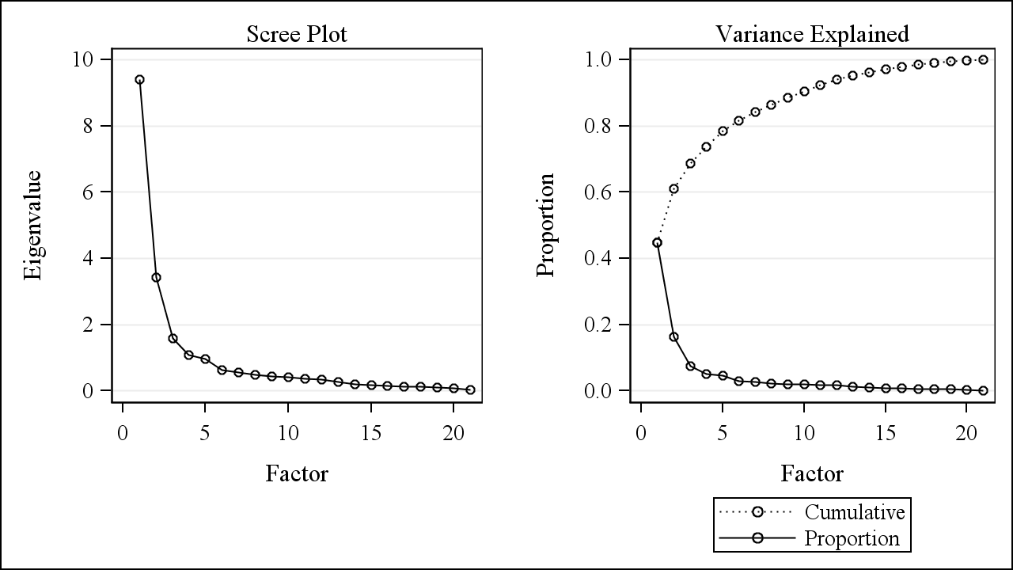

### Table C1: Factor loadings (with varimax rotation) and variance explained for 5 factors kept in the Full variables factor analysis (N=64928). (PC3) for Census 2000

**Highlighted values are loadings greater than 0.60 (if rounded to 2 decimal places)**

| **Variable** | **Factor1** | **Factor2** | **Factor3** | **Factor4** | **Factor5** |
| --- | --- | --- | --- | --- | --- |
| Educ_minBA_rev | 0.91138 | 0.02698 | 0.06332 | 0.11535 | -0.19600 |
| Occup_I_rev | 0.90698 | 0.09459 | 0.09846 | 0.11112 | -0.08669 |
| inc_IntDivRent_rev | 0.76857 | 0.19505 | 0.44369 | 0.12886 | 0.16553 |
| HUcost_medownval_cbrt | -0.71883 | 0.29267 | -0.15233 | -0.11747 | -0.11774 |
| inc_HHge50k_rev | 0.71176 | -0.02910 | 0.28885 | 0.51030 | 0.18366 |
| inc_medHH_cbrt | -0.70347 | 0.03027 | -0.34434 | -0.49272 | -0.18357 |
| Educ_minHS_rev | 0.68358 | 0.37734 | 0.28705 | 0.33839 | -0.19204 |
| phone_none_cbrt | 0.62665 | -0.01975 | 0.23002 | 0.42258 | 0.08494 |
| birth_foreign_cbrt | -0.22790 | 0.90290 | 0.07270 | -0.02748 | 0.10043 |
| race_hisp_cbrt | 0.19944 | 0.88026 | -0.02290 | 0.02106 | 0.12099 |
| crowd_gt1_ppr_cbrt | 0.40769 | 0.74310 | 0.25202 | 0.10255 | 0.10128 |
| race_blackNH_cbrt | 0.16563 | -0.04700 | 0.87119 | -0.07369 | 0.09385 |
| vehicle_none_cbrt | 0.21750 | 0.24149 | 0.65645 | 0.47318 | 0.04584 |
| HU_sampleocc_rev_cbrt | 0.27558 | -0.28483 | -0.09688 | 0.69798 | 0.22083 |
| NotInLaborForce | 0.21406 | 0.07366 | 0.21572 | 0.69188 | -0.40507 |
| samehouse_rev_cbrt | -0.04446 | 0.24142 | 0.09009 | 0.00825 | 0.85897 |
| ownerocc_hh_rev | 0.15527 | 0.28769 | 0.43964 | 0.48765 | 0.55000 |
| Pov_cbrt | 0.53212 | 0.18823 | 0.48754 | 0.51536 | 0.15132 |
| Unemployed_cbrt | 0.42164 | 0.19848 | 0.52753 | 0.33041 | 0.00743 |
| inc_pubass_cbrt | 0.51852 | 0.25288 | 0.44497 | 0.31659 | -0.04022 |
| race_asianNH_cbrt | -0.51797 | 0.58754 | 0.11447 | -0.18971 | 0.18585 |
|  |  |  |  |  |  |
| Eigenvalue | 9.40730182 | 3.42090246 | 1.57991402 | 1.09268176 | 0.97190969 |
| Difference | 5.98639936 | 1.84098844 | 0.48723225 | 0.12077208 | 0.33615865 |
| Variance Explained | 44.80% | 16.29% | 7.52% | 5.20% | 4.63% |
| Cumulative Variance Explained | 44.80% | 61.09% | 68.61% | 73.81% | 78.44% |
| Variance (Eigenvalue) explained after rotation | 6.1007112 | 3.1922929 | 2.8147053 | 2.8080994 | 1.5569010 |

### Figure C2. Scree Plot and Variance explained plot for the Race/Ethnicity/Crowding variables PCA (PC1) for Census 2000

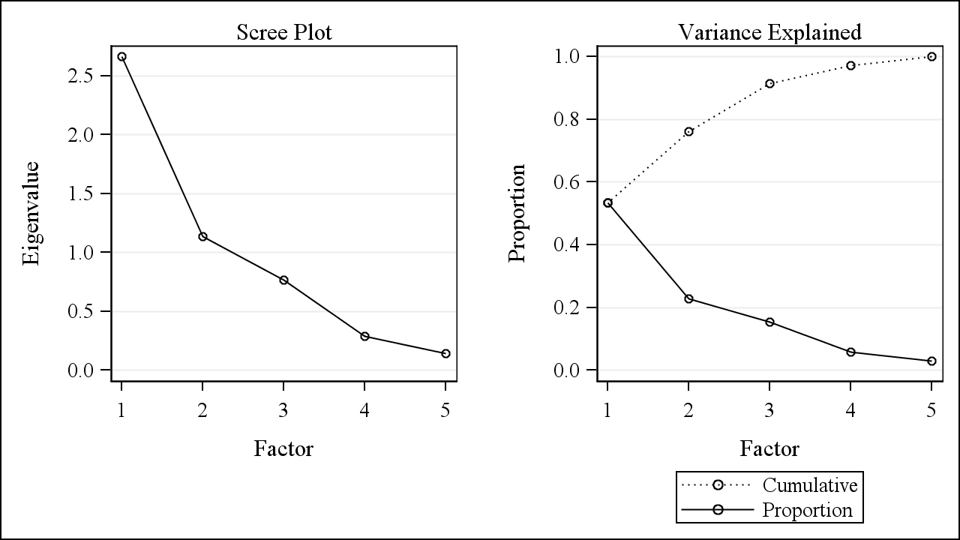

### Table C2: Factor loadings (with varimax rotation) and variance explained for 2 factors kept in the Race/Ethnicity/Crowding variables factor analysis (N=64960). (PC1) for Census 2000

**Highlighted values are loadings greater than 0.60 (if rounded to 2 decimal places)**

| **Variable** | **Factor1** | **Factor2** |
| --- | --- | --- |
| birth_foreign_cbrt | 0.94033 | 0.01601 |
| race_hisp_cbrt | 0.83548 | 0.25496 |
| race_asianNH_cbrt | 0.73108 | -0.28951 |
| crowd_gt1_ppr_cbrt | 0.67531 | 0.56069 |
| race_blackNH_cbrt | -0.04301 | 0.87284 |
|  |  |  |
| Eigenvalue | 2.66349162 | 1.13642995 |
| Difference | 1.52706167 | 0.37138927 |
| Variance Explained | 53.27% | 22.73% |
| Cumulative Variance Explained | 53.27% | 76.00% |
| Variance (Eigenvalue) explained after rotation | 2.5746217 | 1.2252998 |

### Figure C3. Scree Plot and Variance explained plot for the Other SES variables PCA (PC2) for Census 2000

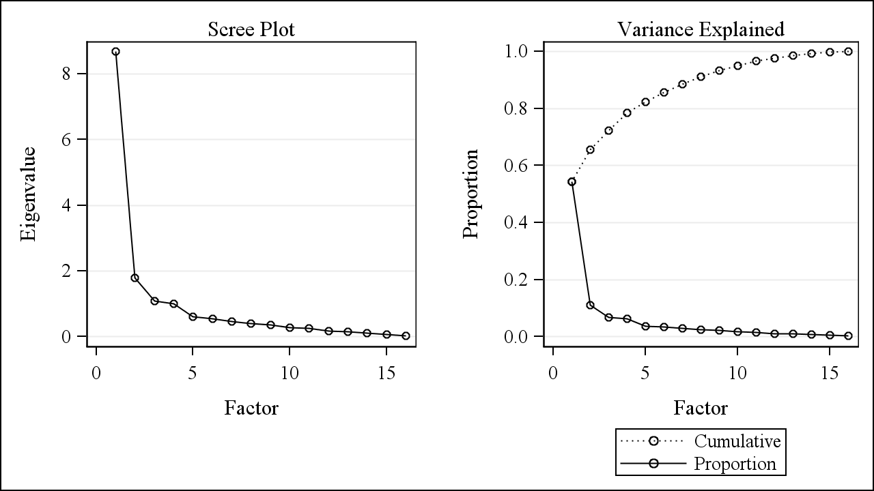

### Table C3: Factor loadings (with varimax rotation) and variance explained for 4 factors kept in the Other SES variables factor analysis (N=64928). (PC2) for Census 2000

**Highlighted values are loadings greater than 0.60 (if rounded to 2 decimal places)**

| **Variable** | **Factor1** | **Factor2** | **Factor3** | **Factor4** |
| --- | --- | --- | --- | --- |
| Educ_minBA_rev | 0.88602 | 0.23828 | 0.07820 | -0.21633 |
| Occup_I_rev | 0.87947 | 0.28665 | 0.04592 | -0.09202 |
| HUcost_medownval_cbrt | -0.73949 | -0.05466 | -0.33983 | -0.04854 |
| inc_IntDivRent_rev | 0.72433 | 0.51986 | 0.03871 | 0.20885 |
| inc_HHge50k_rev | 0.64602 | 0.51982 | 0.42024 | 0.13744 |
| inc_medHH_cbrt | -0.64082 | -0.54792 | -0.39528 | -0.14749 |
| vehicle_none_cbrt | 0.13402 | 0.85073 | 0.11190 | 0.11844 |
| Pov_cbrt | 0.43427 | 0.74700 | 0.27487 | 0.16582 |
| Unemployed_cbrt | 0.34215 | 0.70168 | 0.06108 | 0.06361 |
| inc_pubass_cbrt | 0.43990 | 0.68705 | 0.01349 | 0.01500 |
| ownerocc_hh_rev | 0.07682 | 0.65507 | 0.27448 | 0.57462 |
| Educ_minHS_rev | 0.58502 | 0.65032 | 0.03601 | -0.15235 |
| HU_sampleocc_rev_cbrt | 0.19991 | 0.10633 | 0.87832 | 0.03976 |
| samehouse_rev_cbrt | -0.05581 | 0.10725 | 0.02156 | 0.88584 |
| NotInLaborForce | 0.10883 | 0.58404 | 0.42269 | -0.45507 |
| phone_none_cbrt | 0.55188 | 0.42939 | 0.37074 | 0.03838 |
|  |  |  |  |  |
| Eigenvalue | 8.68522198 | 1.78876618 | 1.07763072 | 1.01086444 |
| Difference | 6.89645581 | 0.71113545 | 0.06676628 | 0.40787501 |
| Variance Explained | 54.28% | 11.18% | 6.74% | 6.32% |
| Cumulative Variance Explained | 54.28% | 65.46% | 72.20% | 78.52% |
| Variance (Eigenvalue) explained after rotation | 4.6827650 | 4.6290741 | 1.7147165 | 1.5359277 |

**ACS2005-2009**

### Figure C4. Scree Plot and Variance explained plot for the Full variables PCA (PC3) for ACS2005-2009

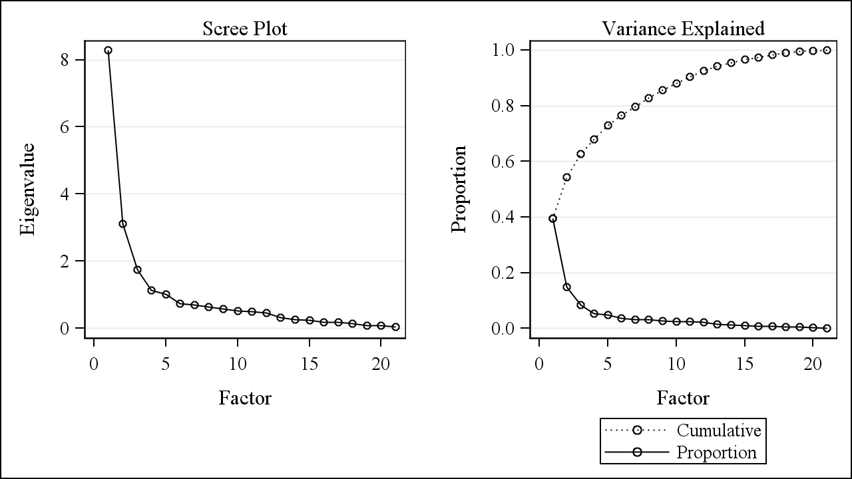

### Table C4: Factor loadings (with varimax rotation) and variance explained for 5 factors kept in the Full variables factor analysis (N=64074). (PC3) for ACS2005-2009

**Highlighted values are loadings greater than 0.60 (if rounded to 2 decimal places)**

| **Variable** | **Factor1** | **Factor2** | **Factor3** | **Factor4** | **Factor5** |
| --- | --- | --- | --- | --- | --- |
| Educ_minBA_rev | 0.91376 | 0.01961 | 0.01255 | 0.17867 | 0.13981 |
| Occup_I_rev | 0.87327 | 0.12400 | 0.10954 | 0.19442 | 0.11013 |
| HUcost_medownval_cbrt | -0.71715 | 0.45905 | -0.26339 | -0.05700 | -0.04548 |
| inc_IntDivRent_rev | 0.69360 | 0.17833 | 0.35702 | 0.42366 | -0.01074 |
| Educ_minHS_rev | 0.65950 | 0.42120 | 0.10533 | 0.26196 | 0.31272 |
| inc_medHH_cbrt | -0.64471 | 0.05930 | -0.47828 | -0.33950 | -0.36207 |
| inc_HHge50k_rev | 0.61878 | -0.04911 | 0.47712 | 0.34050 | 0.40799 |
| birth_foreign_cbrt | -0.24614 | 0.88733 | 0.03338 | 0.06282 | -0.07135 |
| race_hisp_cbrt | 0.16374 | 0.85874 | 0.11818 | -0.05203 | -0.07520 |
| crowd_gt1_ppr_cbrt | 0.37885 | 0.67240 | 0.13158 | 0.14463 | 0.03819 |
| samehouse_rev_cbrt | 0.00589 | 0.14711 | 0.76954 | 0.16401 | -0.13850 |
| ownerocc_hh_rev | 0.05276 | 0.27443 | 0.71291 | 0.35729 | 0.35476 |
| phone_none_cbrt | 0.31402 | -0.02920 | 0.65564 | 0.11239 | 0.01361 |
| race_blackNH_cbrt | 0.04169 | -0.06187 | 0.22215 | 0.76842 | -0.06894 |
| Unemployed_cbrt | 0.33962 | 0.03454 | 0.06993 | 0.66700 | 0.10577 |
| NotInLaborForce | 0.19072 | -0.09961 | -0.12152 | 0.13069 | 0.82148 |
| Pov_cbrt | 0.45936 | 0.10263 | 0.49561 | 0.43636 | 0.37135 |
| vehicle_none_cbrt | 0.05795 | 0.19892 | 0.35832 | 0.58674 | 0.40356 |
| HU_sampleocc_rev_cbrt | 0.18688 | -0.19013 | 0.43884 | -0.04651 | 0.54784 |
| inc_pubass_cbrt | 0.36013 | 0.11536 | 0.07669 | 0.51598 | 0.11027 |
| race_asianNH_cbrt | -0.55473 | 0.52491 | -0.03116 | 0.08110 | -0.16619 |
|  |  |  |  |  |  |
| Eigenvalue | 8.28786184 | 3.11718312 | 1.74896678 | 1.13732680 | 1.02283668 |
| Difference | 5.17067871 | 1.36821634 | 0.61163998 | 0.11449012 | 0.27517632 |
| Variance Explained | 39.47% | 14.84% | 8.33% | 5.42% | 4.87% |
| Cumulative Variance Explained | 39.47% | 54.31% | 62.64% | 68.05% | 72.92% |
| Variance (Eigenvalue) explained after rotation | 4.9989576 | 2.9063842 | 2.8816365 | 2.6091322 | 1.9180647 |

### Figure C5. Scree Plot and Variance explained plot for the Race/Ethnicity/Crowding variables PCA (PC1) for ACS2005-2009

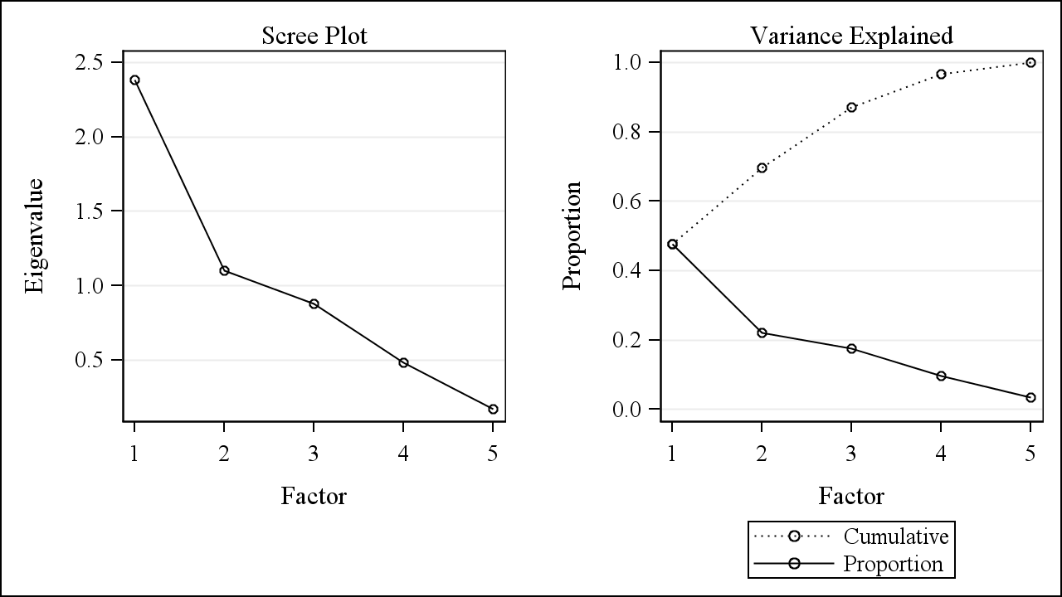

### Table C5: Factor loadings (with varimax rotation) and variance explained for 2 factors kept in the Race/Ethnicity/Crowding variables factor analysis (N=64915). (PC1) for ACS2005-2009

**Highlighted values are loadings greater than 0.60 (if rounded to 2 decimal places)**

| **Variable** | **Factor1** | **Factor2** |
| --- | --- | --- |
| birth_foreign_cbrt | 0.92888 | -0.02707 |
| race_hisp_cbrt | 0.82992 | 0.19799 |
| race_asianNH_cbrt | 0.66946 | -0.41198 |
| crowd_gt1_ppr_cbrt | 0.59992 | 0.51780 |
| race_blackNH_cbrt | -0.01816 | 0.80010 |
|  |  |  |
| Eigenvalue | 2.38014680 | 1.09778906 |
| Difference | 1.28235774 | 0.22299074 |
| Variance Explained | 47.60% | 21.96% |
| Cumulative Variance Explained | 47.60% | 69.56% |
| Variance (Eigenvalue) explained after rotation | 2.3599981 | 1.1179378 |

### Figure C6. Scree Plot and Variance explained plot for the Other SES variables PCA (PC2) for ACS2005-2009

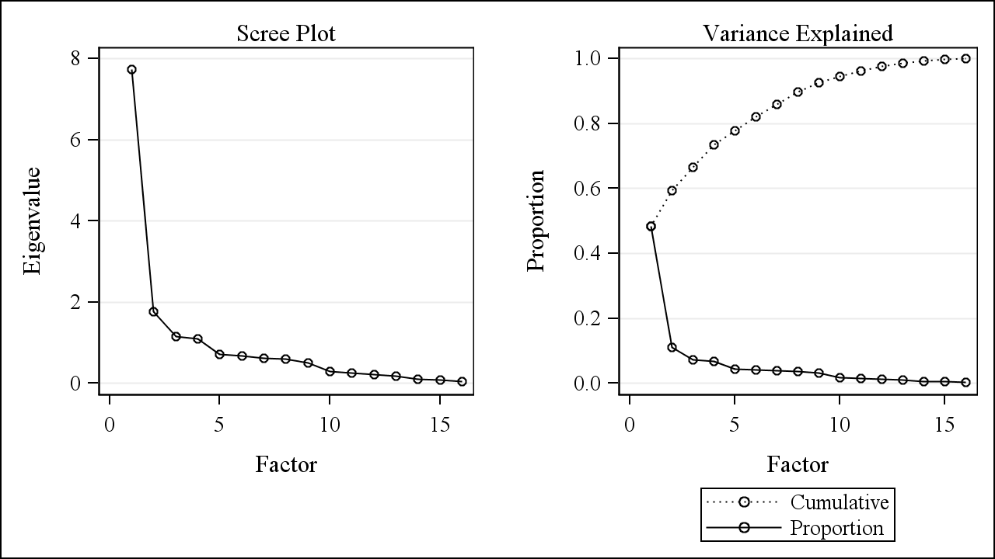

### Table C6: Factor loadings (with varimax rotation) and variance explained for 4 factors kept in the Other SES variables factor analysis (N=64074). (PC2) for ACS2005-2009

**Highlighted values are loadings greater than 0.60 (if rounded to 2 decimal places)**

| **Variable** | **Factor1** | **Factor2** | **Factor3** | **Factor4** |
| --- | --- | --- | --- | --- |
| Educ_minBA_rev | 0.85827 | 0.37279 | -0.05561 | 0.11926 |
| HUcost_medownval_cbrt | -0.83281 | 0.09031 | -0.19356 | -0.24796 |
| Occup_I_rev | 0.80707 | 0.42264 | 0.04927 | 0.06331 |
| inc_IntDivRent_rev | 0.64861 | 0.51163 | 0.34626 | -0.03024 |
| inc_medHH_cbrt | -0.61844 | -0.44281 | -0.41795 | -0.38059 |
| vehicle_none_cbrt | -0.06488 | 0.71067 | 0.37681 | 0.26348 |
| inc_pubass_cbrt | 0.24956 | 0.64212 | 0.10045 | -0.02187 |
| Educ_minHS_rev | 0.49479 | 0.63992 | 0.05344 | 0.15680 |
| Unemployed_cbrt | 0.27591 | 0.60629 | 0.12245 | 0.07270 |
| samehouse_rev_cbrt | 0.02918 | 0.13759 | 0.79304 | -0.10121 |
| ownerocc_hh_rev | -0.02791 | 0.50940 | 0.70647 | 0.27976 |
| phone_none_cbrt | 0.35470 | 0.10446 | 0.63241 | 0.08988 |
| NotInLaborForce | 0.12387 | 0.27354 | -0.21427 | 0.80206 |
| HU_sampleocc_rev_cbrt | 0.21891 | -0.04497 | 0.35385 | 0.68332 |
| inc_HHge50k_rev | 0.58322 | 0.45798 | 0.41470 | 0.41872 |
| Pov_cbrt | 0.38561 | 0.56637 | 0.46586 | 0.33575 |
|  |  |  |  |  |
| Eigenvalue | 7.73706328 | 1.76022188 | 1.15047207 | 1.09439226 |
| Difference | 5.97684140 | 0.60974981 | 0.05607981 | 0.38367857 |
| Variance Explained | 48.36% | 11.00% | 7.19% | 6.84% |
| Cumulative Variance Explained | 48.36% | 59.36% | 66.55% | 73.39% |
| Variance (Eigenvalue) explained after rotation | 3.9517377 | 3.3747376 | 2.5955676 | 1.8201066 |

# APPENDIX D: RESULTS FROM ADDITIONAL METHODS

### Figure D1: Scree Plot and Variance explained plot for the ML factor analysis with all 21 variables for Census 2000

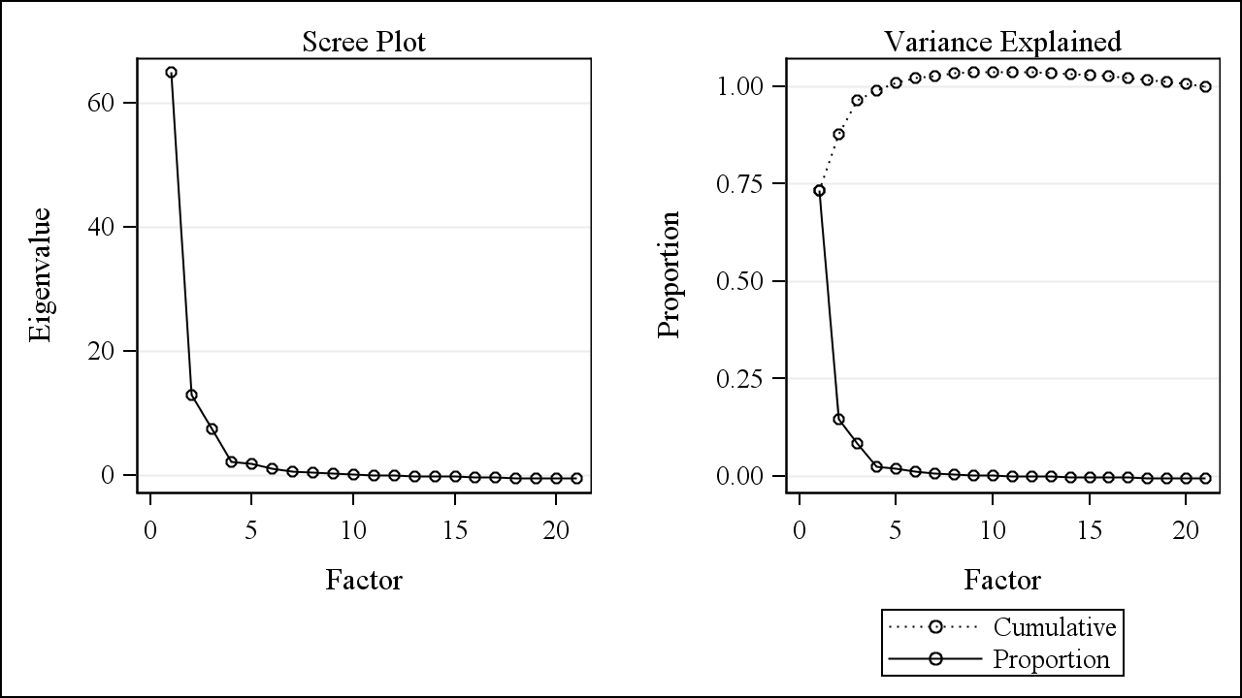

### Table D1: Factor loadings (with promax rotation) and variance explained for ML factor analysis with all 21 variables for Census 2000 (N=64928).

**Highlighted values are loadings greater than 0.50 (if rounded to 2 decimal places)**

| **Variable** | **Factor1** | **Factor2** | **Factor3** | **Factor4** | **Factor5** |
| --- | --- | --- | --- | --- | --- |
| Educ_minBA_rev | 1.01873893 | -0.058041 | 0.04500622 | -0.0712581 | -0.1452688 |
| Occup_I_rev | 0.98697026 | -0.0474838 | 0.10290125 | -0.0501685 | -0.04597 |
| inc_IntDivRent_rev | 0.60255008 | 0.04644692 | 0.04211793 | 0.39208256 | 0.18925345 |
| HUcost_medownval_cbrt | -0.5782566 | -0.1958434 | 0.26576477 | 0.0522774 | -0.125273 |
| NotInLaborForce | -0.0769694 | 0.82354458 | 0.02786619 | -0.0994975 | -0.4529391 |
| Pov_cbrt | 0.08689422 | 0.68509154 | 0.00447124 | 0.26340617 | 0.05436774 |
| vehicle_none_cbrt | -0.1341716 | 0.67625021 | 0.11565299 | 0.23951968 | 0.0124354 |
| inc_HHge50k_rev | 0.46321949 | 0.67079702 | -0.058705 | -0.1631013 | 0.17272454 |
| inc_medHH_cbrt | -0.4375943 | -0.6608455 | 0.08142375 | 0.09822916 | -0.1796191 |
| ownerocc_hh_rev | -0.1010998 | 0.55292967 | 0.20105235 | 0.09745239 | 0.42635044 |
| birth_foreign_cbrt | -0.1609035 | 0.03002224 | 0.99230354 | -0.1570156 | 0.08297137 |
| race_hisp_cbrt | 0.19861033 | -0.0287747 | 0.84979829 | -0.056408 | 0.06160327 |
| crowd_gt1_ppr_cbrt | 0.28834078 | 0.05899099 | 0.60883043 | 0.20638128 | 0.0632757 |
| race_asianNH_cbrt | -0.3627016 | -0.1290957 | 0.60386456 | -0.0580319 | 0.21451337 |
| race_blackNH_cbrt | -0.0834283 | 0.04432822 | -0.2122335 | 0.72423269 | 0.12378301 |
| samehouse_rev_cbrt | -0.0513659 | -0.0776124 | 0.19469815 | 0.08703966 | 0.64008191 |
| Educ_minHS_rev | 0.42446678 | 0.37585625 | 0.26417995 | 0.17593833 | -0.2657944 |
| HU_sampleocc_rev_cbrt | 0.07853826 | 0.46108066 | -0.2991251 | -0.0163836 | 0.01608545 |
| inc_pubass_cbrt | 0.24315278 | 0.35978825 | 0.08270724 | 0.29207588 | -0.0675082 |
| phone_none_cbrt | 0.29761702 | 0.3922548 | -0.1629254 | 0.24454574 | -0.0352977 |
| Unemployed_cbrt | 0.10087298 | 0.40597716 | 0.01993927 | 0.36415534 | -0.0453264 |
|  |  |  |  |  |  |
| Eigenvalue | 64.9660983 | 12.8772665 | 7.5040250 | 2.2478065 | 1.8158513 |
| Difference | 52.0888318 | 5.3732415 | 5.2562184 | 0.4319553 | 0.7986510 |
| Variance Explained | 73.30% | 14.53% | 8.47% | 2.54% | 2.05% |
| Cumulative Variance Explained | 73.30% | 87.83% | 96.30% | 98.84% | 100.89% |
| Variance Explained (Eigenvalue) Eliminating other factors – Weighted | 23.6820337 | 17.1653821 | 15.3100136 | 2.8566604 | 4.5329421 |
| Variance Explained (Eigenvalue) Eliminating other factors – Unweighted | 2.03668305 | 1.78409966 | 2.16290984 | 0.66114052 | 0.96402535 |
| Variance Explained (Eigenvalue) Ignoring other factors – Weighted | 78.1711165 | 76.7265676 | 20.7403326 | 34.2730490 | 10.8357153 |
| Variance Explained (Eigenvalue) Ignoring other factors – Unweighted | 7.26346117 | 7.66724190 | 3.24312430 | 5.08982471 | 1.52408822 |

### Figure D2: Scree Plot and Variance explained plot for the ML factor analysis with all 21 variables for ACS2005-2009

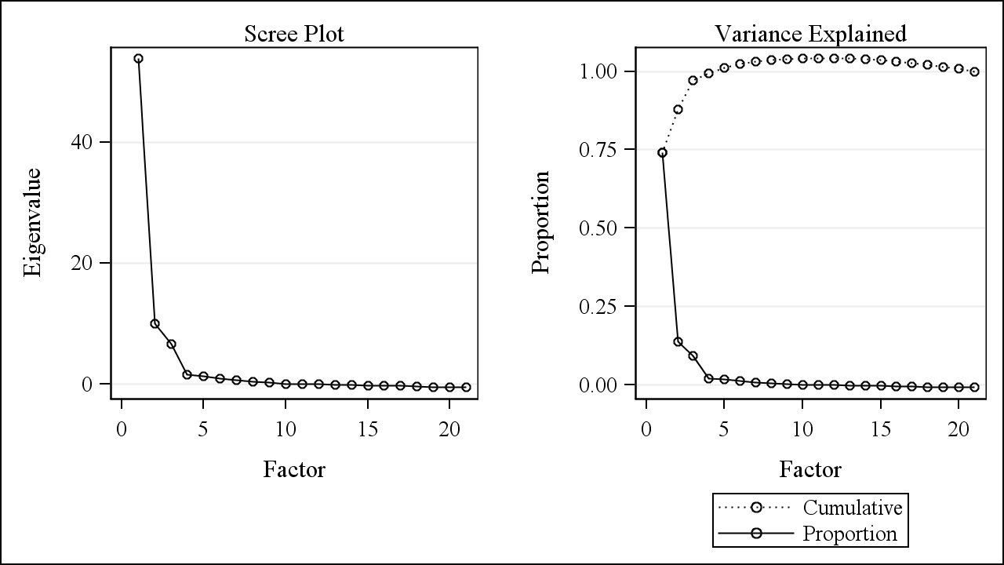

### Table D2: Factor loadings (with promax rotation) and variance explained for ML factor analysis with all 21 variables for ACS2005-2009 (N=64074).

**Highlighted values are loadings greater than 0.50 (if rounded to 2 decimal places)**

| **Variable** | **Factor1** | **Factor2** | **Factor3** | **Factor4** | **Factor5** |
| --- | --- | --- | --- | --- | --- |
| Educ_minBA_rev | 1.06950244 | -0.2265095 | -0.0608411 | 0.03497152 | 0.04760037 |
| Occup_I_rev | 0.96538849 | -0.0871479 | 0.06105098 | 0.01731564 | 0.03299144 |
| inc_IntDivRent_rev | 0.73182513 | 0.36143975 | 0.03316514 | -0.2552186 | 0.28016808 |
| Educ_minHS_rev | 0.65783875 | -0.0259181 | 0.3336323 | 0.23157486 | 0.0608129 |
| HUcost_medownval_cbrt | -0.4990277 | -0.3378717 | 0.36202522 | 0.08638787 | 0.22624968 |
| samehouse_rev_cbrt | -0.1723894 | 0.7834459 | 0.15616775 | -0.2554845 | 0.04710336 |
| ownerocc_hh_rev | -0.1522422 | 0.71463991 | 0.17030751 | 0.15564029 | 0.26987082 |
| phone_none_cbrt | 0.11909494 | 0.56299589 | -0.0428523 | -0.1198582 | 0.0742288 |
| inc_HHge50k_rev | 0.30186327 | 0.54643166 | -0.032127 | 0.32844749 | -0.0651483 |
| inc_medHH_cbrt | -0.3670068 | -0.5435602 | 0.0596262 | -0.2434045 | 0.03302188 |
| Pov_cbrt | 0.21403942 | 0.54298298 | 0.0254114 | 0.23263007 | 0.14452283 |
| birth_foreign_cbrt | -0.1226502 | 0.04562173 | 0.95907282 | -0.007769 | -0.0840605 |
| race_hisp_cbrt | 0.23299261 | 0.06989379 | 0.91443319 | -0.0921515 | -0.1976355 |
| race_asianNH_cbrt | -0.3983651 | 0.04258175 | 0.50817401 | -0.0766709 | 0.03308664 |
| crowd_gt1_ppr_cbrt | 0.4488093 | 0.02090574 | 0.49991458 | -0.0307021 | 0.11722046 |
| NotInLaborForce | 0.05794865 | -0.1963654 | -0.0897244 | 0.74868071 | -0.0822009 |
| race_blackNH_cbrt | 0.13700907 | 0.35795923 | -0.1990109 | -0.1922486 | 0.52105044 |
| HU_sampleocc_rev_cbrt | 0.04129576 | 0.26905421 | -0.2162724 | 0.21177306 | 0.08718808 |
| inc_pubass_cbrt | 0.36528975 | 0.09870126 | -0.0250564 | 0.08631836 | 0.26126625 |
| Unemployed_cbrt | 0.36878068 | 0.12904466 | -0.099476 | 0.06923577 | 0.34592256 |
| vehicle_none_cbrt | -0.0290098 | 0.36904236 | 0.02867157 | 0.31621131 | 0.41133992 |
|  |  |  |  |  |  |
| Eigenvalue | 53.8484533 | 10.0272144 | 6.6839348 | 1.5873863 | 1.2721567 |
| Difference | 43.8212389 | 3.3432796 | 5.0965485 | 0.3152296 | 0.3889925 |
| Variance Explained | 74.13% | 13.80% | 9.20% | 2.19% | 1.75% |
| Cumulative Variance Explained | 74.13% | 87.93% | 97.13% | 99.32% | 101.07% |
| Variance Explained (Eigenvalue) Eliminating other factors – Weighted | 23.4681039 | 13.3870374 | 8.9082814 | 4.7576715 | 1.7907403 |
| Variance Explained (Eigenvalue) Eliminating other factors – Unweighted | 2.56849684 | 1.68586973 | 1.90053412 | 0.78213148 | 0.61560574 |
| Variance Explained (Eigenvalue) Ignoring other factors – Weighted | 68.5107834 | 61.6530869 | 13.2605865 | 41.3600831 | 6.5215747 |
| Variance Explained (Eigenvalue) Ignoring other factors – Unweighted | 6.55911552 | 6.16203296 | 2.75135764 | 4.03144374 | 1.81735468 |

### Figure D3: Scree Plot and Variance explained plot for the ML factor analysis with all 21 variables for Census 2000+ACS2005-2009 combined

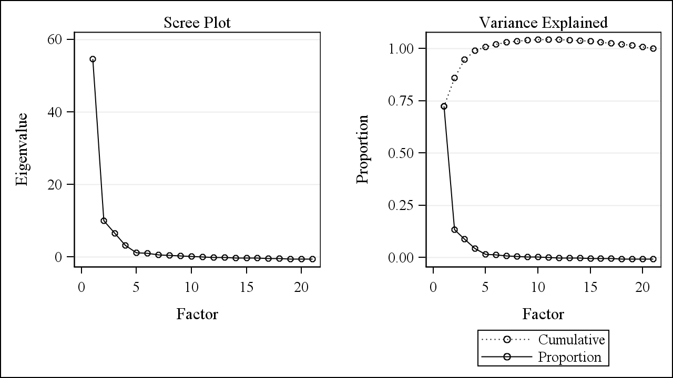

### Table D3: Factor loadings (with promax rotation) and variance explained for ML factor analysis with all 21 variables for Census 2000+ACS2005-2009 (N=129002).

**Highlighted values are loadings greater than 0.50 (if rounded to 2 decimal places)**

| **Variable** | **Factor1** | **Factor2** | **Factor3** | **Factor4** | **Factor5** |
| --- | --- | --- | --- | --- | --- |
| ownerocc_hh_rev | 0.82632302 | -0.2532159 | 0.16692676 | 0.25468432 | -0.0753647 |
| inc_IntDivRent_rev | 0.75247593 | 0.47169592 | 0.05713165 | -0.2810485 | -0.2539475 |
| Pov_cbrt | 0.73970832 | 0.09250362 | 0.00200221 | 0.04757557 | 0.14480371 |
| phone_none_cbrt | 0.66452996 | 0.14348581 | -0.1318548 | -0.1523335 | -0.0570263 |
| vehicle_none_cbrt | 0.61429759 | -0.124348 | 0.13780851 | 0.11140525 | 0.19880049 |
| race_blackNH_cbrt | 0.59347724 | -0.0518386 | -0.0161415 | -0.0550079 | -0.0932655 |
| Unemployed_cbrt | 0.56619388 | 0.16046431 | 0.03997621 | -0.212635 | 0.10516296 |
| Educ_minBA_rev | -0.1231489 | 1.03925636 | -0.0169359 | -0.0457451 | 0.02144241 |
| Occup_I_rev | 0.00452714 | 0.95884368 | 0.0589593 | -0.0135681 | -0.0510677 |
| Educ_minHS_rev | 0.11984389 | 0.57685811 | 0.31357161 | -0.0354331 | 0.29205648 |
| HUcost_medownval_cbrt | 0.03025376 | -0.5427993 | 0.35670567 | -0.4119127 | 0.08186055 |
| birth_foreign_cbrt | 0.02102107 | -0.1263978 | 0.91317139 | 0.01957649 | 0.01028077 |
| race_hisp_cbrt | 0.01659609 | 0.24103076 | 0.811658 | 0.00217898 | -0.0367754 |
| crowd_gt1_ppr_cbrt | 0.02892572 | 0.39007236 | 0.596359 | 0.1892252 | 0.00590153 |
| race_asianNH_cbrt | -0.0577949 | -0.3758872 | 0.57015391 | 0.13653685 | -0.0704453 |
| samehouse_rev_cbrt | -0.1459315 | -0.021489 | 0.16878146 | 0.80146674 | -0.1376295 |
| NotInLaborForce | 0.0070097 | 0.03513462 | -0.075624 | -0.179114 | 0.86114584 |
| HU_sampleocc_rev_cbrt | 0.46339352 | -0.0275258 | -0.3034465 | -0.0891045 | 0.12930061 |
| inc_HHge50k_rev | 0.4119055 | 0.34173676 | -0.1459091 | 0.38676445 | 0.10241289 |
| inc_medHH_cbrt | -0.4294563 | -0.3612192 | 0.15435162 | -0.3909479 | -0.0571648 |
| inc_pubass_cbrt | 0.24367579 | 0.31304478 | 0.11750729 | 0.10338392 | 0.10385788 |
|  |  |  |  |  |  |
| Eigenvalue | 54.5973441 | 10.1210131 | 6.6072946 | 3.2818872 | 1.2504225 |
| Difference | 44.4763309 | 3.5137185 | 3.3254075 | 2.0314646 | 0.2063010 |
| Variance Explained | 72.52% | 13.44% | 8.78% | 4.36% | 1.66% |
| Cumulative Variance Explained | 72.52% | 85.96% | 94.74% | 99.10% | 100.76% |
| Variance Explained (Eigenvalue) Eliminating other factors – Weighted | 11.6576273 | 22.2554463 | 11.6286759 | 8.0764172 | 2.4674914 |
| Variance Explained (Eigenvalue) Eliminating other factors – Unweighted | 2.08168217 | 2.22244314 | 2.50317277 | 1.07821678 | 0.68126234 |
| Variance Explained (Eigenvalue) Ignoring other factors – Weighted | 58.1579576 | 65.7142724 | 12.5830818 | 33.1468007 | 32.2476489 |
| Variance Explained (Eigenvalue) Ignoring other factors – Unweighted | 6.87264374 | 6.48346141 | 2.73455902 | 2.99848040 | 3.60831698 |

### Figure D4: Scree Plot and Variance explained plot for the ML factor analysis with % occupied housing and % receiving public assistance removed for Census 2000

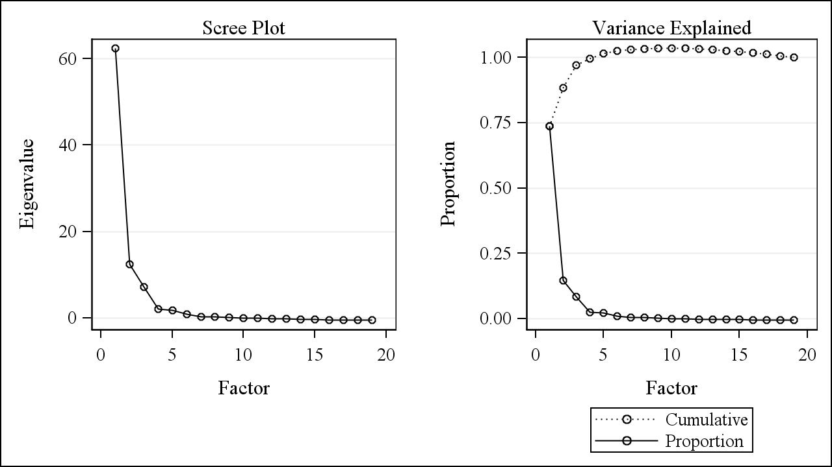

### Table D4: Factor loadings (with promax rotation) and variance explained for ML factor analysis with % occupied housing and % receiving public assistance removed for Census 2000 (N=64928).

**Highlighted values are loadings greater than 0.50 (if rounded to 2 decimal places)**

| **Variable** | **Factor1** | **Factor2** | **Factor3** | **Factor4** | **Factor5** |
| --- | --- | --- | --- | --- | --- |
| Educ_minBA_rev | 1.03559571 | -0.0761189 | 0.06393617 | -0.0773452 | -0.1538926 |
| Occup_I_rev | 1.00332043 | -0.0689602 | 0.11927066 | -0.0568541 | -0.0550741 |
| inc_IntDivRent_rev | 0.61020953 | 0.04766204 | 0.06117621 | 0.37887866 | 0.17799166 |
| HUcost_medownval_cbrt | -0.5991516 | -0.1507016 | 0.27163303 | 0.04321813 | -0.1227882 |
| inc_HHge50k_rev | 0.50499059 | 0.6031115 | -0.0825883 | -0.1654518 | 0.19827138 |
| NotInLaborForce | -0.0670341 | 0.8566242 | 0.01328222 | -0.10631 | -0.4438178 |
| vehicle_none_cbrt | -0.1157051 | 0.70063489 | 0.10975023 | 0.19251769 | 0.03428017 |
| Pov_cbrt | 0.11908192 | 0.68804319 | 0.00743365 | 0.21466784 | 0.07479331 |
| inc_medHH_cbrt | -0.4789764 | -0.6061316 | 0.10133299 | 0.11454349 | -0.2069529 |
| ownerocc_hh_rev | -0.0741762 | 0.5161619 | 0.18211965 | 0.0722669 | 0.45727206 |
| birth_foreign_cbrt | -0.1907762 | 0.06288585 | 0.96532967 | -0.146175 | 0.09266098 |
| race_hisp_cbrt | 0.17544309 | 0.00347088 | 0.84498818 | -0.0556164 | 0.05824304 |
| crowd_gt1_ppr_cbrt | 0.28254501 | 0.09631805 | 0.62372783 | 0.1728906 | 0.0633422 |
| race_asianNH_cbrt | -0.3809592 | -0.1110252 | 0.58867934 | -0.0689789 | 0.2307247 |
| race_blackNH_cbrt | -0.0941206 | 0.1006688 | -0.1857812 | 0.69247427 | 0.10444637 |
| samehouse_rev_cbrt | -0.0451254 | -0.1230881 | 0.1850729 | 0.08195218 | 0.64953029 |
| Educ_minHS_rev | 0.4151433 | 0.43248713 | 0.2758749 | 0.16397232 | -0.2887878 |
| phone_none_cbrt | 0.3235964 | 0.39005557 | -0.1466343 | 0.21556887 | -0.0327832 |
| Unemployed_cbrt | 0.12393031 | 0.43572199 | 0.04129586 | 0.30132221 | -0.0326977 |
|  |  |  |  |  |  |
| Eigenvalue | 62.4384950 | 12.4282335 | 7.2143739 | 2.0651562 | 1.7708431 |
| Difference | 50.0102615 | 5.2138596 | 5.1492176 | 0.2943131 | 0.9280697 |
| Variance Explained | 73.83% | 14.70% | 8.53% | 2.44% | 2.09% |
| Cumulative Variance Explained | 73.83% | 88.53% | 97.06% | 99.50% | 101.59% |
| Variance Explained (Eigenvalue) Eliminating other factors – Weighted | 25.2284911 | 15.1392917 | 14.8820917 | 2.8134925 | 5.1132707 |
| Variance Explained (Eigenvalue) Eliminating other factors – Unweighted | 2.08241895 | 1.60273121 | 2.17782578 | 0.58868633 | 0.97446934 |
| Variance Explained (Eigenvalue) Ignoring other factors – Weighted | 80.0271408 | 75.1144341 | 19.0923580 | 29.6737480 | 14.5280289 |
| Variance Explained (Eigenvalue) Ignoring other factors – Unweighted | 6.91214896 | 6.98295642 | 3.04287635 | 4.17137806 | 1.81954091 |

### Figure D5: Scree Plot and Variance explained plot for the ML factor analysis with % occupied housing and % receiving public assistance removed for ACS2005-2009

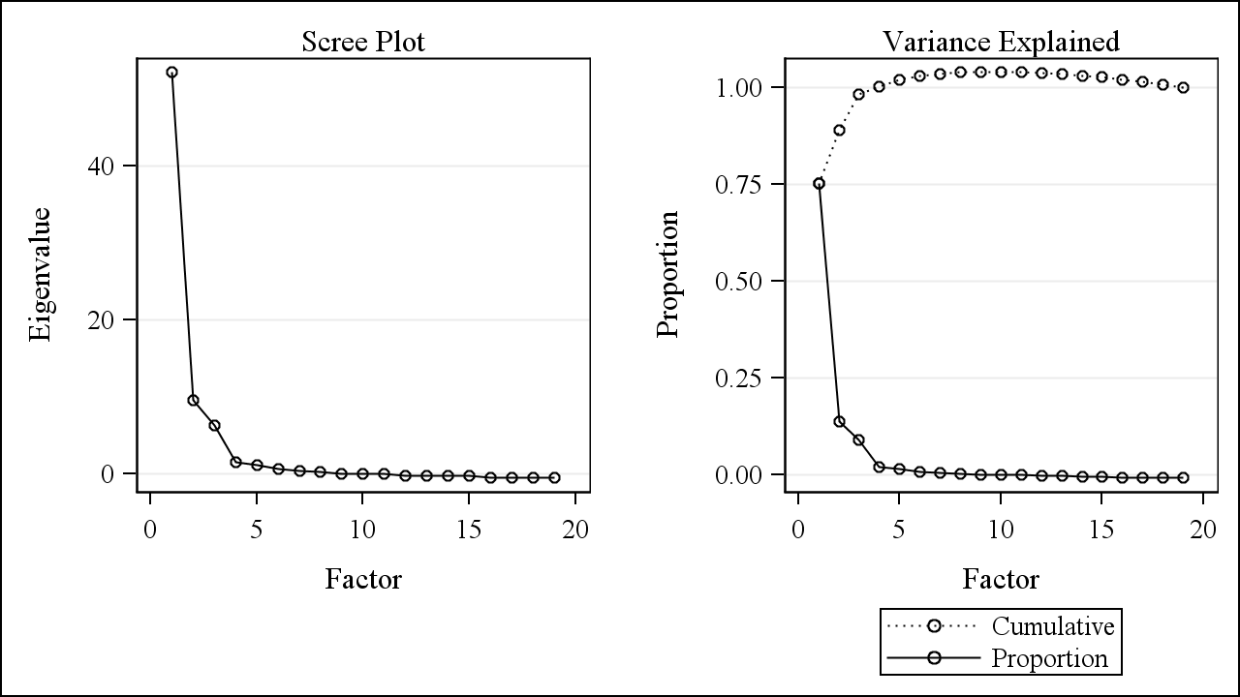

### Table D5: Factor loadings (with promax rotation) and variance explained for ML factor analysis with % occupied housing and % receiving public assistance removed for ACS2005-2009 (N=64074).

**Highlighted values are loadings greater than 0.50 (if rounded to 2 decimal places)**

| **Variable** | **Factor1** | **Factor2** | **Factor3** | **Factor4** | **Factor5** |
| --- | --- | --- | --- | --- | --- |
| Educ_minBA_rev | 1.0629364 | -0.2272587 | -0.0382351 | 0.04065824 | 0.03755338 |
| Occup_I_rev | 0.9575202 | -0.0889742 | 0.0797128 | 0.02439493 | 0.02540779 |
| inc_IntDivRent_rev | 0.72147686 | 0.31787361 | 0.04148423 | -0.2532015 | 0.31139876 |
| Educ_minHS_rev | 0.64187617 | -0.0384305 | 0.33843725 | 0.23826802 | 0.06139493 |
| HUcost_medownval_cbrt | -0.5298922 | -0.3652023 | 0.36765635 | 0.09562449 | 0.20918548 |
| samehouse_rev_cbrt | -0.1731547 | 0.78288638 | 0.15942616 | -0.2611425 | 0.04617898 |
| ownerocc_hh_rev | -0.1617761 | 0.66520604 | 0.1663108 | 0.16152058 | 0.27125425 |
| phone_none_cbrt | 0.12367082 | 0.54850416 | -0.0419048 | -0.1199402 | 0.08369805 |
| inc_HHge50k_rev | 0.31300599 | 0.53956455 | -0.0521128 | 0.3322501 | -0.0506453 |
| inc_medHH_cbrt | -0.37752 | -0.5326893 | 0.07672193 | -0.2473101 | 0.01553946 |
| Pov_cbrt | 0.2096245 | 0.51545743 | 0.0192481 | 0.237586 | 0.14856254 |
| birth_foreign_cbrt | -0.1494807 | 0.05264397 | 0.94027095 | -0.0074087 | -0.0727736 |
| race_hisp_cbrt | 0.21133479 | 0.11447377 | 0.93251591 | -0.1002476 | -0.2234783 |
| crowd_gt1_ppr_cbrt | 0.42102448 | 0.01543901 | 0.52237174 | -0.0254774 | 0.09604898 |
| NotInLaborForce | 0.06599087 | -0.1930637 | -0.1096774 | 0.74385282 | -0.0875418 |
| race_blackNH_cbrt | 0.12412078 | 0.26519442 | -0.2136219 | -0.1850011 | 0.58294071 |
| race_asianNH_cbrt | -0.4182226 | 0.03236512 | 0.49027047 | -0.0719507 | 0.0465433 |
| Unemployed_cbrt | 0.3493939 | 0.08256679 | -0.0876918 | 0.08027547 | 0.34161669 |
| vehicle_none_cbrt | -0.0506768 | 0.28524586 | 0.00929613 | 0.34165554 | 0.43844398 |
|  |  |  |  |  |  |
| Eigenvalue | 52.2483251 | 9.5656199 | 6.3029222 | 1.5196575 | 1.1628538 |
| Difference | 42.6827052 | 3.2626976 | 4.7832647 | 0.3568037 | 0.5493235 |
| Variance Explained | 75.33% | 13.79% | 9.09% | 2.19% | 1.68% |
| Cumulative Variance Explained | 75.33% | 89.12% | 98.21% | 100.40% | 102.08% |
| Variance Explained (Eigenvalue) Eliminating other factors – Weighted | 24.1908115 | 12.2080596 | 8.7549105 | 4.8102095 | 1.8082193 |
| Variance Explained (Eigenvalue) Eliminating other factors – Unweighted | 2.55077357 | 1.43819787 | 1.93257663 | 0.75309774 | 0.61193827 |
| Variance Explained (Eigenvalue) Ignoring other factors – Weighted | 68.3121296 | 60.9788480 | 12.3492136 | 42.4104205 | 10.0985099 |
| Variance Explained (Eigenvalue) Ignoring other factors – Unweighted | 6.23453597 | 5.74417621 | 2.71668043 | 3.85229506 | 2.31227653 |

### Figure D6: Scree Plot and Variance explained plot for the ML factor analysis with % occupied housing and % receiving public assistance removed for Census 2000+ACS2005-2009

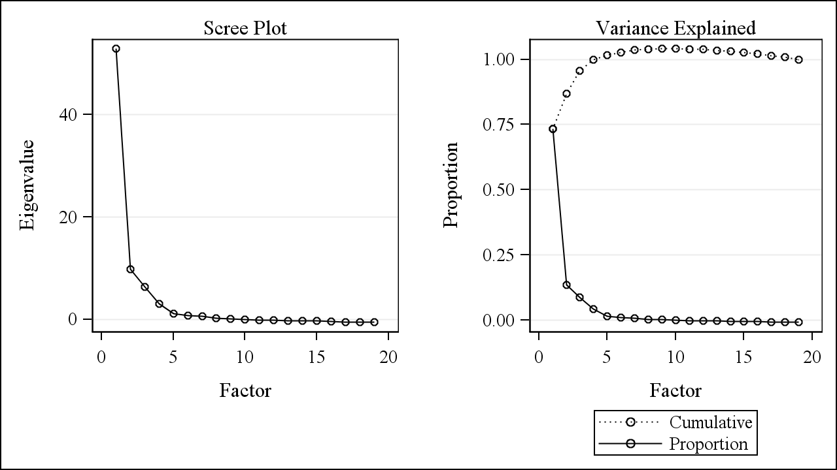

### Table D5: Factor loadings (with promax rotation) and variance explained for ML factor analysis with % occupied housing and % receiving public assistance removed for Census 2000+ACS2005-2009 (N=129002).

**Highlighted values are loadings greater than 0.50 (if rounded to 2 decimal places)**

| **Variable** | **Factor1** | **Factor2** | **Factor3** | **Factor4** | **Factor5** |
| --- | --- | --- | --- | --- | --- |
| ownerocc_hh_rev | 0.80509936 | -0.2575757 | 0.16081193 | 0.27244931 | -0.0675341 |
| inc_IntDivRent_rev | 0.78520827 | 0.45251498 | 0.0512889 | -0.2821234 | -0.2523763 |
| Pov_cbrt | 0.73558464 | 0.07366168 | -0.0089451 | 0.04503793 | 0.17003457 |
| phone_none_cbrt | 0.65788289 | 0.13796282 | -0.1353912 | -0.1437363 | -0.0415927 |
| race_blackNH_cbrt | 0.61652929 | -0.0701185 | -0.0374775 | -0.0677739 | -0.0832658 |
| vehicle_none_cbrt | 0.60959703 | -0.1488382 | 0.11906491 | 0.10281729 | 0.22860262 |
| Unemployed_cbrt | 0.56917132 | 0.13946884 | 0.02557591 | -0.2154038 | 0.12642629 |
| Educ_minBA_rev | -0.1222603 | 1.03709391 | 0.01548146 | -0.0359069 | 0.02390126 |
| Occup_I_rev | 0.00282511 | 0.95461146 | 0.08943744 | -0.0014418 | -0.0447672 |
| HUcost_medownval_cbrt | 0.02980316 | -0.5552416 | 0.33051292 | -0.4104868 | 0.08031147 |
| Educ_minHS_rev | 0.12146515 | 0.55260113 | 0.32064874 | -0.0389608 | 0.30879028 |
| birth_foreign_cbrt | 0.02062958 | -0.1519826 | 0.91295481 | 0.03126003 | 0.00495734 |
| race_hisp_cbrt | 0.01936574 | 0.21879716 | 0.81920851 | 0.01643073 | -0.044452 |
| crowd_gt1_ppr_cbrt | 0.03076283 | 0.36946562 | 0.60313147 | 0.19588375 | 0.00630429 |
| race_asianNH_cbrt | -0.0492599 | -0.3911502 | 0.55645912 | 0.13594673 | -0.0798575 |
| samehouse_rev_cbrt | -0.1550236 | -0.0144389 | 0.1822249 | 0.8025161 | -0.1435555 |
| NotInLaborForce | -0.0045979 | 0.02507132 | -0.0830876 | -0.1842957 | 0.86054443 |
| inc_HHge50k_rev | 0.39945936 | 0.33948852 | -0.1318577 | 0.38901022 | 0.11967116 |
| inc_medHH_cbrt | -0.4205672 | -0.358338 | 0.14081795 | -0.3934358 | -0.0736149 |
|  |  |  |  |  |  |
| Eigenvalue | 52.9431546 | 9.7881145 | 6.3650497 | 3.0582564 | 1.1803629 |
| Difference | 43.1550401 | 3.4230648 | 3.3067933 | 1.8778936 | 0.3854781 |
| Variance Explained | 0.7336 | 0.1356 | 0.0882 | 0.0424 | 0.0164 |
| Cumulative Variance Explained | 0.7336 | 0.8692 | 0.9574 | 0.9998 | 1.0161 |
| Variance Explained (Eigenvalue) Eliminating other factors – Weighted | 11.5100057 | 21.8452793 | 11.5828502 | 8.1282477 | 2.4487294 |
| Variance Explained (Eigenvalue) Eliminating other factors – Unweighted | 1.90243730 | 2.10805119 | 2.34280967 | 1.05504796 | 0.66193877 |
| Variance Explained (Eigenvalue) Ignoring other factors – Weighted | 58.7759512 | 65.6543357 | 12.8876057 | 33.9461582 | 34.8285587 |
| Variance Explained (Eigenvalue) Ignoring other factors – Unweighted | 6.41363977 | 6.04166454 | 2.65884115 | 2.87337796 | 3.57717690 |